VILLAGE OF CLARKSVILLE, MICHIGAN
ZONING ORDINANCE
DECEMBER 2, 1996
Effective March 1, 1997

Zoning Ordinance as amended
September 13, 2010, Ordinance #41
March 7, 2011, Ordinance #43

Village of Clarksville, Michigan

CLARKSVILLE VILLAGE ZONING ORDINANCE

TABLE OF CONTENTS

PREAMBLE 4
ARTICLE 1: SHORT TITLE 4
ARTICLE 2: PURPOSE AND LEGISLATIVE INTENT 4
ARTICLE 3: ADMINISTRATION AND ENFORCEMENT 6
ARTICLE 4 DEFINITIONS AND INTERPRETATIONS 14
ARTICLE 5: SUPPLEMENTAL REGULATIONS 38
ARTICLE 6: ZONING DISTRICTS, MAP AND SCHEDULE OF REGULATIONS 76
Section 6.5 A-1 DISTRICT: GENERAL AGRICULTURAL DISTRICT 80
Section 6.6 R-1 DISTRICT: RESIDENTIAL SUBDIVISION DISTRICT 84
Section 6.7 R-2 DISTRICT: RESIDENTIAL DISTRICT 87
Section 6.8 MP DISTRICT: MULTIPLE-FAMILY RESIDENTIAL DISTRICT 90
Section 6.9 P DISTRICT: PROFESSIONAL OFFICE 98
Section 6.10 TC DISTRICT: TOWN CENTER DISTRICT 100
Section 6.11 BC DISTRICT: BUSINESS AND COMMERCIAL DISTRICT 105
Section 6.12 DI DISTRICT: DEVELOPMENT AND INDUSTRIAL DISTRICT 109
ZONING MAP 114
ARTICLE 7: USES AUTHORIZED BY SPECIAL USE PERMIT 115
ARTICLE 8: SITE PLAN REVIEW 133
ARTICLE 9 AMENDMENTS 154
ARTICLE 10: OFF—STREET PARKING AND LOADING 159
ARTICLE 11: SIGNS, NAME PLATES, AND ADVERTISING STRUCTURES 167
ARTICLE 12: NONCONFORMING USES OF LAND AND STRUCTURES 179
ARTICLE 13: VILLAGE OF CLARKSVILLE BOARD OF APPEALS 183
ARTICLE 14: FEES AND PERFORMANCE GUARANTEES 192
ARTICLE 15: RELATIONSHIP TO OTHER ORDINANCES 194
ARTICLE: 16 SEVERABILITY CLAUSE 194
ARTICLE: 17 EFFECTIVE DATE 194

VILLAGE OF CLARKSVILLE, MICHIGAN
ZONING ORDINANCE
ERRATA PAGE
PAGE PARAGRAPH CORRECTION
Table of Contents Article 11 Name Plates
60 5.11.4 D station
69 5.17.2 A analysis
76 6.1.1 MR
90 6.8 MR
114 Map DI District
119 7.1.9 A Official
129 7.2.3 B 2 only in
130 7.2.3 B 3e uses as home park
169 SIGN Placard
175 A. Establishment
B. Establishment (two times)
176 A. (Column 4) 2 ft.
C. (Column 5) establishment (two times)

ZONING ORDINANCE
OF THE
VILLAGE OF CLARKSVILLE

PREAMBLE
AN ORDINANCE ENACTED TO PROVIDE FOR THE ESTABLISHMENT OF ZONING DISTRICTS AND REGULATIONS FOR THOSE AREAS OF THE VILLAGE OF CLARKSVILLE, WITHIN WHICH THE PROPER USE OF LAND AND NATURAL RESOURCES MAY BE ENCOURAGED AND REGULATED; TO PROVIDE FOR THE LOCATION, SIZE, AND TYPE OF USES THAT MAY BE MADE OF REAL PROPERTY; TO PROVIDE FOR SANITATION, SAFETY, LIGHT, AND OTHER PROTECTIVE MEASURES; TO REGULATE THE DENSITY OF POPULATION; TO PROVIDE FOR THE ADMINISTRATION, ENFORCEMENT AND AMENDMENT OF THIS ORDINANCE; TO PROVIDE FOR APPEALS, AND FOR THE ORGANIZATION AND PROCEDURES TO BE FOLLOWED BY THE BOARD OF APPEALS; TO PROVIDE FOR PENALTIES FOR VIOLATIONS; TO PRESCRIBE DUTIES FOR THE VILLAGE PLANNING COMMISSION AND TO PROVIDE FOR THE ESTABLISHMENT OF A VILLAGE BOARD OF APPEALS PURSUANT TO PUBLIC ACT 110, OF MICHIGAN PUBLIC ACTS OF 2006 AND TO PROVIDE FOR THE REPEAL OF ALL OTHER ORDINANCES, OR PARTS THEREOF, INCONSISTENT HEREWITH AND CONTRARY HERETO.
Whereas, after review of the proposed Ordinance, the village Council of the Village of Clarksville has reviewed and held public hearings on the proposed Ordinance;
Now Therefore Be It Resolved, the Council of the Village of Clarksville, Michigan, ordains:

ARTICLE 1: SHORT TITLE
This Ordinance shall be known and may be cited as the "Village of Clarksville Zoning Ordinance". All articles, section and other topical headings are for reference only and shall not be construed to be part of this Ordinance.

ARTICLE 2: PURPOSE AND LEGISLATIVE INTENT
Section 2.1 PURPOSE: Pursuant to the authority granted to the Village of Clarksville by the Public Acts of the State of Michigan and based upon the Village Comprehensive Development Plan and Policies for the future, this Ordinance is established for the following purposes.
Sec 2.1.1 Promoting and protecting the public health, safety, and general welfare.
Sec 2.1.2 Protecting the character and the stability of the open space, residential, and non-residential areas within the Village of Clarksville and promoting the orderly and beneficial development of such areas.
Sec 2.1.3 Providing adequate light, air, privacy and convenience of access to all individual property.

Sec 2.1.4 Regulating the intensity of use of land and lot areas and determining the area of open spaces surrounding buildings and structures necessary to provide adequate light and air and to protect the public health.
Sec 2.1.5 Lessening and avoiding congestion on the public highways and streets.
Sec 2.1.6 Promoting healthful surrounding for family life in residential areas.
Sec 2.1.7 Protecting the public and adjacent uses from fire, explosion, noxious fumes or odors, excessive heat, dust, smoke, glare, vibration, and other health and safety hazards.
Sec 2.1.8 Preventing the overcrowding of land and undue concentration of buildings and structures, so far as possible and appropriate in each zoning district by regulating the use and bulk of buildings in relation to the land surrounding them.
Sec 2.1.9 Enhancing the social and economic stability of the Village.
Sec 2.1.10 Enhancing the aesthetic desirability and community design of the environment throughout the Village. and,
Sec 2.1.11 Conserving the expenditure of funds for public improvements and services.
Section 2.2 LEGISLATIVE INTENT: Zoning districts contained in this Ordinance each have a defined purpose and are based on the Village of Clarksville Comprehensive Development Plan. The districts are sized to be adequate to handle long-term needs, and yet must be monitored relative to any necessary changes or updating as time passes. While the various regulations limit the use of properties, the Ordinance provides land owners with a range of choices, flexibility, and options for development.

ARTICLE 3: ADMINISTRATION AND ENFORCEMENT
Section 3.1 ADMINISTRATION
The provisions of this Ordinance shall be administered by the Village Planning Commission and the Village Council in accordance with Act 110 of the Michigan Public Acts of 2006, the Zoning Enabling Act.
The Planning Commission shall have the primary responsibility for the administration and enforcement of the Ordinance; and shall adopt and file with the Village Council, rules and guidelines to assist the Building and/or Development Official(s) and the Village Planning Commission in administering and enforcing this Ordinance.
The Village Council, with the recommendation of the Village Planning Commission, shall employ or contract a Development Official to act as its officer to effect the proper and consistent administration and enforcement of this Ordinance. The terms and conditions of employment shall be established by the Village Council. The Development Official or his/her agent shall have the power of a police officer, whose jurisdiction is the enforcement of this Ordinance. Acting in this capacity, the Development Official shall, among other responsibilities, be empowered to issue appearance summons; seek the issuance of warrants for the arrest of alleged violators through the office of the County Prosecutor; bring criminal action in the name of the Village against violators of the provisions of this Ordinance.
Section 3.2 RELIEF FROM PERSONAL RESPONSIBILITY
The Development Official, officer, Planning Commissioner or employee charged with the enforcement of this Ordinance, while acting for the Village, shall not thereby render himself liable personally, and he/she is hereby relieved from all personal liability for any damage that may accrue to persons or property as a result of any act required or permitted in the discharge of his official duties. Any suit instituted against any officer or employee because of an act performed by him/her in the lawful discharge of his/her duties and under the provisions of the Ordinance shall be defended by the legal representative of the County until the final termination of the proceedings. In no case shall the Development Official or any of his/her subordinates be liable for costs in any action, suit or proceeding that may be instituted in pursuance of the provisions of the Ordinance; and any Officer acting in good faith and without malice, shall be free from liability for acts performed under any of its provisions or by reason of any act or omission in the performance of his/her official duties in connection herewith.
Section 3.3 DUTIES OF THE BUILDING AND DEVELOPMENT OFFICIAL
It shall be the responsibility of the Development Official to enforce the provisions of this Ordinance and in so doing shall perform the following duties:
3.3.1 Issue Permits: All applications for zoning permits shall be submitted to the Development Official who shall issue zoning permits and certificates of occupancy when all applicable provisions of this

ordinance have been complied with.
3.3.2 File Applications: The Development Official shall maintain files of all applications for zoning permits and for certificates of occupancy and shall keep records of all zoning permits and certificates of occupancy issued. These shall be filed with the Development Official, such files and records shall be open to public inspection. Copies shall be furnished upon request, at cost, to any person.
3.3.3 Official Copies: Maintain one official copy of an updated Zoning Ordinance and Zoning District Map, and its amendments, in accordance with Article 6, Section 6.1.2.
3.3.4 Inspections: The Development or this authorized agent shall be empowered to make inspections of buildings or premises in order to properly carry out the enforcement of this Ordinance.
3.3.5 Record of Complaints: The Development Official shall keep a record of every identifiable complaint of a violation of any of the provisions of this Ordinance, and of the action taken consequent to each such complaint, such records shall be public record.
3.3.6 Report to Village Council: The Development Official shall report to the Village Council periodically at intervals of not greater than one (1) year, summarizing for the period since the last previous report of all building permits, and certificates of occupancy, all complaints of violation, all appeals, variances and exceptions granted by the Zoning Board of Appeals and state action taken subsequent thereto.
Section 3.4 DUTIES OF THE PLANNING COMMISSION
3.4.1 Adopt rules and guidelines for the proper administration and enforcement of the Ordinance.
3.4.2 Act as a policy board on matters of enforcement and administration of the Ordinance not covered by adopted rules or guidelines.
3.4.3 Conduct Public Hearings.
3.4.4 Make comprehensive review and recommend changes to the Zoning Ordinance every five (5) years.
3.4.5 Review all proposed requests for special use permits and/or amendments to the Zoning Ordinance for compliance with requirements of the Ordinance based on Articles 7 and 9 and thence recommend appropriate action to the Village Council for approval, disapproval or modification.
Section 3.5 ZONING PERMITS
The following provisions shall apply in the issuance of any zoning permit in addition to any other requirements for a particular use contained in this Ordinance.
3.5.1 Commencement: Excavation for building or structure shall not be

commenced; the erection, addition to, alteration of, or moving of any building or structure shall not be undertaken, or any land shall not be used, or an existing use of land shall not be changed to a use of the different type of class, until a zoning permit or a certificate of occupancy has been secured from the Development official. A zoning permit shall not be issued for those uses requiring a special use permit as provided for in this Ordinance, until a special use permit has been approved in compliance with the provisions of Article 7 of this Ordinance. A zoning permit shall not be issued for those uses requiring more than ten (10) parking spaces until the site plan has been reviewed and approved, as provided in Article 8 of this Ordinance.
3.5.2 Application for Zoning Permit: There shall be submitted to the Development official with each application for a zoning permit the following:
A. In the case of a permit for a dwelling or other building intended for human occupancy and having waste water plumbing, a written report from Ionia County Health Department certifying in writing the approval of a private sanitary sewage disposal system, or when public sanitary sewage service is available or required by local ordinance, a written notice of acceptance of hook-up or a tap-in fee receipt shall be required.
B. When a new or rehabilitated driveway is intended, a receipt of application for a driveway permit from the Ionia County Road Commission shall be required.
C. All applications for a zoning permit shall require an accurate scale map showing the following:
1. The location, shape, area, dimensions, and legal descriptions of the parcel, location of easements and centerline of road.
2 The location, setbacks, dimensions, height of the existing and/or proposed structures, to be erected, altered or moved on the parcel.
- The existing or intended uses.
- The proposed number of sleeping rooms, dwelling units, occupants, employees, customers, and other users.
- The yard, open space and parking space dimensions.
- Any change to the contour of the parcel involved.
- Identify surface water and waterways.
D. Applicant must comply with this Ordinance, the currently approved State Construction Code Act of 1972, Act 230, 1972, the Ionia County Drain Commission Standard Construction Specifications for Open and Closed Drains, the Village of Clarksville Subdivision Control Procedures pursuant to P.A. No. 288 of 1967, the Ionia County Soil Erosion and

Sedimentation Control Ordinance pursuant to P.A. 347 of 1972, the Ionia County Health Department Sanitary Code, and all other County and Village Ordinances that are applicable to the proposed building, structure or land use.
E. Proof of equitable title shall be required with any application for a zoning permit in order to assure compliance with dimensional requirements of this Ordinance and to protect public easements from encroachment.
Section 3.6 ADMINISTRATIVE PROVISIONS
3.6.1 Suspension of Permit: Any permit issued shall become invalid if the authorized work is suspended or abandoned for a period of six (6) months after the time of commencing the work, unless in the case of building permits the development proposed shall have passed its first building inspection.
3.6.2 Previous Approvals: Nothing in the ordinance shall require changes in the plans, construction or designated use of a building for which a lawful building, electrical, or mechanical permit has been heretofore issued or otherwise lawfully authorized, and the construction and/or installation of which shall have been actively prosecuted within ninety (90) days after the effective date of this Ordinance; and the entire building or installation shall be completed as authorized within two (2) years after the date of approval of the application.
3.6.3 Revocation of Permits: The Development official or the County Electrical, Plumbing, or Mechanical Official may revoke a permit or approval issued under the provisions of this Ordinance in case of any false statement or misrepresentation of fact in the application or on the plans on which the permit or approval was based.
3.6.4 Inspection: The Development official shall cause to be made the appropriate inspections as required under the State Construction Code and the Department of Labor General Rules (Parts 1-9).
A. These inspections shall include:
Site inspection - To insure proper placement of the structure.
Footing/Foundation - After forms are set and prior to placement of concrete.
Subgrade Plumbing, Electrical and Mechanical - After any interior, subgrade plumbing, electrical or mechanical ducts, pipes or conduit is installed and before work is concealed in any manor.
Backfill - After concrete, block, or other foundation is in place and damp/water proofed, and all required moisture barriers are installed and before earth backfill.
Electrical Service (Permanent or Temporary) - As required.

Rough-in Electrical - When all boxes, wire, conduit, or the electrical connections are installed and before work is concealed in any manor.
Rough-in Plumbing - When all fittings, distribution and soil pipes have been installed and before work is concealed in any manor.
Rough-in Mechanical - When all returns and plenums have been installed and all cutting and notching has been completed.
Special RI (Building Plumbing, Electrical, Mechanical) - Whenever there are fire rated assemblies, fire alarm systems, through penetration systems, fire dampers and the like, these shall be inspected before work is concealed in any manor.
Rough-in Building - After all Plumbing, Electrical, and Mechanical, any special rough-in approvals have been made, all framing material is in place, and before boarding or concealing in any manner.
Final Electrical - After all fixtures and cover plates have been installed and all connections made.
Final Plumbing - After all fixtures, faucets, appliances and gauges have been installed, piping tested, and all other connections and vents made or installed.
Final Mechanical - After all venting, electrical and mechanical connections are made and all appliances set.
Final Building - After all Plumbing, Electrical, and Mechanical final approvals have been given, and all work relating to life safety is structurally complete.
Special Inspections - Nothing in this Ordinance shall be construed as limiting inspections during regular business hours or whenever work is being pursued and as may be considered appropriate by the respective official, provided the inspector announces himself and presents his credentials if requested. Any of the above inspections may be combined with other inspections if all work necessary for these inspections has been completed and has not been concealed.
B. The respective officials will make the necessary inspections and shall either approve that portion of the construction as completed or shall notify the permit holder or his agent wherein the construction fails to comply with this Ordinance or the State Construction Code.
3.6.5 Fees: All fees for inspection and the issuance of permits or certificates required under this Ordinance shall be collected by the Development official in advance of issuance. The amount of such fees shall be established by resolution of the Village Council and shall be in an amount sufficient to defray the cost of inspections and supervision necessary for the implementation and enforcement of this

Ordinance.
Section 3.7 CERTIFICATE OF USE AND OCCUPANCY
No land shall be occupied or used, and no building shall be used or changed in use until a certificate of occupancy shall have been issued by the Development official stating that the building and its intended use complies with the provisions of this Ordinance.
3.7.1 Certificates for Existing Buildings: Certificates of occupancy may be issued upon request for existing buildings, structures, or parts thereof, or existing uses of land if, after inspection such uses of land are in conformity with the provisions of this Ordinance.
3.7.2 Administration of Zoning Permits and Certificates of Occupancy: In cases where a building permit is required under the State Construction Code, the application and issuance of a zoning permit and a certificate of occupancy shall be fully coordinated and integrated into the building permit application and inspection process. As such, an application for a building permit shall also serve as an application for a zoning permit and the granting or final approval on a building permit shall constitute a final approval of a zoning permit, and eligibility for a certificate of occupancy.
Section 3.8 ENFORCEMENT - VIOLATIONS - PENALTIES
3.8.1 Violations and Penalties: The Development official shall enforce the provisions of this Ordinance. Violations of any provisions of this Ordinance are declared to be nuisance per se. Any and all building or land use activities considered possible violations of the provisions of this Ordinance observed or communicated to the Village's contracted police agency or the Ionia County Sheriff's Department or to any Village officials shall be reported to the Development official. Violations reported to the Department shall not be subject to the enforcement procedures below until and unless the person or entity reporting the alleged violation has been identified.
3.8.2 Enforcement Procedure: It shall be unlawful for any person to commence operations of any kind that are in violation of the terms of this Ordinance, and any violations shall be subject to the penalties herein prescribed.
A. Inspection of Violation: The Development official or his agent shall inspect each alleged violation of this Ordinance within three (3) working days of receipt or a notice or an alleged violation and issue an order to correct to the offender.
B. Correction Period, Requirements of Notice: Whenever a violation has been confirmed by the Development official, the Official or his agent shall give notice in writing by 1st Class Mail addressed to the owner or occupant of the property where the violation exists and to any person(s) otherwise responsible for said violation. The notice shall specify the location and nature of the violation, and shall

indicate that the owner, occupant or person otherwise responsible, is required to abate the violation within thirty (30) calendar days of the receipt of the notice, or file the necessary appeal forms with the Clarksville Village Zoning Board of Appeals within thirty (30) calendar days of the receipt of the notice. Such notice shall require the person thus notified to immediately declare to the Development official his acceptance or rejection of the terms of the order. If the occupant or owner of the premises is unknown or cannot be located, notices shall be given by posting a copy of said notice upon a conspicuous part of the property where the public nuisance is located and by mailing a copy of said notice by 1st Class Mail, addressed to the owner or party in interest at the address shown on the current tax records. A violation not corrected within the specified time shall be referred to the County Prosecuting Attorney.
3.8.3 Any person violating any of the provisions of this Ordinance shall upon conviction thereof, be punished by imprisonment in the County Jail for not more than ninety (90) days, or by a fine of not more than One Hundred ($100.00) Dollars and the costs of prosecution, or by both such fine and imprisonment in the discretion of the Court. Each day that a violation is permitted to exist shall constitute a separate punishable offense. The imposition of any sentence shall not exempt the offender from compliance with the requirements of this Ordinance. Violation of this Ordinance is hereby declared a nuisance per se and conviction of the penal provisions shall not preclude proceedings to abate such a nuisance.
3.8.4 Cumulative Rights and Remedies: The rights and remedies provided herein are cumulative and in addition to any other remedies provided by law.
3.8.5 The Development official may refuse to issue new Zoning Permits to a person who has failed to correct violations or to any person representing a firm which has failed to correct violations of this Ordinance or the current State Construction Code.
Section 3.9 LAND SUBDIVISION
3.9.1 Subdivision of Land: The lands with in the Village will be subdivided in accordance with the Subdivision Control Act 288 of Michigan Public Acts of 1967, as amended, MCLA 560.101 et seq.
3.9.2 Division of Lots: The division of a lot in a recorded plat is prohibited, unless approved following application to the Village of Clarksville Planning Commission. The application shall be filed with the Development Official and shall state the reasons for the proposed division. The division, to be approved by the Village Planning Commission, shall have the suitability of the land for building purposes approved by the Ionia County Health Department. No building permit shall be issued, or any building construction commenced, prior to approval. No lot in a recorded plat shall be divided into more than four (4) parts and the resulting lots shall be not less than the dimensional requirements permitted by the county zoning ordinance. The

division of a lot resulting in a smaller area than prescribed herein may be permitted but only for the purpose of adding to the existing building site or sites. The application shall so state and shall be in affidavit
Section 3.10 INTERPRETATIONS AND APPLICATION
3.10.1 In the interpretation, application and enforcement of this Ordinance, whenever any of the provisions or limitations imposed or required herein are more stringent than any other law or ordinance, then the provisions of this Ordinance shall govern, provided that whenever the provisions of any other law or ordinance impose more stringent requirements than are imposed or required by this Ordinance, then the provisions of such other law or Ordinance shall govern.

ARTICLE 4 DEFINITIONS AND INTERPRETATIONS
Section 4.1 INTENT AND PURPOSE: The purpose of this Article is to establish rules for the interpretation of the text of this Ordinance, to define certain words and terms, and to provide the interpretation of this Ordinance by adoption of a technical dictionary. Certain words and terms do not appear in this Article, which have special application and are defined in Article 5 "Supplemental Regulations", Article 7 "Special Use Permit", and in Article 11 "Signs, Nameplates, and Advertising Structures"
Section 4.2 USE OF WORDS AND TERMS: For the purpose of this Ordinance any word or term no defined in this Article shall be interpreted by reference to "The Illustrated Book of Development
Definitions", Harvey S Moshowitz and Carl G. Lindbloom, 1981, Rutgers University, P.O. Box 489 Piscataway, New Jersey 08854, except when clearly contrary to the context in which the word is used. Any word which is neither defined in this Ordinance or in the above mentioned reference book shall be interpreted by the use of the American Heritage Dictionary of the English Language, New College Edition. 1980.
Section 4.2.1 Words used in the present tense shall include the future tense, words used in the singular shall include the plural, and words in the plural number shall include the singular, unless the context clearly indicates and stipulates the contrary.
Section 4.2.2 The words person, proprietor, property owner, and operator shall include any recognized for of legal entity.
Section 4.2.3 The words property, lot, parcel, real estate, premises, plot, and land shall be interpreted to mean real property as delineated and described by legal documents and instruments.
Section 4.2.4 The word road shall also mean highway, street, alley, drive, land and other public thoroughfare.
Section 4.2.5 The word building shall include the word structure.
Section 4.2.6 The words used and occupied when applied to any land or building shall be construed to include the words intended, arranged, or designed to be used or occupied.
Section 4.2.7 The word shall is always interpreted as mandatory and never as permissive or discretionary.
Section 4.2.8 The word may shall be interpreted as permissive or discretionary.
Section 4.2.9 The word required shall be construed to be mandatory.
Section 4.3 DEFINITIONS
Accessory Structure: A building or structure located on the same lot as the principal building or structure. The use of which is incidental or secondary to the principal building or use.

Accessory Use: A use of land or of a building or portion thereof which is customarily and naturally incidental to, subordinate to, and devoted exclusively to the principal use of the land or building and located on the some lot with the principal use.
Advertising Sign/Structure: A structural poster, panel or painted sign, either free-standing or attached to a building for the purpose of conveying information, knowledge or ideas to the public about a subject unrelated to the premises upon which it is located.
Advertising Sign/Structure: Any outdoor sign, display, device, figure, painting, drawing, message, placard, poster, billboard, or other comparable object, used as a means to convey information or direct attention to a business, product, service or commodity.
Aggregate: An inert material used as a component of concrete, mortar, plaster and bituminous pavements. Sand, gravel or crushed stone are the most common aggregates.
Agriculture Land Use: Means of, or pertaining to, or connected with, or engaged in agricultural or tillage which is characterized by the act or business of cultivating or using land and soil for the production of crops for the use of animals or humans, and includes, but is not limited to, purposes related to agriculture, farming, dairying, pasturage, horticulture, floriculture, viticulture, and animal and poultry husbandry. See "Farm and "Prime Agricultural Land".
Alley: A generally narrow vehicular or pedestrian right-of-way that permits access to a rear yard, parking lot or other area of a parcel. Alleys are not designed for general traffic and afford only a secondary means of access.
Alteration: Any modification, remodeling, change, or rearrangement in the structural or supporting members such as bearing walls, columns, or girders, as well as any change in the doors or windows which affect the means of egress which is undertaken without adding to the floor area, height, or physical size of the building or structure.
Ambient Noise: Background noise or noise that cannot be identified as coming from any particular source.
Apartment: a room or group of rooms that is designed to function as a single, complete dwelling unit and is located in a multiple-family dwelling.
Appraised Value: The value of property as estimated by an individual qualified to appraise that type of property.
Aquifer: Subsurface rock or other materials capable of holding a significant amount of water in their interstices. Certain types of material - such as course sands, gravel and limestone, are more likely to produce aquifers.
Area Variance: A zoning variance that is granted concerning the size and shape of a building lot and the size, shape, and location of the physical structure to be located on the lot. This type of variance concerns such zoning requirements as density, required yards, number of parking and unloading spaces, frontage, lot size or height.

Automobile Repair and Commercial Garages: A premise where the following services may be carried out in a completely enclosed building: general repairs; engine rebuilding; collision; painting; and undercoating of vehicles.
Automobile/Gasoline Service Stations: Structures and premises used or designed to be used for the retail sale of fuels, lubricants, or grease and other operating commodities for motor vehicles, including the customary space and facilities for the installation of such commodities; and including space for temporary minor repairs, or service such as polishing, washing, cleaning, greasing, but not including bumpin^{g}, painting, or refinishing thereof.
Base Flood Level: The highest elevation of a flood having a one percent chance of being equaled or exceeded in any given year.
Basement: The portion of a building which is partly below and partly above grade, and having greater than one-half its vertical height below normal grade. A basement shall not be counted as a story (See Figure 4.1).
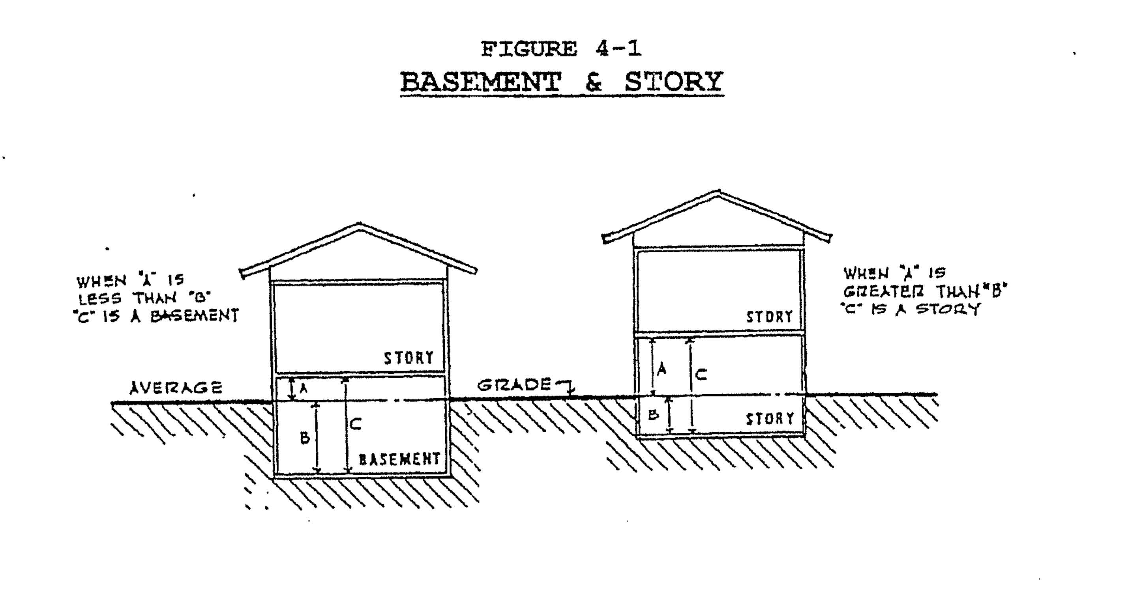
FIGURE 4 —1
BASEMENT & STORY
Bed and Breakfast: "Bed and Breakfast" means a private single family residential structure that meets the following criteria:
AVERAGE
51 C \\\NI ISTOAT \.\\ ASE EH
- Offers accommodations to transient tenants in eight or fewer sleeping rooms including rooms occupied by the innkeeper or manager, one or more of which are available for rent to transient tenants.
- Serves only breakfast to its transient tenants at no extra cost.
- Has a smoke detector in proper working order in every sleeping room and a fire extinguisher in proper working order on every floor.
Berm: An earthen mound designed to provide visual interest, screen undesirable views, and/or decrease noise.
Bond: A form of insurance required of an individual or firm to secure the performance of an obligation; as in performance bond.
Board of Appeals: The Village Council of Clarksville is the Board of Appeals.

Building: A combination of material, whether portable or fixed, forming a structure having a roof supported by columns or by walls affording a facility or shelter for use or occupancy by persons, animals or property.
Buffer: a strip of land, including a specified type and amount of planting or structures, which may be required to protect/screen on type of land use from another, or minimize or eliminate conflicts between them.
Building Area: The area included within surrounding exterior walls (or exterior walls or fire walls) exclusive of vents, shafts and courts. Areas of the building not provided with surrounding walls shall be included in the building area if included within the horizontal projection of the root or floor above.
Building Code: An ordinance governing the design, construction, alteration, enlargement, repair, demolition, removal, conversion, use, and maintenance of all buildings and structures known as the Building Code, specifically Ordinance No. XX of the Village of Clarksville or County of Ionia.
Building, Front Line of: The line that coincides with the face of the building nearest the front line of the lot, which includes sun parlors and enclosed porches, but not steps.
- The front building line on any lot with an outside simple curve will be the straight-line chord that intersects the side lines at the point of intersection with the required front set-back line. See Illustrations in Section 17 of this Ordinance.
- The front building line on any lot with an inside simple curve will be the straight line tangent perpendicular to the arc radius at the midpoint of the curve.
- Front building lines on lots with compound, unbroken-back or reverse curves will be determined using the tangent or chord which provides the greatest set-back toward the interior of the lot from the required set-back line and front lot line.
Building Height: The vertical distance measured from the established grade to the highest point of the roof surface for flat roofs; to the deck line of mansard roofs; and to the average height between eaves and ridge for gable, hip, and gambrel roofs. Where a building is located on sloping terrain, the height shall be measured from the average ground level of the grade at the building wall (See Figure 4-2).
FIGURE 4 -2
BUILDING HEIGHT

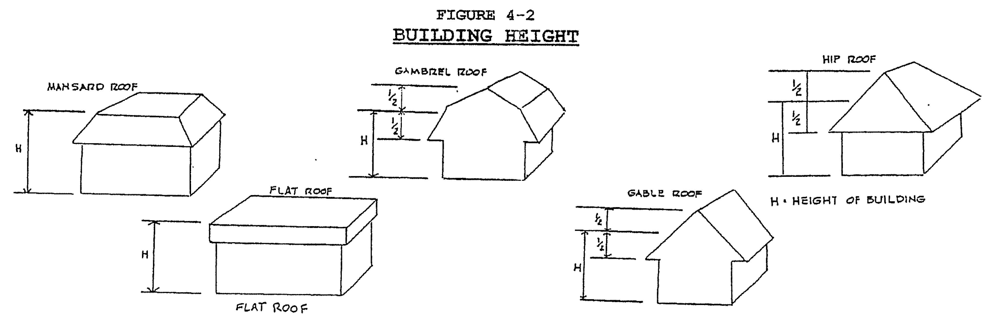

Building Line(s): A line defining the front, side, and rear yard requirements outside of which no building or structure may be located.
Building Official: The officer or other designated authority charged with the administration and enforcement of the Village Building Code, or his or her duly authorized representative.
Campground: As defined in Public Act 368 of 1978 as amended MCLA 331.12501 et seq.
Carport: A partially open structure, intended to shelter one or more vehicles. Such structure(s) shall comply with all yard requirements subject to a private garage.
Child Care Center/Day Care Center: A facility, other than a private residence, receiving more than six (6) preschool or school age children for group care for periods of less than twenty-four (24) hours per day, and where the parents or guardians are not immediately available to the child. It includes a facility which provides care for not less than two (2) consecutive weeks, regardless of the number of hours of care per day.
Cellar: That portion of a building which is partly or completely below grade and having at least on-half (1/2) its height below grade.
Central Commercial Core/Central Business District: That portion of the Village of Clarksville that is characterized as the older, traditional center of the village where business activity, governmental functions, services and residential land uses are integrated in a consolidated pattern. This area is further characterized by smaller lots sizes, more intense land and building use, mixed land uses, and higher percentages of lot coverage by buildings.
Changes in Use: A use of a building, structure or parcel of land, or portion thereof which is different from the previous use in the way it is classified in this Ordinance or in the State Construction Code, as amended.
Church Uses/Religious Institutions: Churches, synagogues, mosques, church schools, church residences and church owned land used for related church functions.
Clear Vision Area: The unobstructed view across a corner space which is created by the intersection of two vehicular ways that allows a motorist to see on-coming traffic or pedestrians (See Figure 4-1). This vision area shall be clear of any opaque obstructions within a specified distance along or from the right-of-way line(s) of all streets and drives.
FIGURE 4-1
CLEAR VISION AREAS

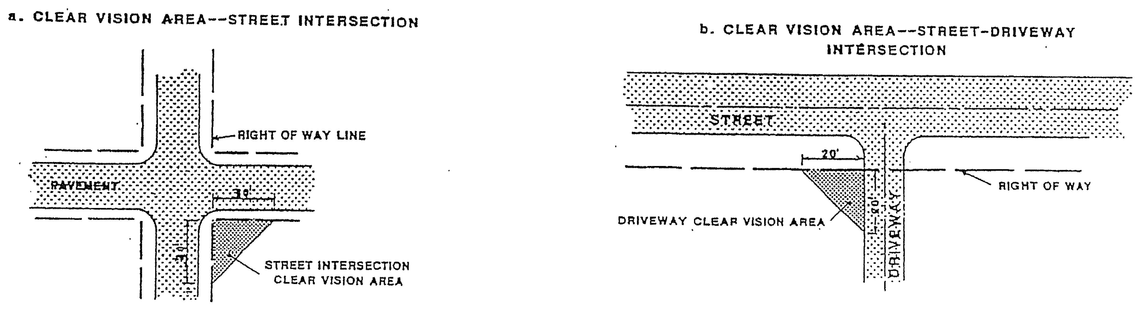
Clear Zone: The innermost area of a runway approach, either within the airport or under the control of airport authorities.
Clinic (Medical): A building where human patients, who are not lodged overnight, are admitted for examination and treatment by a group of physicians, dentists, or similar professionals.
Clinic (Animal); A building where animal patients, who may or may not be lodged overnight, are admitted for examination and treatment by a veterinarian or similar professionals.
Cluster Development: A development where structures are arranged in closely related groups, units are typically of the same type or design character, and built at densities in certain areas of a site while preserving the natural features in others in others on the same site.
Cold Storage: As it applies in this Ordinance, "cold storage" pertains to the cooperative keeping of farm produce or goods under climate controlled conditions for more than one farm or agricultural enterprise.
Commercial Recreation Facility: An outdoor recreational facility located near a major travel corridor or a natural feature including but not limited to campgrounds, athletic fields, golf course, racetrack or other spectator/participatory facility that charges a fee for its utilization.
Commercial Use: An activity carried out for pecuniary gain including but not limited to retail sales, repair service, or salvage operators, business offices, food service, entertainment and brokerages.
Commercial Vehicle: Any motor vehicle which has a commercial license and/or which has a gross vehicle weight rating (GVWR) of over 10,000 pounds.
Common Land: A parcel or parcels of land together with the improvements thereon, the use, maintenance and enjoyment of which are intended to be shared by the owners and occupants of the individual building units in a planned unit development.
Comprehensive Development Plan: The statement of policy by the Planning Commission and Village Council relative to the agreed upon and officially adopted guidelines for a desirable physical pattern for future community development. The Plan consists of a series of maps, charts, and written material representing in summary from the soundest concept for community growth to occur in an orderly, attractive, economical, and efficient manner thereby creating the very best community living conditions. It is a blueprint for decision making for the future development and framework of the community.
Comprehensive Plan: An official document that serves as a guide to the long-range development of the County.
Condominium: The ownership of a dwelling unit and the space enclosed by the description thereof as contained in the master deed for the complex or project established in conformance with the provisions of the condominium Act 59 of 1978, as amended, MCLA 559.101 et seq.
Condominium, Site: A site condominium is a development containing residential, commercial, office, industrial or other structures or

improvements for uses permitted in the zoning district in which it is located, in which each co-owner owns in common with the other owners a specifically amount of land space for common use, and in which each co-owner owns exclusive rights to a volume of space within which a structure or structures may be constructed, herein defined as a condominium unit, as described in the master deed. [Also see Section 5.9.2 (P) for Site Condominium specific definitions]
Construction Contractors Establishment: A parcel of land building or structure, or a portion thereof used to store trucks, excavating equipment, supplies, tools, or materials utilized by construction contractor, subcontractors, and builders.
Convalescent or Nursing Homer A residential facility designed to provide a range of personal and medical care services to chronically ill or disabled individuals and which is licensed by the State of Michigan.
Convenience Commercial Establishment: A retail, office, restaurant, tavern, service business, or other commercial use permitted in Section 10.2 of this Ordinance, which is operated from a single building containing not more than one thousand and fifty (1,050) square feet in gross floor area.
Convenience Retail: Establishments which sell primarily goods which are edible or disposable in small quantities directly to the consumer and usually situated in a free-standing building of less than 3,000 square feet in size.
Corner Lot: A lot that is situated at the junction of at least two streets, at which the angle of interception is no greater than 135 degrees. This Ordinance specifies that corner lots have two front yards, one rear yard and one side yard (See Figure 4-5).
Cul-de-Sac: A street with an outlet at only one end and a turnaround area at the other end.
Customary Agricultural Operation: A condition or activity which occurs on a parcel of land in connection with the commercial production of farm products and includes but is not limited to noise, odors, dust, fumes, operation of machinery and irrigation pumps, ground and aerial seeding and spraying, the application of chemical fertilizers, insecticides and herbicides, and the employment of labor when such conditions or activities are conducted in a usually or generally accepted manner (See Farm).
Density: The number of dwelling units situated on or to be developed on a net acre of land_
- Low Density. Less than one dwelling per acre.
- Medium Density. Two or more than dwellings per net acre of land but less than six dwellings per net acre of land.
- High Density. More than seven dwellings per net acre of land.
Density, Gross: "Gross Density" means a figure which equals the total number of dwelling units on a lot divided by the total number of acres included in the lot.

Density, Net: "Net Density" means a figure which equals the total number of dwelling units on a lot divided by the total number of acres included in the lot, excluding any lot area owned by a government entity, used as a public or private street or occupied by a non-residential use.
Development: The construction, reconstruction, conversion, structural alteration, relocation, or enlargement of any structure and mining excavation, land filling or land disturbance and any extension of an existing use of land. (See Figure 4-4 for illustration of development options).
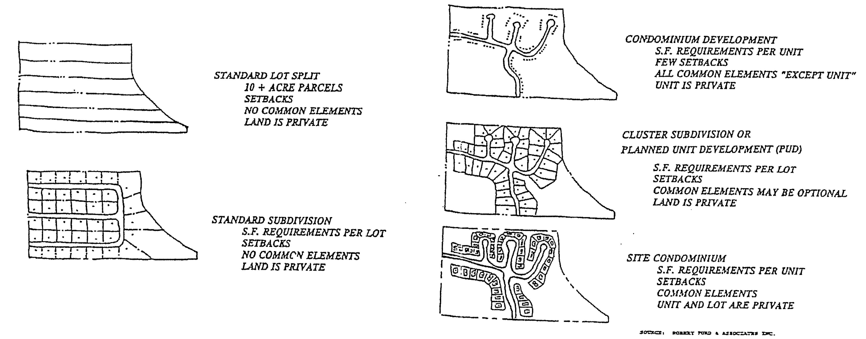
FIGURE 4-4
DEVELOPMENT OPTIONS AND SITE ILLUSTRATIONS

Development Official: The public official or contracted official whose duty is to administer and enforce this Ordinance.
Development Permit: A permit issued to a person, proposing a development which is regulated by this Ordinance, which indicates compliance with the Ordinance and thereby granting permission to proceed.
Directional Sign: A sign which gives a name, place, location, and general nature of a specific establishment or attraction and is intended to give directions to that place.
Disturbed Land: A parcel of land which is graded, filled, excavated, or mined or stripped of its natural vegetative cover or grass for a purpose other than agriculture land use.
Driveway: A private path of travel over which a vehicle may be driven which provides access from one- or two parcels of land to a public or private road.
Drive-In Facilities: Commercial enterprises that permit the consumer to do business or be entertained without leaving his car.
Driveway: A private access to property abutting a public street.

Dump: A disposal site on which solid wastes are indiscriminately placed and left uncovered and are not cited in the Ionia County Solid Waste Management Plan.
Dwelling Unit: A single unit providing complete, independent living facilities for one or more persons, including permanent provisions for living, sleeping, eating, cooking, and sanitation.
Dwelling, Single-Family: A detached building including a mobile home, designed for or occupied as one dwelling unit with common cooking and utilities and complies with the following regulations:
(A) The dwelling shall meet the dimensional requirements of the State Building Code.
(B) All habitable rooms within the dwelling shall have an average ceiling height of not less than 7 feet 6 inches in at least 50 percent of the required area, with no portion less than five (5) feet in height.
Exceptions:
- Beams and girders spaced not less than 4 feet on center may project not more than 6 inches below the required ceiling height.
- All other rooms, including hallways and corridors shall have a ceiling height of not less than 7 feet measured to the lowest projections from the ceiling.
(C) The single-family dwelling, including mobile homes and manufactured housing shall have a minimum exterior breadth/caliper/width of twenty (20) feet. (This is to imply that the minimum dimension between any two opposing exterior walls, measured at any point on the horizontal, shall be at least twenty (20) feet.) Breezeways, garages, porches, and other appurtenances shall not be considered part of the required 20 feet.
(D) All single-family dwellings shall comply with the pertinent building code. If the dwelling is a mobile home, all construction, plumbing, electrical apparatus and insulation within and connected to said mobile home shall comply with the "Mobile Home Construction and Safety Standards" as promulgated by the United States Department of Housing and Urban Development, being 24 CFR 3280, as amended. Additionally, all dwellings shall comply with applicable roof snow load and strength requirement.
(E) The dwelling shall be placed upon and secured to a permanent foundation in accordance with the State Building Code and, where applicable, the manufacturer's installation instruction.
(F) Skirting shall be installed if the dwelling is not placed upon a basement or crawl space. The skirting shall be installed in accordance with Act 419 of 1976, The Mobile Home Commission Act.
(G) If the dwelling is manufactured off the site, it shall be installed with the wheels removed. In addition, a dwelling shall not have an exposed towing mechanism, undercarriage or chassis.

(H) The dwelling shall have a roof with a pitch of at least 2 in 12. (Earth sheltered homes being excluded from this requirement.)
Dwelling, Multiple-Family: A building or structure under one roof designed for occupancy by three (3) or more persons or families each occupying a single, complete independent dwelling/housing unit. Such a building often has a common heating, electrical or water system (but may be metered separately) and may also have common hallways, stairs or elevators.
Dwelling, Two-Family/Duplex: A building containing two dwelling units.
Earth Shelter Home: A building which is partially or entirely below grade and is designed and intended to be used as a single-family residence.
Easement: An interest in or right over land of another, providing secondary access to the property (i.e., as in utility easement).
Echo Dwelling: A complete, self-contained living unit created within an existing single-family home or detached. It has its own kitchen, bath, living area, sleeping area and usually separate entrance and is for up to two (2) blood relatives of those persons occupying the principal dwelling unit.
Erected: The construction, alteration, reconstruction, moving upon, or any other physical activity upon a lot.
Essential Services: The erection, construction, alteration or maintenance by public utilities or municipal departments or commissions, of overhead surface or underground gas, electrical, steam, petroleum, or water distribution or transmission systems, collection, communication, supply or disposal systems, including mains, drains, sewers, pipes, conduits, tunnels, wires, cables, fire alarm boxes, police call boxes, traffic signals, hydrants, towers poles, and similar equipment and accessories in connection therewith, but not including buildings, except those necessary to house the foregoing, reasonably necessary for the department or commission or for the public health or safety or general welfare, shall be permitted as authorized or regulated by law and other ordinance of the pertinent jurisdiction in any use district, it being the intention thereof to except such erection, construction, alteration, and maintenance from the application of this Ordinance, except electrical substations and gas regulator stations which require a special use permit as provided elsewhere in this Ordinance.
Excavation: Removal or recovery by any means whatsoever, of soil, rock, sand, gravel, eat, muck, marrow, shale, limestone, clay, or other mineral or organic substances, other than vegetation, from water or land, whether exposed or submerged.
Existing Use: The use of a parcel of land or a structure at the time of the enactment of this Ordinance, or amendment thereof.
Explosive: A chemical compound or mechanical mixture, that is commonly used or intended for the purpose of producing an explosion, that contains any oxidizing and combustible units, or other ingredients, in such proportions, quantities, or packing, that an ignition by fire, by friction, by concussion, by percussion or by detonator of any part of the compound or mixture may cause such a sudden generation of highly heated gases that the resultant gaseous pressures are capable of producing destructive effects on contiguous objects

or destroying life and limb.
Family: An individual, two or more persons related by, marriage or adoption, or a group not to exceed six persons not related by blood or marriage, occupying premises and living as a single nonprofit housekeeping unit with single culinary facilities as distinguished from a group occupying a boarding house, lodging house, club, fraternity, hotel or similar dwelling for group use. Domestic servants residing on the premises shall be considered as part of the family.
Fee Simple Title: Refers to the broadest, most extensive and unconditional estate in land that can be enjoyed. A fee simple estate is perpetual in duration (subject to the sovereign power of eminent domain) and may be conveyed by its owner either during his life or upon his death. A fee simple title includes all the lessor interests that may be created in land, such as easements and life estates.
Farm: A parcel of land containing at least forty (40) acres which is used for agricultural purposes, but which the raising of fur bearing animals, livery or boarding stables and dog kennels are not included.
Fence: An accessory structure intended for use as a barrier to property ingress and egress, as screen from objectionable vista, noise, and/or for decorative use. A fence may be living as in a hedge or other plantings.
Fence, Screening: An accessory structure to prevent the passage of light and to screen and separate a use from the adjacent property.
Filing Date: The date upon which any application pursuant to this Ordinance is submitted and the required filing fee is paid.
Filling: The depositing or dumping of any matter into or onto the ground except common household gardening and general maintenance.
Flood: A rise in the water level of a water body, or the rapid accumulation of water from runoff or other sources, so that land that is normally dry is temporarily inundated by water. For the purpose of the National Flood Insurance Program, flooding is also defined to include mud slides connected with accumulation of water, and land subsidence along water bodies.
Flood, Base: The base flood elevation shall be used to define areas prone to flooding, and shall describe, at minimum, the depth or peak elevation of flooding (including wave height) which has a one percent (100-year flood) or greater chance of occurring in any given year. This is the minimum level of flooding that the National Flood Insurance Program requires a community to protect itself against in flood plain management regulations.
Flood Hazard Boundary Map (FHBM): An official map, by the Federal Insurance Administration, of those portions of the County where the boundaries of the areas of special flood hazards have been designated as either flood hazard zones (A Zones) or high hazard zones (V Zones).
Flood Plain: That area of land adjoining a lake, river or stream which will be inundated by a base flood.

Floor Area, Gross: The area within the perimeter of the outside walls of the building under consideration, without deduction for hallways, stairs, closets, thickness of walls, columns, or other features (See Figure 4-5).
FIGURE 4-5
FLOOR AREA

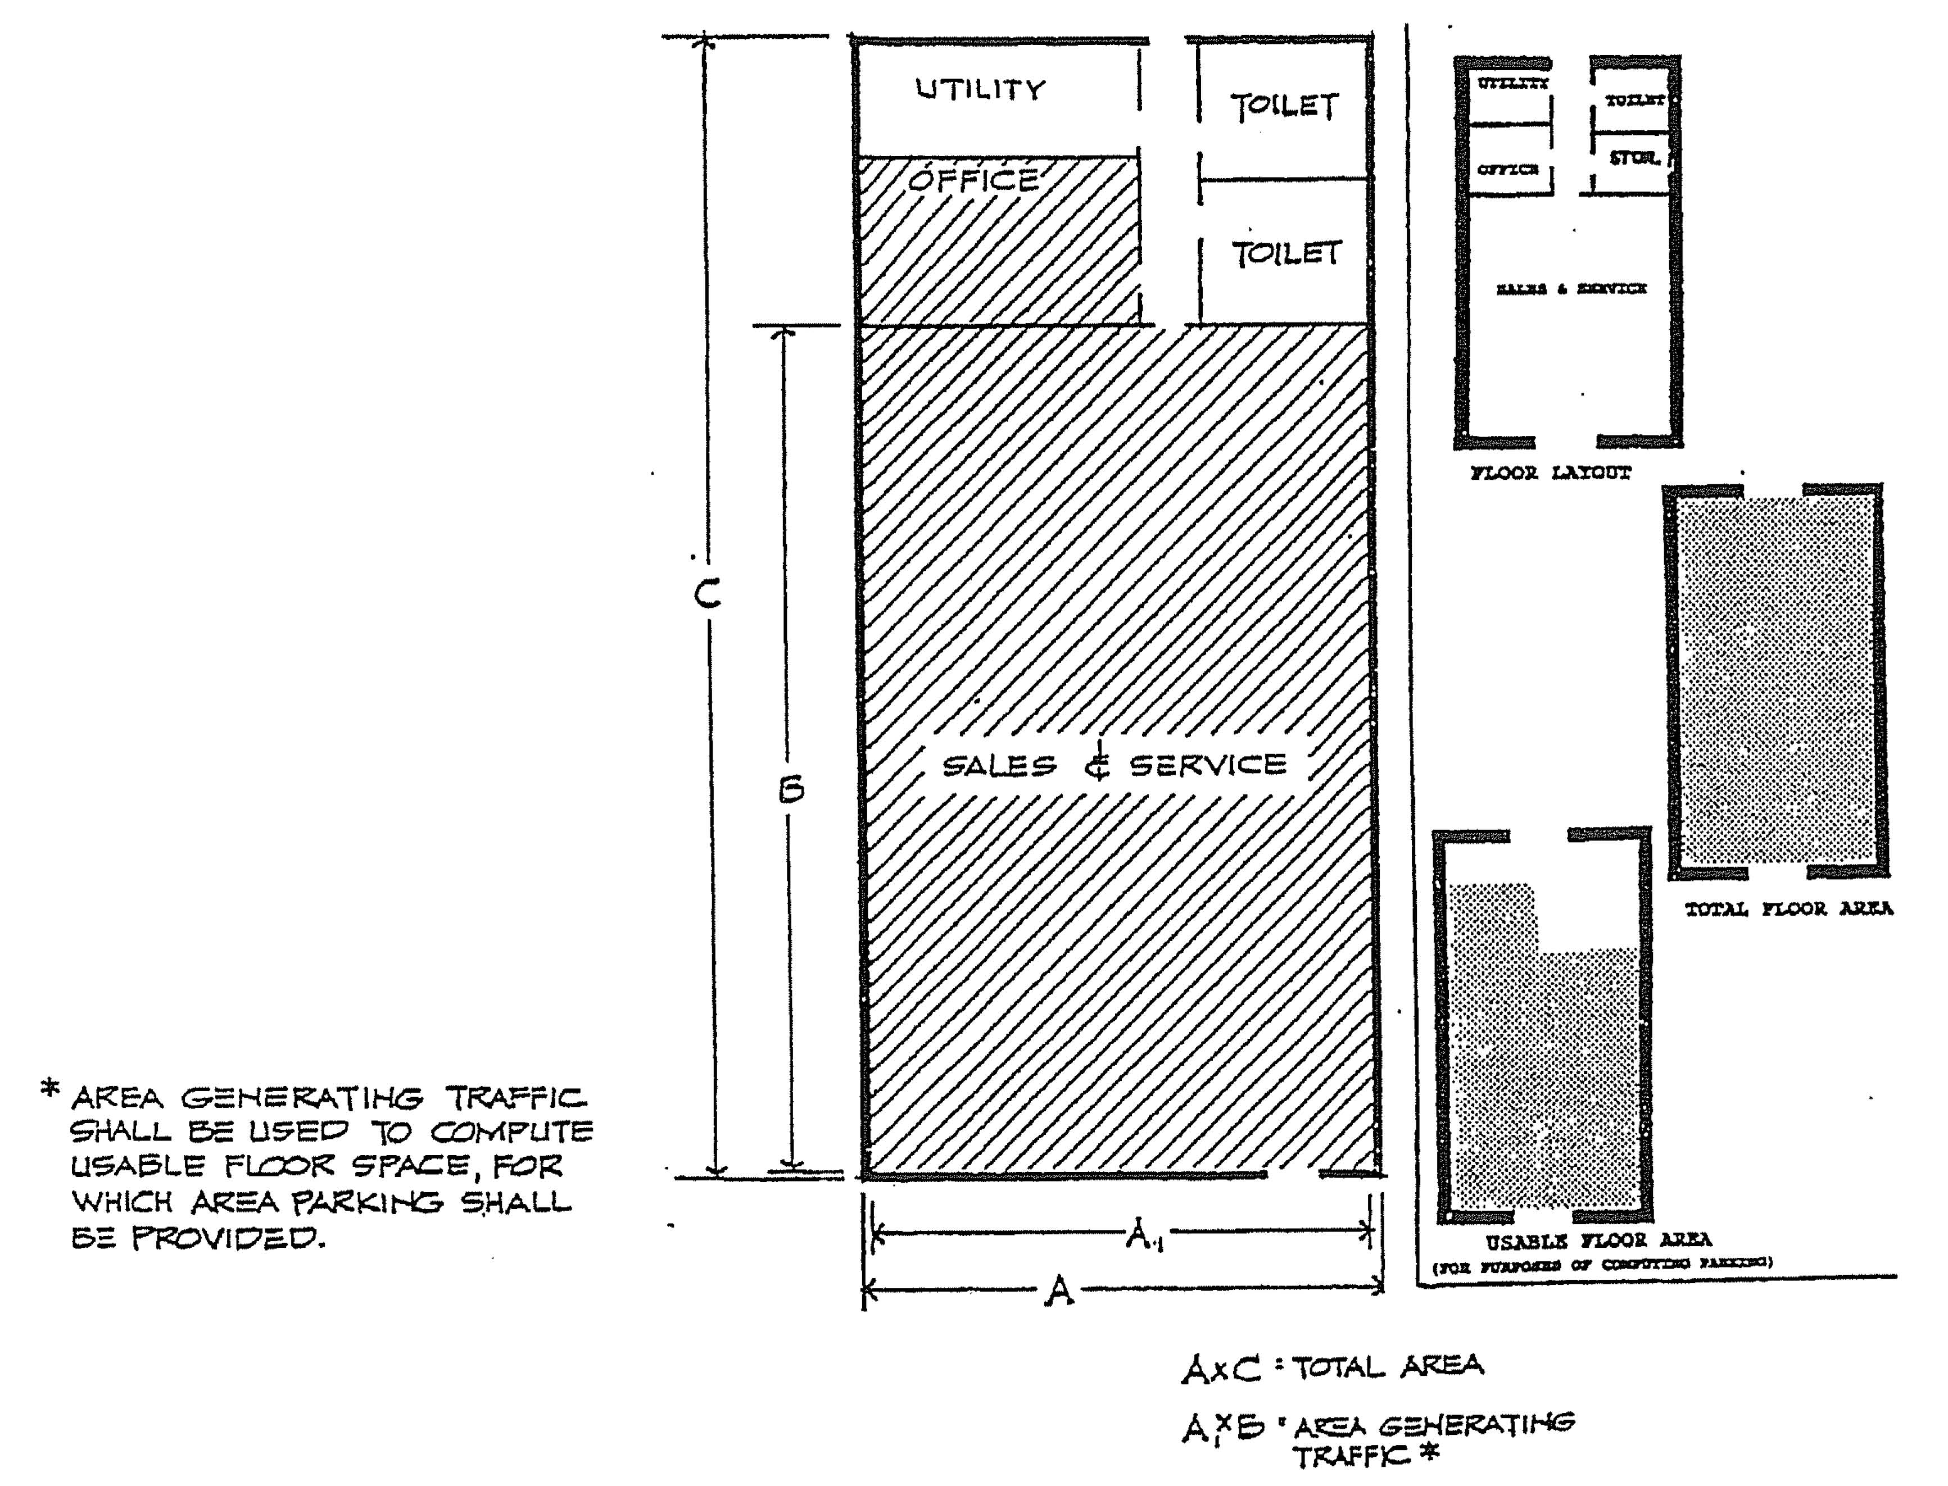
Floor Area Ratio: The ratio between the amount of floor area permitted to be constructed on a building lot and the size of the lot.
Floor Area, Usable (Net): "Usable floor area" means that area used for or intended to be used for the sale of merchandise or services, or for use to serve patrons, clients or customers. Such floor area which is used or intended to be used for hallways, stairways, elevator shafts, utility or sanitary facilities or the storage or processing of merchandise shall be excluded from this computation of "usable floor area". Measurement of usable floor area shall be the sum of the horizontal areas of each story of a structure measured from the internal faces of the exterior walls (See Figure 4-5).
Foreseeable Future: As use in this Ordinance and when pertaining to public utilities, there must be completed an engineering study in order for the public sanitary sewer or water to be considered to be available in the foreseeable future.

Front Yard: See Yard, Front.
General Retail: Stores which sell dry goods, package foods, hardware, appliances, computers, jewelry and other similar merchandise directly to the public.
Grade: A reference plane representing the average of finished ground level adjoining the building at all exterior walls. When the finished ground level slopes away from the exterior walls, the reference plane shall be established by the lowest points within the area between the building and the lot line.
Garage, Private: An accessory building used for parking or storage of vehicles as may be required in connection with the permitted use of the principal building.
Ground Cover: Grasses or other plant growth or material to keep soil from being blown or washed away.
Height: The vertical distance of a structure measured from the average elevation of the finished grade within twenty (20) feet of the structure to the highest point of the structure.
Government, Community-Owned Buildings or Public Buildings: A building or buildings which shall serve as essential services and safety of the community, but shall not serve as a residential facility.
Grandfather Clause: A provision in a newly adopted law regulating certain conduct or activities that allows the regulated activity to continue as previously conducted or otherwise exempts it from compliance with the new law or ordinance. Changes to expand or alter a structure, land or use shall require the total compliance with the provisions of the particular section of the ordinance covering the district in which the building, use or land is located.
Halfway House: Public or private building(s) used principally for the occupancy and therapy of mentally and emotionally ill persons not requiring intensive care, constant care, constant supervision, or confinement. For purposes of this Ordinance, all requirements of public and semi-public institutions shall apply.
Home Occupation, Customary: An occupation, profession or hobby conducted within a single family detached dwelling unit and carried on by the inhabitants thereof, not involving employees other than members of the immediate family resident on the premises, which use is clearly incidental and secondary to the use of the dwelling for dwelling purposes. It does not change the character thereof, and which does not endanger the health, safety, and welfare of any persons residing in that area by reason of noise, noxious odors, unsanitary or unsightly conditions, fire hazards and the like, involved in or resulting from such occupation, profession or hobby. Also, known as cottage industry, home based business, home marketing network, or home interactive distribution or marketing.
Hotel: A building containing six or more guest rooms, intended or designed to be used, or which are used, rented or hired out to be occupied or which are occupied for sleeping purposes by guests.

Household Pets: Any domesticated dog, cat or other animal kept for friendship or hunting purposes. Household pets do not include wild animals or exotic animals.
Identification Sign: A sign which pertains to the use of a premise and contains any or all of the following information:
- The occupant of the use.
- The address of the use.
- The kind of business and/or the principal commodity sold on the premises.
Industrial Use: A Structure, building, or parcel of land, or portion thereof, utilized or inherently designed to be utilized for the purpose of production, manufacturing, processing, cleaning, testing, rebuilding, assembly, distribution, finishing, construction or printing of goods or products and related research and development facilities.
Inoperable Motor Vehicle: A vehicle, as defined in Act 300 of 1939, as amended, which by reason of dismantling, disrepair or other cause is incapable of being propelled under its own power, and which condition exists and continues for a period of seven days (7) and which has no current State of Michigan license or registration properly attached. Removal shall be at owners expense.
Intensity of Land Use: This team means the amount of activity associated with a specific land use. Intensity of land use shall be determined by the Development Official based on the following criteria:
- Amount of vehicular traffic generated;
- Amount of pedestrian traffic generated;
- Noise, odor and air pollution generated;
- Potential for litter;
- Type and storage of materials connected with the operation;
- Total residential units and density, where applicable; and
- Total building coverage on the parcel.
Junk: Shall be considered to be miscellaneous dry solid waste material resulting from housekeeping, mercantile and manufacturing enterprises and offices, including but not limited to scrap metals, rubber and paper; abandoned, wrecked, unlicensed and inoperable automobiles and motor vehicles; rags, bottles, tin cans, and comparable items.
Junk Yard: Any land or building over two hundred (200) square feet in area used for the abandonment, storage, keeping, collecting, or baling of paper, rags, scrap metals, other scrap or discarded materials, or for abandonment, demolition, dismantling, storage or salvaging of automobiles or other vehicles or machinery, or parts thereof.
Kennel, Commercial: Any lot or premises used for the commercial sale, boarding, or treatment of dogs, cats or other domestic animals and which has a license from the Animal Control Office.

Loading Space: An off-street space on the same lot with a building, or group of buildings for the temporary parking of a commercial vehicle while loading or unloading merchandise or materials.
Lot: A parcel of land, excluding any portion in a street or road right-of-way, of at least sufficient size to meet the minimum requirements for use, coverage and lot area, and to provide such setback area and other open space as required by this Ordinance. Such lot shall have access to a public street, and may consist of:
- A single lot of record;
- A portion or portions of lot(s) of record;
- Any combination of complete and/or portions of lots of records; or
- A parcel of land described by metes and bounds, provided that in no case of division or combination shall the area of any lot or parcel created, including residuals, may be less than that required by this Ordinance.
Lots can be corner, interior, or double frontage (See Figure 4-6).
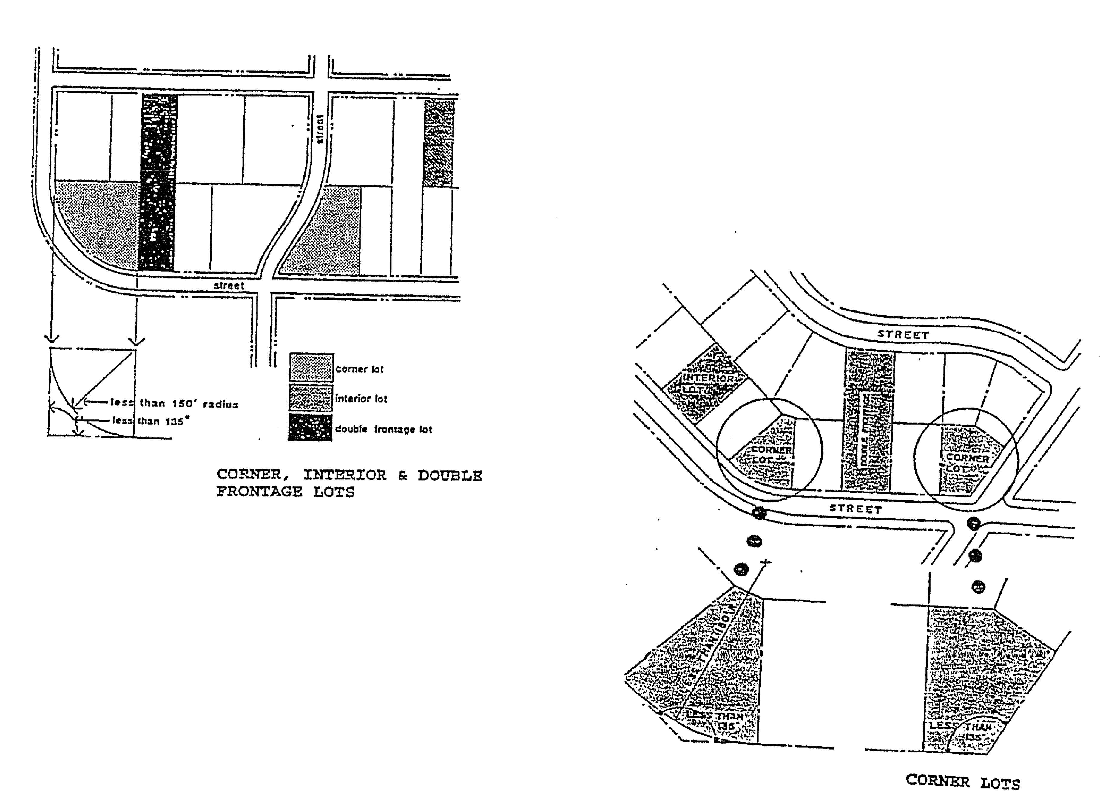
FIGURE 4-6
CORNER, INTERIOR & DOUBLE FRONTAGE LOTS

Lot Area: The area of land within the boundary of a lot excluding any part under water, and in addition, it is the area of land bounded by any back lot line, the right-of-way line of the highway on which it fronts, and the side lot lines intersecting the back lot line and extending to the right-of-way line of the roadway (See Figure 4-7).
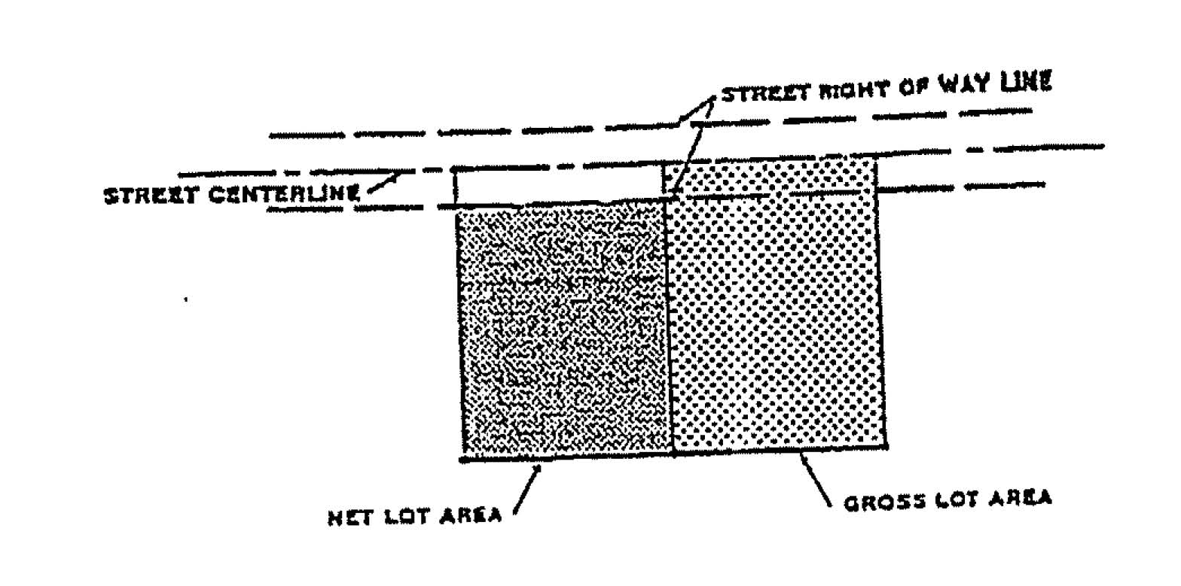
FIGURE 4-7
NET AND GROSS LOT AREA
Lot, Corner: A parcel of land at junction of and fronting or abutting on two or more intersecting streets or roads.
Lot Depth: The horizontal distance between the front and rear lot lines, measured along the median between the side lot lines (See Figure 4-10).
Lot Coverage: The part of percent of the lot occupied by buildings or structures, including accessory buildings or structures.
Lot of Record: A lot which is part of a subdivision and is shown on a map thereof which has been recorded by the Register of Deeds of Clinton County, or a parcel described by metes and bounds, the deed to which has been recorded in said office.
Lot Width: Lot width shall be measured as follows:
- Lot width with parallel side lot lines - The required width shall be measured on a straight line which is perpendicular to the side lot lines. No part of such measuring line shall be closer to the front property line than the depth of the required front yard.
- Lot with non-parallel side lot line - The required lot width shall be measured on a straight line which shall be a measuring line, which is parallel to a straight line which connects the side lot lines where they intersect the front property line. The measuring line shall be located at least the distance of the required front yard from the front property line. If the measuring line is located behind the rear line of the required front yard, the measuring line shall be the front building line.
The required minimum straight line distance between the side lot lines where they intersect the front property lines shall be determined as follows:
(1) For all lots not located on a turning circle of a cul-de-sac street, said distance shall not be less than eighty percent of the required lot width.

(2) For lots located on a turning circle of a cul-de-sac street said distance shall be at least eighty feet. (See Figure 4-8).
FIGURE 4-8
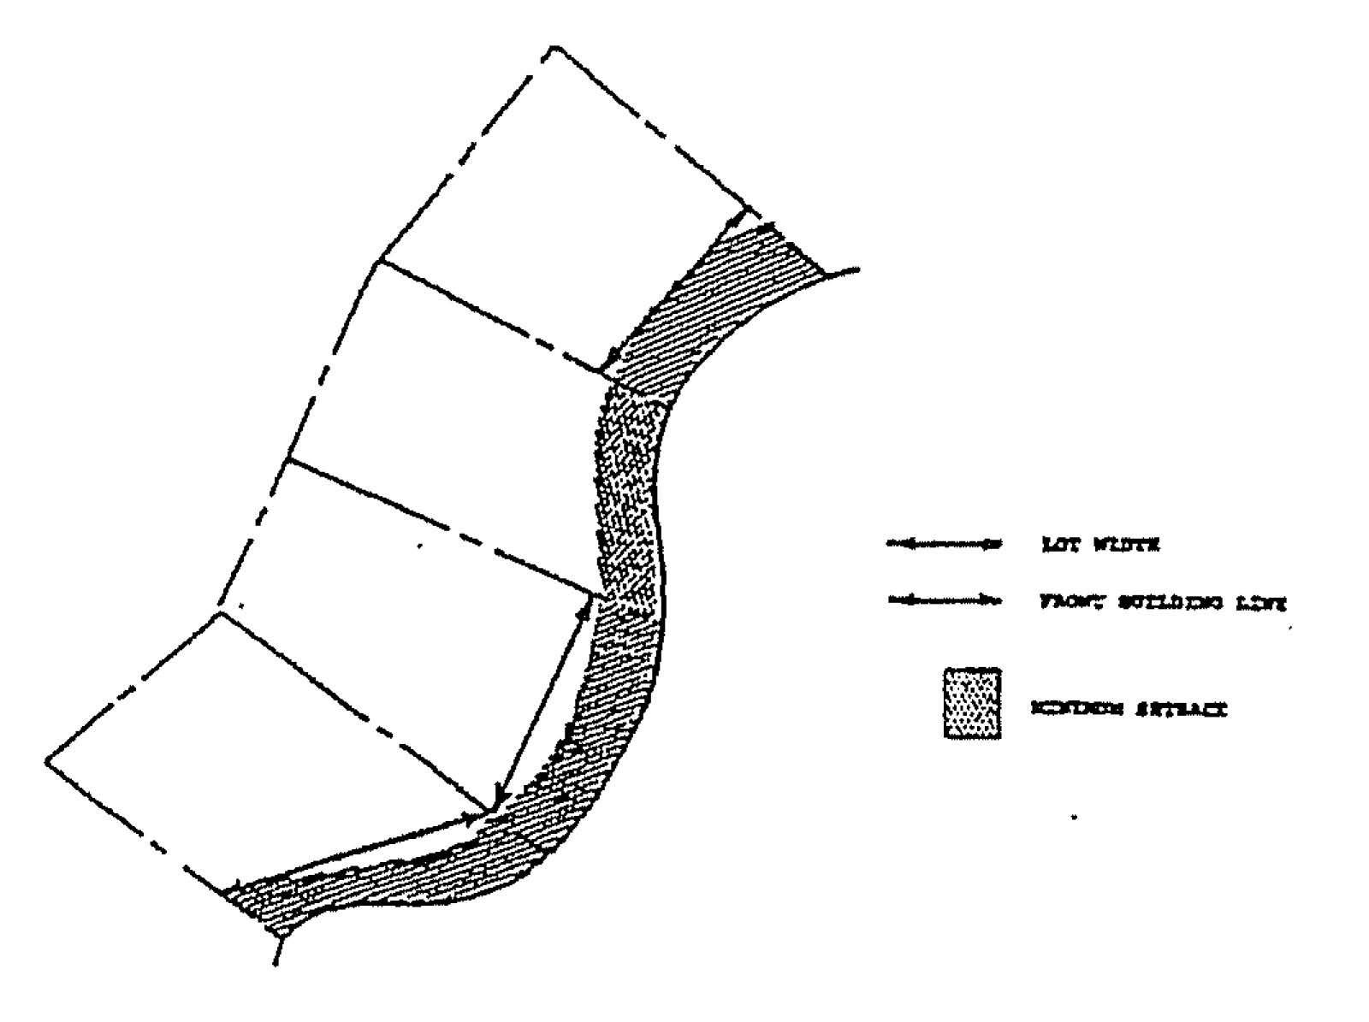
LOT WIDTHS AND SETBACKS ON CURVILINEAR STREETS

Lot Line, rear: Generally considered to be the line that is opposite from the front lot line and also farthest in distance from the front lot line (See Figure 4-10).
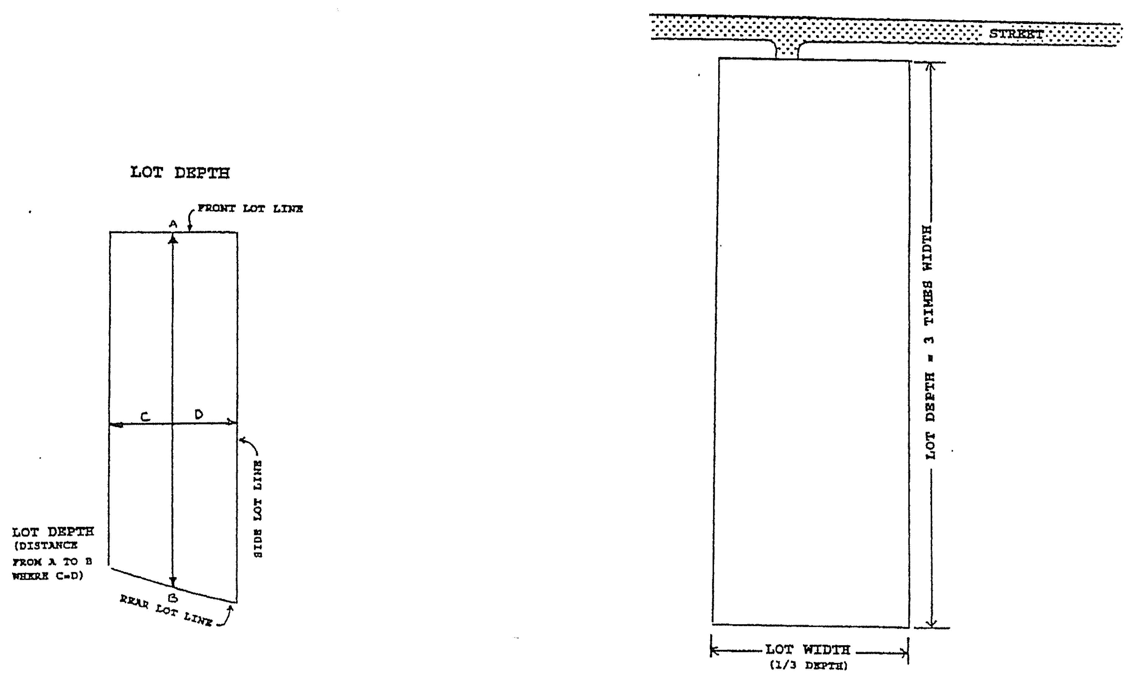
Lot Width to Depth Ratio: Lots created after the effective date of this ordinance having a lot area of less than twenty-five acres shall have a lot width which is equal to or greater than one-third (1/3) the depth of the lot (See Figure 4-9).
FIGURE 4-9
LOT WIDTH TO DEPTH RATIO

Minimum Lot Size: The smallest or least area of a parcel allowed in said district.
Mobile Home: A vehicular, portable structure built on a chassis and designed to be used without a permanent foundation as a dwelling when connected to required utilities and which is, or is intended to be, attached to the ground, to another structure, or to a utility system on the same premises for more than thirty consecutive days. A mobile home does not include a recreational vehicle.
Mobile Home Parks: Any lot, parcel or tract of land under the control or management of any person, occupied or designated for occupancy by more than two (2) mobile homes and including any accessory buildings, structures or enclosures comprising facilities used by the park residents. Such shall comply with the provisions of this Ordinance and P.A. 419 of 1978, as amended.
Modular (Pre-Manufactured) Housing Unit: An assembly of materials or products intended to comprise all or part of a building or structure, and that is assembled, at other than the final location of the unit of the building or structure, by a repetitive process under circumstances intended to insure uniformity of quality and material content. The term is intended to include mobile homes.
Multiple-Family Housing: A structure having three or more dwelling/housing units under a single roof and often having a common heating, electrical or water system (but may be metered separately) and may also have common hallways, stairs or elevators.
Motel: Please see Hotel.
Motor Home: A motor vehicle designed to be utilized as a temporary living quarter normally for recreation, cam^{p}ing or travel purposes having kitchen or bathroom facilities or both.
Mini-Warehousing: A building or portion thereof designed or used exclusively for storing personal property of an individual or family when such is not located on the lot with their residence. Personal property may include, but is not limited to, passenger motor vehicles, house trailers, motorcycles, boats, and campers which are generally stored in residual accessory structures.
New Construction: Structures from which the "start of construction" commenced on or after the effective date of this Ordinance.
Nonconforming Buildings/Structures: A building or structure (or portion thereof) lawfully existing at the time of adoption of this Ordinance or a subsequent amendment thereto, that does not conform to the provisions of this Ordinance relative to height, bulk, area, placement or yards for the zoning district in which it is located (See Figure 4-10a).
Nonconforming Lot: A lot, the area, width, or other characteristic of which fails to meet requirements of the zoning district in which it is located and which was conforming ("of record") prior to enactment of the zoning ordinance.

Nonconforming Use: A building, structure, plot, premises or use of land lawfully existing at the time of the effective date of this Ordinance which does not conform to the regulations of the district in which it is situated (See Figure 4-10b).
FIGURE 4-10
NONCONFORMING BUILDING AND USE ILLUSTRATION
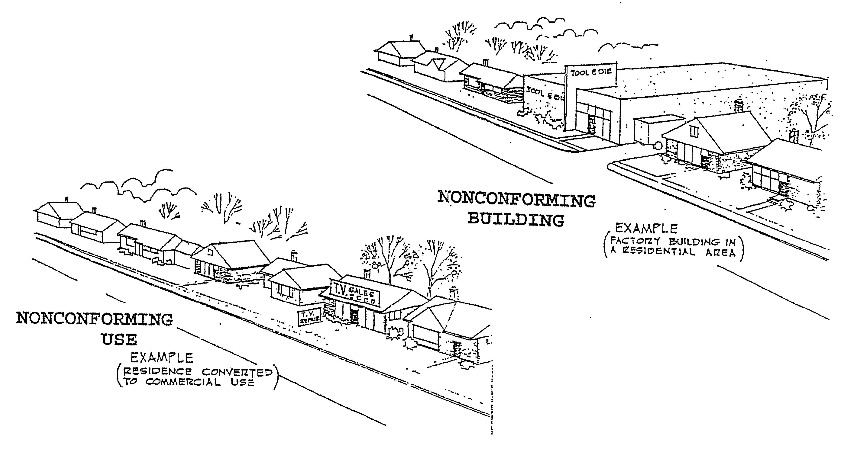

Nuisance: An activity consisting of an unlawful or unreasonable use of property by an individual that causes injury or damages to another or to the public in general. Common examples of phenomena generally considered to constitute nuisances include excessive noise, odor, smoke or vibration.
Occupancy Certificate: A written document received from the Development or Building Official stating that the Village/County Building Code, as amended and this ordinance have been complied with as they apply to the construction of a building or structure and the use of a lot and that the building may now be occupied for by its previously designated purpose.
On-Premise Sign: A sign which advertises only goods, services, facilities, events, or attractions available on the premises where located, or identifies the owner or occupant or directs traffic on the premises. All other signs are off-premise signs.
Open-Space Ratio: The ratio between open space on the lot, whether required or not, and the total lot area.
Open Space, Required: The yard space of a lot which is established by and between the street, or the lot lines and required setback line and which shall be open, unoccupied and unobstructed by any structure or any part thereof, except as otherwise provided in this Ordinance.

Owner: The owner of freehold premises or lesser estate in the premises a mortgagee or vender in possession, an assignee of rents, receiver, executor, trustee, lessee, or any other person, sole proprietorship, partnership, association or corporation directly or indirectly in control of a building structure or real property or his/her duly authorized agent/representative.
Park: A parcel of land, building, or structures used for recreational purposes including but not limited to playgrounds, sport fields, game courts, trails, picnicking areas and leisure time activities.
Performance Bond: A bond posted by a contractor or subcontractor that contains the guarantee of a surety that a specific project will be completed and meet any standards or specifications that have been agreed upon.
Performance Standards: General criteria that are set to ensure that particular structure, type of land use or development will be able to meet certain minimum standards or that its effects on the community will not exceed set limits.
Personal Services: Uses which include but are not limited to dentists, physicians, barbers, beauticians, attorneys and similar services.
Planned Unit Development (PUD): A parcel of land which is planned and developed as a single entity containing residential clusters consisting of individual and multiple building sites and common open space property which may contain varied residential dwelling types, institutional uses or office development, and which is designated and developed under one owner or organized group as a neighborhood or a community unit.
Principal Structure: The main structure to which the premises is devoted.
Principal Use: The main use to which the premises are devoted and the principal purpose for which the premises exist.
Parking Space: A land area of not less thah ten (10) by twenty (20) feet exclusive of driveways and aisles, and so prepared as to be usable for the parking of a motor vehicle, and so located as to be readily accessible to a public street or alley.
Prohibited Use: A use of land or building which is not permitted within a particular land development district.
Public Water Course.: A stream or creek which may or may not be serving as a drain as defined by Public Act 40 of 1956, as amended, being MCLA 280.1 et seq, or any body of water which has definite banks, a bed, and visible evidence of a continued flow or occupancy of water.
Proof of Equitable Title: A recorded land contract agreement or recorded deed conveying to the purchaser interest in real estate and/or any assignments of the purchasers interest thereof.
Public Utility: Any person, firm, corporation, municipal department or board authorized to furnish the public, electricity, gas, steam, sanitary sewer, telephone, telegraph, transportation, or water service.

Private Road: A privately owned and maintained road constructed to Ionia County Road Commission standards and characterized by a joint operating agreement that runs with the land and binds the benefited parcels; is formally named and so marked; an escrow account which insures continued maintenance; to name a few.
PIPP, Pollution Incidental Prevention Plan: A written procedure that will be invoked by an owner or his agent in the event of a potentially polluting incident that could result in soil or groundwater contamination.
Prime Agricultural Land: Land most efficiently suited to the production of row, forage and fiber crops. This land, due to inherent natural characteristics such as level topography, good drainage, adequate moisture supply, favorable soil depth and favorable soil texture, consistently produces the most feed, food and fiber with the least fertilizer, labor and energy requirements.
Refuse/Trash Storage Space: Any exterior space designated by a site plan for containers, structures, or other receptacle intended for temporary storage of solid waste materials.
Rehabilitation: The upgrading of an existing building or part thereof, which is in a dilapidated or substandard condition.
Restoration: The reconstruction or replication of an existing building's original architectural features.
Right-Of-Way: A street, alley or other thoroughfare or easement permanently established for passage of persons or vehicles.
Roadside Stand: A structure for the display and sale of agricultural/garden products, with no space for customers within the structure itself.
Room: An area of a dwelling unit, not including bathrooms, closets and kitchens.
Restaurant: An establishment where food and/or beverages are cooked or prepared and offered for sale and where consumption is permitted on the premises whether or not entertainment is offered, and includes establishments commonly known as bars, grills, cafes, taverns and nightclubs permitting consumption on the premises.
Second Hand Store: A building or portion thereof in which the public sale of previously owned goods, having no generally recognized cultural or historic value as antiques. Is carried-out for a period of time greater than seven (7) consecutive days during a six-month period of time.
Setback: The minimum horizontal distance between the road right-of-way line and a building or structure.
Setback Line: A line parallel with and at the minimum required distance from the road right-of-way line.
Sign(s): Any words, lettering, parts of letters, figures, numerals, phases, sentences, emblems, devices, trade names or marks, or combination thereof, by which anything is made known, such as designation of an individual, a firm, an

association, a profession, a business, a commodity, or product which are visible from any public way and used as an outdoor display.
Solid Waste: Garbage, rubbish, paper, cardboard, metal containers, yard clippings, wood, glass, bedding, crockery, demolished building materials, ashes, incinerator residue, street cleaning, municipal and industrial sludge, and solid commercial and solid industrial waste, animal waste, but does not include human body waste, liquid or other waste regulated by statute, ferrous products, and slag or slag products directed to a slag processor or to a user of slag or slag products.
Special Use Permit: A permit issued by the Planning Commission to a person or persons intending to undertake the operation of a use upon land or within a structure or building specifically identified in the affected zoning district under special uses authorized by permit. These special uses possess unique characteristics and are found to be not injurious to the health, safety, convenience, and general welfare of the County's inhabitants.
Spot Zoning: The assignment of a zoning classification different from the surrounding zoning classifications to a relatively small land parcel. The term is usually employed when the use classification is intended to benefit a particular property owner and is incompatible with the surrounding area.
Structure: Anything constructed or erected the use of which requires location on the ground, or attached to something having location on the ground (See Figure 4-11 for basic structural terms).
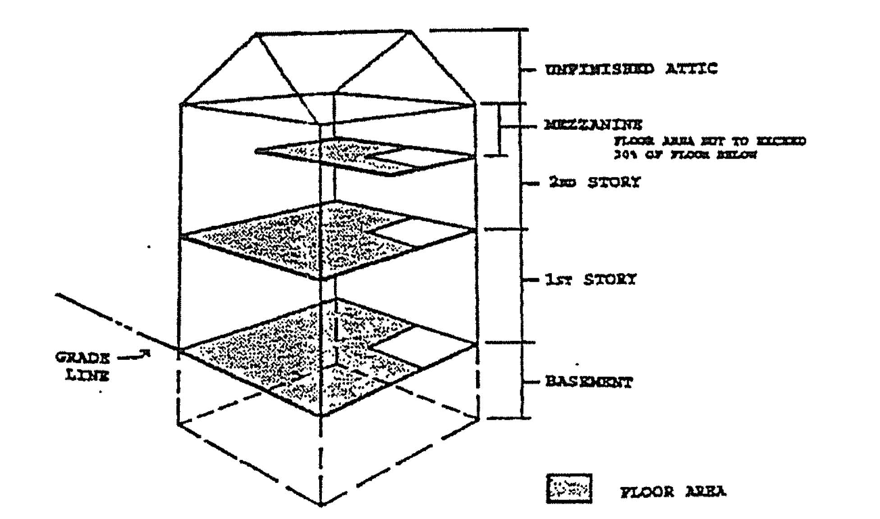
FIGURE 4-11
BASIC STRUCTURAL TERMS AND ILLUSTRATIONS

Street: A public dedicated right-of-way which afford traffic circulation and principal yard means of access to abutting property.
Story: That portion of a building included between the surface of any floor and the surface of the floor above it, or if there is no floor above it, then the space between the floor and the ceiling above it.
Structural Alteration: Any change in the supporting members of a building such as bearing walls, columns, beams or girders, or any substantial changes in the roof and exterior walls.

Subdivision: The partitioning or dividing of a parcel or tract of land by the proprietor thereof or by his/her heirs, executors, administrators, legal representatives, successors or assigns for the purpose of sale, lease of more than one year or of building development, where the act of division creates five or more parcels of land each of which is ten (10) acres or less in area are created by successful division within a period of ten years (10). The subdivision plat (a map or chart depicting the subdivision of land) is regulated by the Public Act 288, Subdivision Control Act of 1967, as amended, MCLA 560.101 et seq.
Substantial Improvement: Any repair, reconstruction, or improvement of a structure, the cost of which equals or exceeds 50 percent of the market value of the structure either (1) before the improvement or repair is started, or (2) if the structure has been damaged and is being restored, before the damage occurred. For the purposes of this definition, "substantial improvement" is considered to occur when the first alteration of any wall, ceiling, floor, or other structural part of the building commences, whether or not that alteration affects the external dimensions of the structure. The term does not, however, include either (1) any project for improvement of a structure to comply with existing state or local health, sanitary or safety code specifications, or (2) any alteration of a structure listed on the National Register of Historic Places or State Inventory of Historic Places.
Swimming Pool: The term "swim pool" shall mean any structure or container located either above or below grade designed to hold water to a depth of greater than twenty-four (24) inches, intended for swimming or bathing. A swimming pool shall be considered as an accessory building for the purposes of determining required yard spaces and maximum lot coverage.
Tower, Free-Standing: Towers erected for communication and/or reception and used privately or commercial purposes.
Town Center (TC): The Town Center is the older traditional commercial core of Clarksville, generally located along Main Street between Ferney and Nash Streets, which is the retail and business activity center for the Village and surrounding area.
Travel Trailer: A vehicular portable structure built on a chassis which is less than thirty five (35) feet in length and is of such a width and weight as not to require special highway movement permits when drawn by a vehicle.
Undefined Terms: Any term not defined herein shall have the meaning of common or standard use.
Variance: A modification of the literal provisions of the zoning ordinance granted in specific cases when strict enforcement of the Zoning Ordinance would cause practical difficulty owing to circumstances unique to the individual property on which the variance is granted.
Warehouse: A building or portion thereof used for storage of goods, merchandise or other property not permitted in a mini-warehouse. This shall not be deemed to include the storage area in connection with a purely retail business when located on the same property.

Watercourse: An open conduit either naturally or artificially created which periodically or continuously contains moving water draining an area of at least two (2) acres.
Yard, Front: An open, unoccupied space extending the full width of the lot between the front lot line and the nearest line of the principal building on the lot (See Figure 4-12).
FIGURE 4-12
LOT AND YARD ILLUSTRATIONS
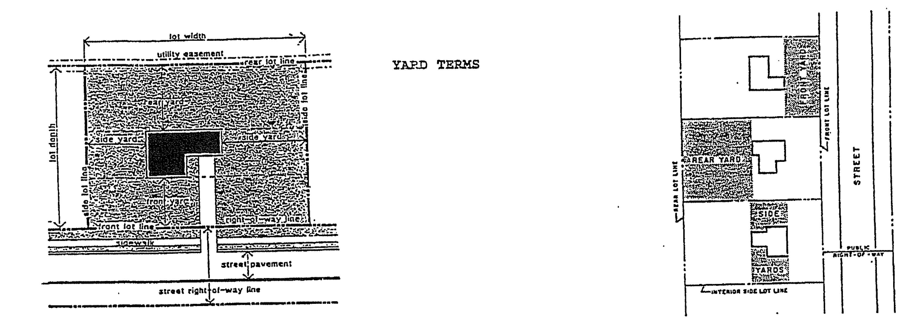

Yard, Front-Required: The minimum required yard extending the full width of the lot and situated between front line and the front building line, parallel to the street line. The depth of the required front yard shall be measured at right angles to the street line, in the case of a straight street line, and radial to the street line, in the case of a curbed street line.
Yard, Rear: An open occupied space extending the full width of the lot between the rear line of the lot and the rear line of the principal building on the lot (See Figure 4-12).
Yard, Rear-Required: The minimum required yard extending the full width of the lot and situated between a rear property line and the rear building line, parallel to the rear property line. The depth of the required rear yard shall be measured at right angles to the rear property line.
Yard, Side: An open, unoccupied space on the same lot with the principal building, between the side line of the principal building and the adjacent side line of the lot and extending from the rear line of the front yard to the front line of the rear yard (See Figure 4-12).
Yard, Side-Required: The minimum required yard extending between the front yard and rear building lines and situated between a side property line and the side building line, parallel to the side property line. The width of the required side yard shall be measured at right angles to the side property line.
Zoning: The dividing of the Village or community into districts of a number and shape considered best suited to carry out the purposes of the Zoning Enabling Act of 2006, Public Act 110, as amended, and the creation of uniform regulations throughout each individual district. Such districts are referred to as Zoning Districts in this Ordinance.

ARTICLE 5: SUPPLEMENTAL REGULATIONS
Section 5.1 PURPOSE
It is the purpose of this Article to establish miscellaneous regulations which have not been specifically provided for in other portions of this Ordinance.
Section 5.2 GENERAL REGULATIONS
5.2.1 Access to a Street: All lots of record created after the effective date of this Ordinance shall have frontage on a public street or private road by Special Use Permit and approved access, except in the case of an officially approved group housing development or an approved mobile home park as provided for in this Ordinance,
5.2.2 Rear Dwelling Prohibited: No building in the rear of and on the same lot with a principal building shall be used for residential purposes except for watchmen, caretakers and domestic employees, whose employment is related to the functions of the principal building, provided that all other requirements of this Ordinance are satisfied.
5.2.3 Unsafe Buildings: Nothing in this Ordinance shall prevent compliance with an order by an appropriate authority to demolish, correct, improve, strengthen, or restore to a safe condition any building declared to be unsafe.
5.2.4 Grading and Filling of Property: The final grade surface of ground areas remaining after the construction of a building or structure and any earth changes made in connection with use of land shall be designed and landscaped such that surface water flows away from the building or structure and is collected or managed in a manner which avoids: Any increase in surface water discharge onto adjacent properties or public roads; the erosion of or filling of any road ditch; the blockage of any public watercourse; the creation of standing water over a private sewage disposal drainage field, and any unnecessary impoundment of surface water. The provision of this section shall be to administer and enforce pursuant to Article 8, Site Plan Review, when applicable. In all other cases the Development official shall determine whether the provisions of this section are met, provided that he first consults with the County Drain Commissioner and the Superintendent of the County Road Commission (if County road right-of-way is involved) before taking any action to correct the situation. When it is determined by the Development official after the aforementioned consultation, that inadequate surface water control exists, no certificate of occupancy shall be issued until the situation is corrected and approved by the Development official.
5.2.5 Required Water Suppl^{y} and Sanitary Sewerage Facilities: No structure for human occupancy shall be erected, altered, or moved upon any lot or premises and used in whole or in part for dwelling, business, industrial, or recreational purposes unless it shall be provided with a safe, potable water supply and with a safe and effective means of collection, treatment, and disposal of human excreta and domestic, commercial and industrial wastes. All such installations and facilities shall conform with the minimum requirements of the Mid-Michigan District

Health Department, Michigan Department of Public Health and/or Department of Natural Resources Waste Water Division.
5.2.6 Mobile Home and Trailer Dwellings Prohibited: No mobile home or trailer shall be occupied as a dwelling in the Village of Clarksville except as provided in the following sections:
- Mobile homes or trailers located in an approved and licensed mobile home park development meeting the requirements of P.A. 96 of 1987, The Mobile Home Commission Act.
- Mobile homes or trailers occupied under the temporary housing occupancy provisions as outlined in this Ordinance.
- Mobile homes or trailers occupied under emergency housing provisions as outlined in this Ordinance.
- Mobile homes as permitted on residential or agricultural zoning districts upon compliance with the standards outlined in this Ordinance.
5.2.7 Soil Erosion and Sedimentation: All development in all districts shall conform to the Ionia County Erosion/Sedimentation Ordinance and general rules; and P.A. 347 of 1972, the State Soil Erosion and Sedimentation Control Act.
5.2.8 Uses of Structures for Temporary Dwellings: No structure shall be used for dwelling purposes that does not meet the minimum standards, as defined in this Ordinance and the current Construction Code. No garage, or other accessory building, trailer coach, cellar, basement, tent, cabin, partial structure, whether of a fixed or portable construction, shall be erected or moved onto a lot and used for any dwelling purpose for any length of time unless authorized by the following sections. The terms "cellar" and "basement," as used in this section, shall not be construed to include earth-sheltered homes as defined in this Ordinance.
5.2.9 Temporary Buildings: Temporary buildings may be permitted for uses incidental to construction work. Such buildings shall be removed upon the completion or abandonment of the construction work or within the period of one (1) year, whichever is the lesser time period.
Section 5.3 SUPPLEMENTARY USE REGULATIONS
5.3.1 Accessory Buildings
Authorized accessory buildings may be erected as a part of the principal building or may be connected to it by a roofed over porch, patio, breeze way, or similar structure, or may be completely detached. If attached to the principal building, an accessory building shall be made structurally a part of it, and shall comply in all respects with the requirements applicable to the principal building. An accessory building not attached and not made a part of the principal building shall not be nearer than ten (10) feet from any other structure on the same lot and shall also comply with the front, rear and side yard requirements of this Ordinance.
A. Accessory Uses - Garages: The structural space which is permissible in residential districts for motor vehicle

storage and for incidental space as accessory to an authorized use, shall not exceed the following:
- In all residential districts, the storage of commercial vehicles shall be limited to one (1) vehicle per residential dwelling which shall not exceed a GVWR of 10,000 pounds or more and is owned and operated by a member of the residence or resident (occupant) at the location of storage.
- Space in a garage accessory to a multiple-family unit or a motel shall not be rented out except to occupants of the principal dwelling.
- An accessory building shall not occupy more than thirty (30%) percent of the area of any required rear yard.
B. Accessory Buildings - All Districts
- In a Rear Yard: No accessory building including detached garages, shall be closer than the required setback for the district.
- In a Side Yard: No accessory building, including garages, shall be erected closer to any side lot line than the permitted distance for the district.
- On a Corner Lot: No accessory building shall be closer to the side street lot line than the side yard setback of the principal building on the lot. Where the rear line of a corner lot coincides with the side line of an adjoining lot in a residential district, an accessory building shall not be closer than five (5) feet to the common lot line.
- Accessory Structures Design. Owners of accessory structures are encouraged to design and construct the exterior to blend or be architecturally compatible or similar to the principal structure or building in all zoning districts.
Section 5.4 SUPPLEMENTARY AREA REGULATIONS
5.4.1 Exception to Required Lot Area.
A. Any legally created lot created and recorded prior to the effective date of this Ordinance may be used for any permitted use even though the lot area and/or dimensions are less than those required for the district in which the lot is located, provided:
- That the other requirements of the Residential District are met.
- That no adjacent land or lot is owned by the owner of

the lot in question.
3. That no lot shall be so reduced in area that the required open spaces will be smaller than those established as a minimum for the district in which the lot is located.
5.4.2 Lot Area Can Be Allocated Once: No portion of a lot can be used more than once in complying with the provisions for lot area and yard dimensions for the construction of a proposed building or the alteration of an existing building.
Section 5.5 SUPPLEMENTARY HEIGHT REGULATIONS
5.5.1 Permitted Exceptions - Structural Appurtenances:
A. The following structural appurtenances shall be permitted to exceed the height limitations. Exceptions may be authorized only when all of the following conditions are satisfied: No portion of any building or structure, permitted as an exception to a height limitation, shall be used for human occupancy or for commercial enterprise. Any structural exception to height limitations shall be erected only to such height as may be necessary to accomplish the purpose it is intended to serve, so as not to become a hazard to aviation. Structural appurtenances exceeding the maximum height limitations within ten (10) miles of a public airport shall not be allowed without the approval of the Airport Zoning Board having jurisdiction. If the roof area of structural elements permitted to exceed the height limitations exceed twenty (20%) percent of the gross roof area, they shall be considered as integral parts of the whole structure and thereby shall not exceed the height limitations.
- Ornamental in purpose, such as church spires, belfries, cupolas, domes, ornamental towers, flag poles and monuments.
- Appurtenances to mechanical or structural functions, such as chimneys and smoke stacks, water tanks, elevator and stairwell penthouses, ventilators, bulkheads, radio towers, masts, aerials, television antennas, fire and hose towers and cooling towers.
- Commercial free-standing towers when not attached to a building or structure, shall be constructed in compliance with state and federal regulations pertinent thereto.
- Free-standing towers, such as T.V. or radio towers, intended primarily to serve the occupants of the main structure, shall not exceed one and one half times the structural height limitations for structures in that district.

B. Small energy wind convertors shall be permitted in the A-1 and A-2 Districts by right provided that the tower does not exceed 100¹ and there is compliance with Section A. The units may be permitted in the Zone District by right provided the units do not exceed 35 feet in height and meet all the required setbacks for accessory buildings.
5.5.2 Permitted Exceptions - Residential District:
A. There shall be no exceptions permitted for residential structures; certain nonresidential structures in residential districts may be permitted to exceed height limitations provided there is compliance with the provisions of Article 4 inclusive. Solar collectors attached to the roof of a structure shall not be included in the height measurement for the purpose of this section.
5.5.3 Permitted Exceptions, Business and Industrial Districts:
A. In any business or industrial district, any principal building may be erected to a height in excess of that specified for the district, provided each front, side and rear yard is increased one (1) foot for each one (1) foot of such additional height.
1. In those districts not requiring one or more yard setbacks, any portion of a principal building may be erected to a height in excess of that specified for that particular district provided that such portion is set back from all street, lot and required yard lines one (1) foot for each foot of additional height.
Section 5.6 (Open)
Section 5.7 SWIMMING POOL REGULATIONS FOR ALL DISTRICTS
Pools used for swimming or bathing shall conform to the yard setback requirement as required for accessory uses and structures in this Ordinance and comply with the State Construction Code and Ionia County Public Health requirements.
Section 5.8 JUNK, INOPERABLE VEHICLES, AND ANTIQUE AUTOMOBILES 5.8.1 Junk
A. No person shall store, place, abandon or permit to be stored, placed, abandoned, or allow to remain, in any district, a dismantled, partially dismantled, unlicensed, unrestorable, or inoperable motor vehicle, junk, rubbish, trash, old furniture, used lumber, unused or discarded machines or equipment, or litter upon any premises, except in an approved and licensed salvage or junk yard or in the case of motor vehicles unless confined in a wholly enclosed structure.

B. No person shall store, place, abandon or permit to be stored, placed, abandoned, or allow to remain, in any district, wrecked or inoperable farm machinery, unless hidden from all vantage points from the general public.
5.8.2 Antique Automobiles
- A junk vehicle is considered an inoperable vehicle that is not a "restorable vehicle". A "restorable vehicle", often considered an antique/historic vehicle, is in turn defined as an inoperable vehicle ACTIVELY being used in a restoration in connection with a HOBBY.
- The restorable vehicle must be in active use as the object
of the restoration effort or as a "parts car". A deteriorated car just sitting around does not qualify as a "parts car". A "parts car" is one that the hobbyist used for "donor parts in the restoration process of another similar vintage vehicle.
- All junk vehicles or inoperable vehicles that do not qualify as restorable vehicles shall not be parked or stored in the open in any zoning district of this Ordinance. The only exception is vehicles parked in connection with a business legitimately using such vehicles, such as a body ship or wrecking yard, in zoning districts where such businesses are authorized. In such cases vehicle storage must meet the screening requirements as required in Section 8.6 of this Ordinance.
5.8.3. Standards
- No inoperative, restorable vehicle shall be parked or stored in the front yard or within the required setback of the side yard of property of any zoning District in this Ordinance.
- No more than one restorable vehicle or parts car consisting only of a car or pickup truck may be stored in the open in inoperable condition on any residential lot. A cover or wrap is to be provided to conceal the vehicle parked in the open.
- All doors, hatches, and trunk lids shall be secured against entry by small children.
- Open storage of parts, tools, and materials is forbidden.
- Restorable vehicles shall be registered and/or licensed by the state of Michigan as an historic vehicle.
- The hobbyist/owner/collector shall provide credentials that substantiate his/her hobbyist-collector status through membership in a national, state or local car club.

Section 5.9 REGULATIONS CONCERNING SUPPLEMENTAL USES:
5.9.1 Home Occupations
- Intent: It is the intent of this section to set forth the requirements for establishing a Home Occupation as an accessory use of a single family detached dwelling unit such as involving the crafting, electronic/mail order sale or marketing of goods, the provision of services, or the instruction in a craft or fine arts which are conducted entirely within the dwelling unit by one or more persons, all of whom reside within the dwelling, and which is clearly incidental an secondary to the use of the dwelling as a residence.
- Location: The zone district where the residence is located is zoned A-1, R-1, and R-2.
- Regulations and Standards:
- The Development Official shall determine whether or not a use shall be requires to obtain a Special Use Permit in order to operate as a home occupation. It, in the opinion of the Development Official, the proposed home occupation/business activities meet all of the following conditions, such home occupation may be conducted with out a Special Use Permit.
- A home occupation shall only be conducted within the premises of a single-family detached dwelling unit. Home occupations are not permitted within two-family or multiple-family dwellings. Farms and farming operations are considered home occupations.
- There shall be no outdoor, on-site storage of materials, equipment, or accessory items and/or display of materials, goods, or supplies used in the conduct of the home occupation. The on-site storage of commercial vehicles used incidentally for or used in the home occupation business shall not be permitted. Only normal household type of equipment and furniture are to be used in the home occupation. Computers, FAX machines, and copiers may all be used in the home occupation.
- Only members of the immediate family who reside on the premises shall be employed in any part of the operation of the home occupation. All activities related to the home occupation shall be carried on entirely indoors of the dwelling unit.
- Home Occupations are permitted only in the principal structure/building. However, in no case shall more than twenty-five percent (25%) or four hundred and eighty (480) square feet, whichever is smaller, of the gross floor area of the principal building be utilized for a home occupation.

6. A home occupation shall not generate an unduly burdensome amount of traffic for the general area in which it is located. Unless the Planning Commission stipulates otherwise, the home occupation shall not generate more than ten trips per day, excluding trips generated by the occupants of the home. Adequate parking spaces shall be provided on the premises for persons patronizing the establishment. The following factors shall be considered when reviewing whether traffic generation is unduly burdensome:
- Is the subject parcel located at the entrance or the interior of a subdivision?
- Is the proposed home occupation conducted on the basis of appointments or does the traffic peak at certain times of the day?
- Do the traffic volumes vary on a seasonal basis?
- Do alternatives exist to generating traffic to the home?
7. The establishment of a home occupation shall not necessitate exterior modification or alter the fire rating, except as may be required by the Development Official, to any structure/building on the property.
8. The Planning Commission may stipulate the hours of operation in order to avoid possible disquieting effects from the home occupation to adjacent properties.
9. Uses which shall be prohibited as home occupations shall include, but shall not be limited to the following:
- antique shops
- convalescent and nursing homes
- day care centers or nursery schools, however, day care services may be provided and are related to size.
- funeral homes
- food preparation for catering
- kennels
- medical or dental clinics or hospitals, or animal hospitals
- refuse collection businesses
- repair of automobiles, motorcycles, boats trailers, trucks or similar equipment or vehicles.
- walk-in customer retail sales of any product -
EXCEPT - those products sold that are directly
incidental to the permitted home occupation
(i.e. hair care products by a hair dresser)
10. The use of a garage or accessory buildings for home

occupation is not permitted.
- Signs shall be permitted in general accordance with Article 11, of this ordinance, but in no case shall exceed two (2) square feet in area, is not illuminated and is mounted flat against the wall of the dwelling.
- Compliance with all other applicable laws and ordinances.
D. Standards for Farms and Farm Operations
1 The incidental sale of farm produce is permitted from the roadside provided:
- The sale is temporary and/or seasonal (not to exceed 180 days)
- The sale is of produce grown on the land from which the sale takes place.
- All temporary displays and signs advertising temporary sale are removed from the roadside when not in use.
- Other retail sales shall be limited to items made by the family residents of the dwelling where the home occupation is located.
- In the agricultural production district only, persons requiring the use and storage of backhoes and other heavy equipment, trucks, well drilling rigs, and other similar equipment pertinent to their business operation and for their livelihood, shall be permitted.
- In the agricultural production district only, the outdoor storage of farm implements, materials, and equipment is permitted and shall be completely fenced to obstruct view to a height equal to the elevation of the tallest material equipment to be stored where the farm abuts any residential properties.
- No more than four (4) persons other than members of the immediate household permanently occupying such dwelling shall be employed on the site at any one time in the home occupation.
5.9.2 Site Condominium
A. Purpose: The purpose of this Section is to ensure that plans for site condominium developments within Village of Clarksville proposed under the provisions of the Condominium Act, Act 59 of Michigan Public Acts of 1978, as amended, shall be reviewed with the objective and intent of achieving the same characteristics as if the development and improvements therein were being proposed pursuant to the Michigan Subdivision Control Act, Act 288 of the Public Acts of 1967, as amended. It is also the intent of this Section

to ensure that such development is in conformance with the requirements of this Zoning Ordinance, as amended; the Village of Clarksville Subdivision Control Ordinance, as amended; and other applicable Village Ordinances and county, state and federal regulations.
B. Operating Definitions and Development Terms (See Figure 5-1)
1. Building Envelope: The area of a condominium unit within which the principal building or structure may be constructed, together with any accessory structures, as described in the master deed for the site condominium
project. In a single-family residential site condo project, the building envelope refers to the area of each condominium unit within which the dwelling and any accessory structures may be built.
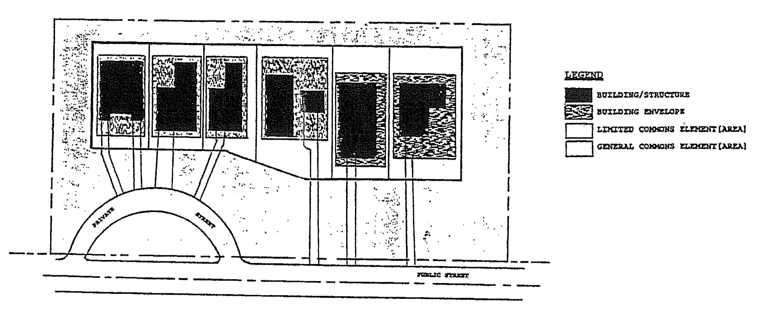
FIGURE 5-1
SITE CONDOMINIUM - SITE ILLUSTRATION

BUILDING ENVELOPE + LIMITED COMMONS ELEMENT = "LOT" OR "BUILDING SITE"
- Building Site or Lot: 'The building envelope and the limited commons area together in a site condo development is considered the functional equivalent of a standard subdivision "lot".
- Condominium Act: The Condominium Act, Act 59 of Michigan Public Acts of 1978, as amended.
- Condominium Building or Structure: The principal building or structure intended for or constructed upon a lot or building site, together with any attached accessory structures; e.g. in a residential development, the condominium structure would refer to the house and any attached garage. A "Condominium Structure" can also be a "Building Envelope".

- Condominium Project or Site Condominium Subdivision Project: A condominium project developed under Public Act 59 of 1978, as amended, consisting of more than one (1) condominium unit which is not subject to the provisions of the Subdivision Control Act 288 of 1967, as amended.
- General Commons Elements/Areas: "General Common Elements" means the land area other than the limited commons areas of the site condominium development that are held in common by all co-owners and used for parks, streets, open space or other common activities.
- Limited Commons Elements/Areas: "Limited Common Elements" means a portion of the general commons elements reserved in the master deed for the exclusive use of less than all of the co-owners and used for landscaping, vehicle parking areas, or driveways.
- Master Deed: The condominium document recording the condominium project, to which are attached as exhibits and incorporated by reference the bylaws for the project and the condominium subdivision plan for the project. All other information required by Section 8 of the Michigan Condominium Act are included.
- Mobile Home Condominium Project: A condominium project in which mobile homes are intended to be located upon separate sites which constitute individual condominium units.
- Setback - Front, Side, and Rear Yard: Distance measured from the respective front, side and rear yard boundary lines associated with the building lot to the respective front, side and rear of the condominium structure/building envelope.
- Site Condominium Unit: A condominium unit established in compliance with the Condominium Act which consists of an area of vacant land and a volume of vacant air space, designed and intended for separate ownership and use as described in the site condominium project master deed, and within which a building or other improvements may be constructed by the condominium unit owner.
- Condominium Documents: The master deed, recorded pursuant to the Condominium Act, and any other instrument referred to in the master deed or bylaws which affects the rights and obligations of a co-owner of the condominium.
- Condominium Subdivision Plan: The drawings and information prepared in accordance with Section 66 of the Condominium Act.

- Contractible Condominium: A condominium project from which any portion of the submitted land or buildings may be withdrawn in accordance with this Ordinance and the Condominium Act.
- Conversion Condominium: A condominium project containing condominium units some or all of which were occupied before filing of a Notice of Taking Reservations under Section 7 of the Condominium Act.
- Expandable Condominium: A condominium project to which additional land may be added in accordance with this Ordinance and the Condominium Act.
- Notice of Proposed Action: The notice required by Section 7 of the Condominium Act, to be filed with the Village of Clarksville and the appropriate agencies of Ionia County.
- Approval Required: All proposals to divide property other than according to the Subdivision Control Act must go through the Village of Clarksville Zoning Ordinance Site Plan Review process. In determining whether to approve a site plan for a site condominium, the Planning Commission shall consult with the Development Official, Village Attorney, Ionia County Drain Commission and Ionia County Road Commission, regarding the adequacy of the master deed, deed restrictions, utility systems and streets, site layout and design, and compliance with all requirements of the Condominium Act and this Ordinance. A S^{p}ecial Use Permit may be required for a site condominium project where the provisions of particular sections of this Ordinance identify the need for such a permit.
- General Requirements and Standards
- No construction, grading, work, or other development shall be done upon the land intended to be used for a site condominium until a final site plan has been approved, except with express permission of the Planning Commission. No permits for erosion or sanitary sewage facilities shall be issued for property in a site condominium development until a final site plan has been approved by the Planning Commission and is in effect. This requirement shall include contractible, conversion, and expandable site condominiums.
- A building, structure, or use to be placed on a
condominium lot requires site plan approval under
Article 8 of the Village of Clarksville Zoning Ordinance
before a certificate of zoning compliance may be issued.
- The Planning Commission shall have the authority to review and approve or deny preliminary and final site plans for site condominiums.
- Each site condominium unit shall be located within a zoning district that permits the proposed use and can

include commercial, industrial or residential buildings.
- The building envelope and the limited commons area together in a site condo development is considered the functional equivalent of a standard subdivision "lot". The total of these site condo lots shall not cover more than seventy-five (75) percent of the total land area in the site condo development, thereby leaving a minimum of twenty-five (25) percent for general commons area.
- The site condominium developments must meet the use and dimensional requirements of the zoning district in which they are located.
- For the purposes of this Ordinance, each condominium lot shall be considered equivalent to a single lot and shall comply with all regulations of the zoning district in which it is located. In the case of a site condominium containing single-family detached dwelling units, not more than one dwelling unit shall be located on a condominium lot, nor shall a dwelling unit be located on a condominium lot with any other principal structure or use. Required yards shall be measured from the boundaries of a condominium lot. Ground floor coverage and floor area ratio shall be calculated using the area of the condominium lot.
- Each condominium lot shall be connected to public water and sanitary sewer facilities or have an approved water/utility system by the appropriate County and/or state agencies.
- Relocation of boundaries between adjoining condominium lots, if permitted in the condominium documents, as provided in Section 48 of the Condominium Act, shall comply with all regulations of the zoning district in which located and shall be approved by the Development Official. These requirements shall be made a part of the bylaws and recorded as part of the master deed.
- Each condominium lot that results from a subdivision of another condominium lot, if such subdivision is permitted by the condominium documents, as provided in Section 49 of the Condominium Act, shall comply with all regulations of the zoning district in which located and shall be approved by the Planning Official. These requirements shall be made a part of the condominium bylaws and recorded as part of the master deed.
- All information required by this Ordinance shall be updated and furnished to the Village and the applicable certificates of zoning compliance must be approved prior to the issuance of the building permits.
E. Preliminary Site Plan Requirements
1. A preliminary site plan shall be filed for approval with

the Planning Commission on or before the time the notice of proposed action is filed with the Development Official.
2 The preliminary site plan shall include all land that the developer intends to include in the site condominium project and prepared in accordance with the following
requirements. Fifteen (15) copies of the site plan shall be submitted to the Village. The preliminary plan shall be drawn at a scale of not more than one hundred (100) feet to the inch and shall include or be accompanied by the following information:
- The name of the project, the name and address of the developer; the name, address and seal of a registered surveyor or engineer preparing the Plan; and a description of the property to be developed.
- A key map showing the location and position of the property and its relationship to surrounding streets and the surrounding area including existing zoning of abutting areas.
- North arrow, scale, contour interval, and legend when appropriate.
- Contour elevations adjusted to USGS datum at not more than five (5) foot intervals.
- Where appropriate, establish flood plain contours and elevations adjusted to USGS datum.
- The location of all existing streets, lots, plats, public utilities, drains, streams or bodies of water on/or abutting the property.
^{g.} The lot lines, intended layout, and intended use of the entire property owned or represented by the developer. The following shall be included:
- Street and sub-street right-of-way -locations, width and curve radii.
- Proposed street names.
- Boundaries of all limited common elements, general common elements and building envelopes.
- Building site lines, site line dimensions to the nearest foot, site and block numbers, and building site areas to the nearest (10) square feet.
h. The location and dimensions of all existing or
proposed easements or open space reserves,

including electrical and telephone easements.
i. The locations and tentative sizes of proposed sanitary sewers, storm sewers, and catch basins, water mains, culverts, bridges, ponding areas, ponds, and lagoons.
Statements regarding:
- Intent to utilize private water or sewerage facilities.
- Zoning and lot size requirements.
- Zoning requirements for front, side, and rear yards.
- Size and type of street(s).. (Developers are encouraged to utilize the road design and construction standards of the Ionia County Road Commission.)
- Intent to install gas, sidewalks, streetlights, and shade trees.
- Use of rivers, streams, creeks, lakes, or ponds.
k. The use and occupancy restrictions and
maintenance provisions for all general and
limited common elements as will be contained in
the Master Deed.
F. Final Site Plan Requirements
- A final site plan for any phase of development shall not be filed for review by the Planning Commission unless a preliminary site plan has been approved by the Planning Commission and is in effect.
- A final site plan shall be filed for review by the Planning Commission for the total site condominium project or for each phase of development shown on the approved preliminary site plan.
- In addition to the provisions of this Section of the Ordinance, the final site plan shall meet the requirements of Article 8 of the Village of Clarksville Zoning Ordinance.
- A final site plan shall include all information required in Section 66 of the Condominium Act, and the master deed and bylaws. The final site plan shall also include all information required in Article 8 of this Ordinance. [EXCEPTION: In the case of a site plan application for a site condominium project that consists only of condominium lots with no buildings or other structures,

the locations of and the dimensions of condominium lots, setbacks, and required yards shall be shown on the final site plan].
5. The applicant shall provide proof of approvals by all County and State agencies having jurisdiction over the improvements in the site condominium development, including but not limited to the Ionia County Drain Commissioner, Ionia County Road Commission, and the Mid-
Michigan District Health Department. The Planning Commission shall not approve a final site plan until each County and State agency having such jurisdiction has approved that portion of the final site plan that is subject to its jurisdiction.
- Revision of Site Condominium Subdivision Plan: If the site condominium subdivision plan is revised, the final site plans shall be revised accordingly and submitted for review and approval or denial by the Planning Commission before any building permit may be issued, where such permit is required.
- Streets and Roads: All streets and roads, whether public or private, proposed for any site condominium, shall be developed with the minimum design, construction, inspection, approval, and maintenance requirements of the Village of Clarksville Subdivision Control Ordinance and the Ionia County Road Commission. In a case where private streets are proposed, the Planning Commission may approve a different set of design and construction standards if approved by the Village Engineer. The Site Condominium Association shall be responsible for maintenance, signage, and snow removal on all private roads and for the ingress and egress of all emergency and public service vehicles.
- Dedication of Private Streets: Whenever a private street, as recorded in the master deed, is to be dedicated for public use, it is necessary to obtain the consent of all co-owners, mortgagees, and other persons interested in the condominium.
- Amendments to Master Deed or Bylaws: Any amendment to a master deed or bylaws that affects the approved preliminary or final site plan, shall be reviewed and approved by the Planning Commission before any building permit may be issued, where such permit is required. The Planning commission may require its review of any amended site plan if, in its opinion, such changes in the master deed or bylaws require corresponding changes in the approved site plan.
- Relation to Subdivision Ordinance: All site condominiums shall conform to the design, layout, and improvements standards of the Village of Clarksville Subdivision Control Ordinance inclusive, and any financial guarantees determined to be necessary by the Planning Commission. The standards and requirements of these sections that are intended to apply to lots in a subdivision shall apply instead to condominium lots. Nothing in this Section shall be construed as requiring a site condominium to obtain plat approval under the Village of

Clarksville Subdivision Control Ordinance or the Michigan Subdivision Control Act.
- Development Agreement: The Planning Commission may require, as a condition of approval, that the applicant enter into a development agreement with the Village of Clarksville, incorporating the terms and conditions of final site plan approval and record the same in the Office of the Register of Deeds for Ionia County.
- Construction Located in General Common Element: Any application for a building permit for construction to be located in a general common element shall include written authorization by the Condominium Association for the application.
- Monuments and Lot Irons. Monuments shall be set at all boundary corners and deflection points and at all road right-of-way intersection corner and deflection points. Lot irons shall be set at all condominium lot corners and deflection points of condominium lot lines.
The Village Engineer may grant a delay in the setting of required monuments or irons for a reasonable time, but not to exceed one year, on condition that the developer deposit with the Village Clerk cash, a certified check, or any irrevocable bank letter of credit running to the Village of Clarksville, whichever the developer selects, in an amount as determined from time to time by resolution of the Village Board of Supervisors. Such deposit shall be returned to the developer upon receipt of a certificate by a surveyor registered in the state of Michigan that the monuments and irons have been set as required, within the time specified. If the developer defaults, the Village Council shall promptly require a registered surveyor to set the monuments and irons in the ground as shown on the condominium site plans, at a cost not to exceed the amount of the security deposit.
- Rights-of-way and Utility Easements: All rights-of-way and utility easements shall be described separately from individual condominium lots and shall be accurately delineated by bearings and distances on the condominium subdivision plan and the final site plan. The rights-of-way and utility easements shall be separately designed for their individual purpose, such as access, roadway, location, installation, maintenance and replacing of public utilities. The developer shall dedicate to the appropriate agency all easements for utilities. All streets shall be dedicated to the County of Ionia and shall be constructed in accordance with the standards of the Ionia County Road Commission. Water, sewer and electrical easements may be placed within streets, subject to the approval of the Village Engineer and the standards of the Ionia County Road Commission.
0. Improvements: All improvements in a site condominium shall comply with the design specifications as adopted by the Village of Clarksville and/or the appropriate Ionia County

agency and any amendments thereto from time to time.
5.9.3 Adult Businesses
- Purpose: The purpose and intent of this section is to regulate the location of, but not to exclude, adult businesses in Ionia County by preventing the concentration of such uses in close proximity to each other and to minimize the negative impacts of their operation by separating such uses from residential, office/commercial and other areas of public congregation. This regulation is done with the understanding that the County recognizes that there are some uses which, because of their very nature, have serious objectionable operational characteristics, particularly if several of them are concentrated under circumstances having a deleterious effect upon adjacent residential, office and commercial areas. The County recognizes that the regulation of such uses is necessary to ensure that adverse effects will not contribute to the blighting or downgrading of surrounding residential neighborhoods, nonresidential areas or other places of public congregation.
- Definitions: As used in this section:
- "Adult bookstore" means an establishment which excludes minors, as defined in M.C.L.A. 722.51 et seq., and has, as a significant portion of its stock in trade, books, periodicals, magazines, newspapers, pamphlets, pictures, photographs, motion pictures films and/or videotapes, or novelty items or paraphernalia which are distinguished or characterized by their emphasis on matter depicting, describing or relating to "specified sexual activities" or "specified anatomical areas," or an establishment with a segment or section devoted to the sale or display of such material which exceeds thirty-five percent of the floor area of the establishment.
- "Adult business" means adult bookstores, adult movie theaters, adult personal service businesses, adult cabarets, adult novelty businesses, massage parlors and nude modeling studios, or any combination thereof, as defined in this section, which meets one or more of the criteria defined in paragraph 5.9.3 B.(3).
- "Adult business, significant portion" means a business where a significant portion of the stock in trade or services provided meets at least one of the following criteria:
- Thirty-five percent or more of the stock,
materials, novelties or services provided are
classified as adult materials and/or services as
defined herein.
- Thirty-five percent or more of the usable floor area of the building in which the adult business is located, is used for the sale, display and/or

provision of services classified as adult materials and/or services, as defined herein. The advertising (signs, publications, television, radio, and other media) associated with the business depicts, describes or relates to specified sexual activities and/or specified anatomical areas.
4. "Adult cabaret" means an establishment (which may or may not include the service of food or beverages) having as an activity the presentation or display of male or female impersonators, dancers, entertainers, waiters, waitresses or employees who display specified anatomical areas as defined herein.
5. "Adult motion picture theater" means an establishment, in a completely enclosed building or room, which excludes minors, as defined in M.C.L.A. 722.51 et seq., and offers, for an admission fee, membership fee or other valuable consideration, the viewing of motion picture films, videotapes, pictures or photographs, cable television, satellite transmissions or the visual media, which are thstinguished or characterized by their emphasis on matter depicting, describing or relating to specified sexual activity or specified anatomical areas, as defined herein, for the observation of patrons therein.
6. "Adult novelties" means objects, items, and/or devices offered for sale which are designed for sexual stimulation or which stimulate human genitals.
7. "Adult personal service business" means a business having as its principal activity a person, while nude or while displaying specified anatomical areas, as defined herein, providing personal services for another person. Such businesses include, but are not limited to, modeling studios, body painting studios, wrestling studios, personal dance rooms, and conversation parlors.
8. "Buttock" includes the perineum and anus of any person.
9. "Massage parlor" means an establishment wherein private massage is practiced, used or made available as a principal use of the premises.
10. "Massage" means offering for sale through the use of
physical, mechanical or other devices, the manipulation
of body muscle or tissue by rubbing, stroking, kneading,
tapping or vibrating of the body of another.
11. "Nude modeling studio" means a place which offers as its principal activity the providing of models to display specified anatomical areas, as defined herein, for artists and photographers for a fee.

12. "Offered for sale" means offered in exchange for money, a membershi^{p} fee or any other valuable consideration.
13. "Sodomy" means sexuality bestiality.
14. "Specified anatomical areas" means:
- Human male genitals in a. discernible turgid state, even if completely and opaquely covered; or
- Less than completely covered:
- Female breasts below a point immediately above the top of the areola.
- Human genitalia and the pubic region; and
- A buttock and anus.
15. "Sexual intercourse" includes genital coitus, fellatio, cunnilingus, anal intercourse or any other intrusion, however slight, of any person's body.
16. "Specified sexual activities" are defined as:
- Acts of human masturbation, sexual intercourse or sodomy;
- Fondling or other erotic touching of human genitalia, a public region, a buttock, an anus or a female breast.
- Human genitalia in a state of sexual stimulation or arousal.
C. Location of Uses. Any existing building or land, or new building hereinafter erected, converted or structurally altered, used for an adult business, shall meet all of the following conditions:
- No adult business, as defined herein, shall be permitted within a 1,000 foot radius of an existing adult business. Measurement of the 1,000 foot radius shall be made from the outermost boundaries of the lot or parcel upon which the proposed adult use will be situated.
- No adult business, as defined herein, shall be permitted within a 1000 foot radius of any residentially used or zoned land as depicted on the Official Zoning Map and defined in this Zoning Code. Measurement of the 1,000 foot radius shall be made from the outermost boundaries of the lot or parcel upon which the proposed adult use will be situated.
- No adult business, as defined herein, shall be permitted within a 1,000 foot radius of a school, library, park, playground, licensed group day care center, church convent monastery, synagogue or similar place of worship or other place of public congregation. Measurement of the 1,000 foot radius shall be made from the outermost boundaries of the lot or parcel upon which the proposed

adult use will be situated.
D. Miscellaneous Requirements.
- No person shall reside in or permit any person to reside in the premises of an adult business.
- The provisions of this section regarding massage parlors shall not apply to hospitals, sanitariums, nursing homes, medical clinics or the offices of a physician, surgeon, chiropractor, osteopath, psychologist, clinical social worker or family counselor who is licensed to practice his or her respective profession in the State of Michigan, or who is permitted to practice temporarily under the auspices of an associate or an establishment duly licensed in the State of Michigan, clergymen, certified members of the American Massage and Therapy Association and certified members of the International Myomassethics Federation who have a current massage therapist license.
Section 5.10 DRIVE-IN RESTAURANT OR FAST FOOD ESTABLISHMENT
5.10.1 Site Development Standards: Drive-in restaurants and fast food establishments shall be subject to the following restrictions:
A. Minimum Lot Area: 20,000 Square feet
B. Minimum Lot Width: 125 feet
C. Structure Location: The location of all structures including partially enclosed or covered service areas shall conform to the following requirements:
1. | Front Setback: | 75 feet
2. | Side Setback: | 25 feet
3. | Rear Setback: | 25 feet

- Motor Vehicles Access: All points of entrance or exit for motor vehicles shall be no closer than thirty (30) feet from the intersection of the right-of-way lines of two streets and not closer than ten (10) feet from an adjacent property line. The minimum driveway width at the curb line shall be thirty (30) feet. The minimum width of access drive shall be sixteen (16) feet. The angle of intersection of the centerline of any driveway with the centerline of the street shall be no less than sixty (60) degrees unless separate acceleration and deceleration lanes are provided. No more than two (2) driveway approaches shall be permitted on any street frontage.
- The outdoor space used for service shall be hard surfaced and adequately drained.

- All outdoor storage areas including areas for the storage of trash and rubbish shall be surrounded by an opaque wall at least six (6) feet high, and a view obstructing door.
- Drive-in restaurant management shall provide adequate trash and litter containers and policing for the parking lot and the shoulders of adjacent roadways. These areas shall be completely cleared of accumulated debris as often as necessary to ensure a neat appearance, but no less than once at the close of each business day.
Section 5.11 AUTOMOBILE SERVICE STATION AND COMMERCIAL GARAGE
5.11.1 Intent: this section provides standards for automobile
service stations and commercial garages. Generally, automobile service stations will be located adjacent to public streets and roads and commercial garages shall be located near high volume arterial highways.
5.11.2 Permitted Uses: The following uses may be permitted by issuance of a Special Use Permit in conjunction with automobile service stations.
- Retail sales of ^{g}asoline, oil, and similar products.
- Automobile washing.
- Automobile maintenance, including minor mechanical repairs.
5.11.3 The following uses may be permitted in conjunction with commercial garages.
- Automobile towing, including parking of a wrecker and inoperative vehicles waiting for immediate repair.
- Parking and storage or inoperative vehicles, provided that such parking or storage areas shall be within an enclosed building or shall be screened by an opaque fence not less than six (6) feet in height.
- Automobile body repairs.
5.11.4 Site Development Standards: Automobile service stations and commercial garages shall comply with the following site development standards:
A. The minimum site size shall be 15,000 square feet, and in addition, the following:
- Gasoline service stations shall have five hundred (500) square feet of site area for each additional pump over four (4) and 1,000 square feet of site area for each additional service bay over two (2).
- Commercial garages shall have 1,000 square feet of site area for each additional service bay over two (2).

There shall also be three hundred (300) square feet of additional site area for each space intended for storage of inoperable vehicles.
B. The minimum site width shall be one-hundred fifty (150) feet.
C. Building Setbacks: Building setbacks shall comply with front yard requirements for the applicable zoning district. Gasoline pump accessory structures, or island, shall be set back no less than fifty (50) feet from all street or highway r/o/w lines and shall not be located closer than twenty-five (25) feet to any property line abutting a residential
district. Hydraulic hoists, pits and all lubrication, greasing, automobile washing, and repair equipment shall be entirely enclosed within a building.
D. Access Drives: There shall be no more than two (2) access driveway approaches for any gasoline service stations and/or commercial garage, each of which, however, shall not exceed thirty (30) feet in width at the property line.
- If the service station site fronts on two (2) or more streets, the driveways shall be located as far from the street intersection as practical but no less than fifty (50) feet.
- No driveway or curb cut for a driveway shall be located
within ten (10) feet of an adjoining property line as
extended to the curb or pavement, or within twenty (20)
feet of any exterior lot line as extended.
- Any two (2) driveways providing access to a major
thoroughfare shall be separated by an island with a
minimum distance of twenty (20) feet in width along the
curb or edge of the pavement.
- The entire service area shall be paved with a permanent surface of concrete or asphalt.
E. A landscaped buffer strip not less than twenty (20) feet wide shall be developed adjacent to all automobile service station and
Section 5.12 MOTEL, MOTOR-HOTEL, HOTEL AND TRANSIENT LODGING FACILITIES except tent or camp sites provided there is compliance with the following:
5.12.1 Minimum floor area of each guest unit shall contain not less than 250 square feet.
5.12.2 The minimum lot area shall be one (1) acre with a minimum width of one hundred fifty (150) feet, provided that there shall be at least eight hundred (800) square feet of lot area for each guest.
5.12.3 The maximum lot coverage of all buildings, including accessory building shall not exceed more than twenty-five (25%) percent

of the area within the boundary lines of land developed at any one time.
5.12.4 Minimum yard dimensions: All buildings shall observe a setback of not less than seventy-five (75) feet from any road right-of-way, and not less than forty (40) feet from any side or rear property line.
5.12.5 The maximum building height shall not exceed two (2) stories or twenty-eight (28) feet.
5.12.6 Site Screening: The site may be enclosed by open structure wood or wire fences, shrubs and/or trees which, along any yard line, shall not exceed six (6) feet in height. No screening shall impair safe vertical or horizontal sight distance for any moving vehicles. Screening at least four (4) feet high shall be erected to prevent headlight glare on adjacent residential or agricultural property. No screening shall be closer than fifty (50) feet to any street line, except headlight screening shall not be closer than thirty (30) feet.
5.12.7 Lighting: All outdoor lighting shall be arranged so that it is deflected from adjacent properties, streets and thoroughfares, and shall not impair the safe movement of traffic.
5.12.8 Swimming pools and other outdoor recreational uses, which are accessory to the main use and provided swimming pools are securely enclosed by a fence at least six (6) feet in height.
5.12.9 Accessory uses, such as meeting rooms, taverns, bars, or similar uses, provided such shall be conducted within the same building as the principal use. A caretaker or proprietor's residence shall be permitted as an accessory use only when the principal use is a motel, motor-hotel, hotel, or other transient tourist facility.
5.12.10 | Exceptions to Required Lot Areas, Width and Yards: In cases where an owner or lessee proposes an integrated site development of a unified group of buildings, the Appeal Board may grant a variance waiving or modifying the lot area, lot width, and yard requirements except front yard requirements, provided the proposed development conforms to the basic intent of this district and complies with the parking requirements as herein provided.

5.12.11 Motor Vehicle Access:
A. Site Plans: All site plan proposals submitted for this district shall provide for the proper handling of traffic on the highway, frontage road, or street giving access to the district. No access by motor vehicles, other than stated herein, shall be permitted to a minor or residential street. All points of entrance or exit shall be no closer than fifty feet from the intersection of the right-of-way lines of two (2) streets.

B. Interstate or interchange site location: Whenever a proposed use is located adjacent to or within one-half (1/2) mile of an existing, or planned state or Interstate limited access highway interchange, it shall be incumbent upon the applicant to show that the proposed site location shall not cause unsafe traffic congestion resulting at or in conjunction with said limited access interchange, and the applicant shall request and submit with his application a written recommendation from the Traffic Division of the Michigan Department of State Highways. In no case, shall private access drives be less than two hundred (200) feet from an interchange.
5.12.12 Signs shall be those identifying any of the permitted uses within this district and shall be in accordance with the provisions of Article 11.
5.12.13 Off-Street Parking and Loading Requirements shall be in accordance with the provisions of Article 10 and shall conform to the following:
A. At motels, motor-hotels, hotels and other transient residential uses, parking shall be furnished on the immediate premises.
5.12.14 The storage of refuse and space required for the accumulation and out loading of garbage, trash, scrap, waste, and containers therefore shall be contained within an enclosed structure.
Section 5.13 MINI-WAREHOUSES
5.13.1 Intent and Purpose: It is the intent and purpose of this section to provide development regulations for mini-warehouses. The following procedures and requirements have been established to ensure that adequate provisions are made for, but not limited to, exterior appearance, safety, landscaping, screening, on-site parking and circulation, type of items that can be stored and use limitations of the storage areas.
5.13.2 Authorization Mini-warehousing shall be permitted in conjunction with a multiple-family dwelling, mobile home park and as cited elsewhere in this Ordinance.
5.13.3 Site Development Standards: Mini-warehouses shall be subject to the following standards:
A. Lot Coverage - Lot coverage of all structures shall be limited to 40 percent of the total area.
B Off-street Parking - One space shall be provided for each 12 storage cubicles, equally distributed throughout the storage area. This parking requirement may be met by the provision of parking lanes as described below. Two off-street parking spaces shall be provided at the manager's quarters plus one additional space for every 25 storage cubicles to be located

at the manager's office for the use of prospective clients.
C. On-Site Circulation and Driveway Widths - All one-way driveways shall provide for one 10-foot parking lane and one 15-foot travel lane. Traffic direction and parking shall be designated by signing or painting. All two-way driveways shall provide for one 10-foot parking lane and two 12-foot travel lanes. The parking lanes may be eliminated when the driveway does not serve storage cubicles.
- Landscaping - A landscaping strip, shall be provided along all street frontages and along borders where subject property abuts any residential zoning district; and constructed in accordance with the requirements of Article 12.
- Signs - Shall comply with all the applicable requirements of Article 11.
- Business Activities - No business activities other than the rental of storage units shall be conducted on the premises.
- Storage Uses - Mini-warehouse developments shall be limited to dead storage use only. Auctions, commercial or garage sales, servicing or repair of motor vehicles, boats, trailers, snowmobiles, lawn mowers, and other similar equipment are prohibited.
- Outside Storage - All storage located upon the parcel shall be contained within a fully enclosed building.
- Living Quarters - Warehousing in excess or 40,000 square feet may provide living quarters for the on-site manager.
- Driveways, Parking and Loadina - All driveways, parking, loading and vehicle circulation area shall be constructed of an all-weather dustless surface.
- Hazardous Materials - The facility shall be utilized for the storage of flammable, hazardous or explosive materials, as defined in Article 14.
- Setbacks - All buildings shall be setback at least 75 feet from any state or federal highway. There shall be a setback of at least 50 feet from all other roads, or as prescribed in the applicable district, whichever is greater. The rear and side property line setback shall be in accordance with Schedule A or B depending upon the zoning district where it is located.
Section 5.14 PERMITS FOR CONSTRUCTION OF TEMPORARY ASPHALT OR CEMENT PLANTS
The Development Official or agent shall be authorized to issue temporary land use permits for cement and asphalt plants when such are necessary for road construction under contract with a governmental unit and/or the Michigan Department of Transportation.
A. The property owner, or operator of the plant, shall make

application for a land use permit in the office of the Department of Planning and Zoning and shall pay the appropriate fee.
B. The permit shall delineate a specific period of time commensurate with the length of the road construction contract, but in no case shall exceed 120 calendar days. Any extension of the permit may be obtained by applying for a special land use permit.
C The property upon which the plant is located shall be zoned A1, A-2, MR, or M-1.
- The plant shall be located upon the site with a legal mineral extraction operation.
- The plant shall not be constructed closer than one hundred (100) feet to any adjoining property boundary and five hundred (500) feet to any adjoining residence, unless written approval is obtained from the owner of the subject residence.
Section 5.15 TEMPORARY HOUSING PERMITS FOR EMERGENCY SITUATIONS
The Development Official may issue temporary housing permits to authorize the occupancy of a mobile home or recreational vehicles when a single-family dwelling has been destroyed by fire, collapse, explosion, Acts of God, or acts of a public enemy.
5.15.1 The permit shall be conditioned upon compliance with the following standards:
- The permit shall delineate a time duration not to exceed 180 calendar days.
- The owner of the damaged structure or his agent shall acquire a permit for repair or reconstruction of the damaged structure prior to occupancy of the mobile home or recreational vehicles.
- The mobile home or recreational vehicle will be conditioned upon approval from the Mid-Michigan District Health Department, but may be allowed up to thirty (30) days with temporary sanitary facilities as approved by the Development Official.
Section 5.16 TEMPORARY HOUSING PERMITS
5.16.1. Intent and Purpose
A. This Ordinance recognizes that a vital need exists in our community in caring for individuals who, due to age, illness or disease, can no longer care for themselves.
B, It is the intent of this section to provide standards that will allow the placement of mobile homes on the same lot as

the principal dwelling, that would not otherwise be allowed by this Ordinance, where the provisions contained herein are complied with and where there is a proven need for supervision of an individual(s).
5.16.2 Introduction
- A person(s) may make application to the Ionia County Development Official for a land use permit to occupy a mobile home as an accessory use to a principal dwelling on unplatted parcels in the A-1, A-2, and R Districts if a medical condition exists such that the occupant(s) of the principal dwelling or the proposed mobile home requires continued supervision.
- The permit shall be conditioned upon compliance with the following standards:
5.16.3 Standards for Compliance
- The medical condition shall be attested to and certified by a licensed physician stating the nature of the disorder and specifying the level and type of continued care needed by the patient. The certification shall be on a form provided by Ionia County.
- The temporary housing permit shall be conditioned upon approval from the Mid-Michigan District Health Department.
- The temporary housing permit shall be issued to the person(s) with the medical condition and is for that applicant(s) use only and shall not be transferable to any other owner or occupant. The permit shall authorize the placement of one (1) mobile home on the subject property to be occupied by the person(s) with the medical condition or by the individual(s) caring for the applicant.
- It shall be the responsibility of the applicant to contact the Ionia County Development Official for a certificate of occupancy pursuant to the requirements of the Michigan Constitution Code, P.A. 230 of 1972 prior to occupancy.
- The person(s) with the medical condition shall not be employed, or suited for gainful employment.
- The mobile home shall conform to the mobile home construction safety standards of the U.S. Department of Housing and Urban Development.
G. The mobile home shall comply with the site development requirements for accessory buildings in relation to siting.
- The mobile home shall be equipped with an approved and listed smoke detection device installed adjacent to each sleeping area.
- The mobile home shall comply with P.A. 133 of 1974, as

amended. (Shall be equipped with a multi-purpose ABC fire extinguisher having a minimum 2A-10B-C rating.)
- The mobile home shall be placed on a foundation in compliance with the manufacturer's installation instructions and the applicable provisions of the Michigan Construction Code.
- The mobile home shall be anchored to protect against wind
damage. The anchoring system shall be designed and constructed in compliance with the U.S. Department of Housing and Urban Development (HUD) regulations entitled "Mobile Home Construction Safety Standards" and be approved for sale and use within the State by the Michigan Construction Code Commission.
- The mobile home shall be skirted in accordance with the applicable provisions of P.A. 96 of 1987, the Mobile Home Commission Act.
- Upon receiving an application for a temporary housing permit to occupy a mobile home as an accessory use to a principal dwelling because of an existing medical condition, the Department of Planning and Zoning shall contact all persons to whom real property is assessed within five hundred (500) feet of the proposed mobile home site stating that the Department will issue the permit at the end of a seven (7) day calendar day time period unless an aggrieved party, can demonstrate a "just-cause" why the subject permit should not be issued.
In the event the issuance of the permit is challenged, the department shall notify all person(s) to whom real property is assessed within five hundred (500) feet of the proposed mobile home site of a public meeting to be held ten (10) calendar days after the issuance of the permit has been challenged in order to give all parties an opportunity to speak to the subject permit.
Based upon the information presented prior to and at the public hearing, the Development Official shall either deny or grant the permit.
- The mobile home unit, tieing temporary in nature, shall be vacated and removed within ninety (90) days of the cessation of the occupancy for which it was intended.
0. It shall be the responsibility of the Development Official or his agent to review each permit on an annual basis to ensure continued compliance with the permit. If it is determined upon such review that a violation of the permit has occurred, the Official shall take the appropriate enforcement action as stated in Section 3.8 of this Ordinance.
Section 5.17 PLANNED SHOPPING CENTER
5.17.1 Intent and Purpose: It is the intent of this section to provide for and encourage the development of grouped retail sales and service establishments at logical and sound

locations within the Village of Clarksville. Typically, such planned centers are located on a single unified site and are designed and constructed as an integrated unit for shopping and other business activity.
The unique and changing characteristic of this type of business activity calls for standards and procedures which cannot be adequately covered by any one of the customary business district classifications. In recognition of these unique characteristics, the requirements of this section have been designed to provide for the flexible application of protective standards so that an efficient, attractive and pleasing shopping environment can be created for both the businessperson and the customer.
5.17.2 Review Procedure: The owner or owners of a tract of land which comprises five (5) acres or more shall submit to the Village Planning Commission a request for establishing a planned shopping center in the Business and Commercial ("BC") District of the Village Zoning Ordinance. The site requested shall be located upon a surfaced arterial or major road. Such request shall also be accompanied by the following evidence and supporting data, without which an application shall not be accepted by the Village Planning Commission.
- A market analysis by a recognized, reputable market analyst setting forth conclusively economic justification and needs for the establishment of a center of the type and size proposed by the applicant. This analysis shall be based upon, but not limited to such factors as the trade area of the community and travel time from various parts thereof to the proposed center site; general development trends and anticipated population changes; economic trends and disposable income characteristics; expected sales volumes of the center as indicated by the demand for certain types of retail merchandise; existing or anticipated competing commercial facilities; and other data and analyses which relate to the need for, feasible success, and stability of the proposed center.
The purpose of this requirement is to protect the Village from the over development of retail sales and service establishments which could prove highly injurious to the community welfare.
- A site plan defining the areas to be developed for buildings; the areas to be devoted to parking; the location of pedestrian and vehicular circulation and the points of ingress and egress; the location of walls, landscaped areas, terraces and other open spaces; the provision of spaces for loading, unloading, and servicing; the location, size and number of signs; and the treatment proposed for required strip areas to protect abutting land uses and zoning districts.
- A traffic survey prepared by qualified experts indicating the effect of the proposed shopping center on adjacent streets and also indicating the anticipated points of origin, direction,

and amount of traffic flow to and from the proposed center.
D A list of proposed uses to be included in the proposed center, with the area of each to be devoted to retail space.
E. A statement of financial responsibility to assure construction of the planned shopping center in accordance with the site plan and the requirements of this section.
If the proposed required rezoning and development request are approved and a Planned Shopping Center is created, the owner or owners of the parcel of land in question shall submit final plans of center development to the Planning Commission prior to the issuance of a building permit for construction. Such final plans shall include a time schedule for completion of construction of the center and the Commission shall approve or disapprove such final plans within forty-five (45) days from the date of submission and shall forward its written approval or disapproval to the Development Official.
Approval of final plans by the Planning Commission shall include approval of the development proposals contained within the plan as well as agreement to the construction schedule set forth by the developer. If the development proposal is approved by the Planning Commission, the Development Official shall issue the necessary permits for construction.
Section 5.17.3 SITE DEVELOPMENT STANDARDS AND REQUIREMENTS:
5.17.1. Types of Structures: All permitted activities shall be conducted entirely within a wholly enclosed permanent building, except as noted in the following:
- The parking of customer and employee's automobiles.
- The loading and unloading of commercial vehicles, which must take place directly into or out of a building.
- Temporary exhibitions and special quasi-civic events, PROVIDED they are conducted in spaces designed for such possible purposes on the final plans submitted with the application for a building permit.
- Recreational facilities, incidental tot the center's principal operations, of a nature normally conducted out-of-doors.
- Gasoline service stations, PROVIDED that they conform to the site development requirements of Article 5 of this Ordinance.
- Other out-buildings intended for specific individual business uses such as a restaurant or a bank, PROVIDED that they are shown on the center plan and conform to the site development and use standards contained in this Ordinance.
5.17.2. Parking and Loading Areas and Circulation: All automobile
parking areas, loading/unloading areas, and interior
circulation for motor vehicles shall be designed in accordance

with the following requirements:
- Notwithstanding the parking space requirements specified in Article 10 of this Ordinance, there shall be provided one (1) square foot of parking space for every four (4) square feet of gross floor area of the aggregate of all building space devoted to retail sales and/or services. For the purposes of this provision, parking areas shall be deemed to include only actual parking spaces and necessary appurtenant drives and vehicular access on the shopping center property.
- Any individual parking space in the center shall be accessible by clearly demarcated walks from the shopping area. Also, there shall be walkways to connect with the sidewalk systems in the public right-of-ways serving the center.
- Automobile, pedestrian and truck traffic shall be separated to he fullest possible extent.
- Pedestrian travel from any establishment within the center to any other establishment shall be possible without crossing a vehicular way.
- Automobile circulation design shall provide for access to parking areas in such a way that there shall be no backing up of vehicles into any external street under conditions of anticipated maximum center-destined traffic. Also, circulation design shall include clearly marked lanes, parking spaces, no parking zones, safety zones and loading/unloading areas.
- The circulation design shall consider service roads which connect with adjacent businesses and land uses.
- All areas accessible to vehicles or pedestrians shall be illuminated.
- Loading/unloading areas shall be situated in the architectural and functional design of the center to obscure its (their) view from the public and separated from the general public or customer on-site circulation patterns.
5.17.3 External Access: Access to the shopping center shall be provided by at least one (1) direct access from a major or arterial street. Further, the owners or developers of the center shall show, to the complete satisfaction of the Village Planning Commission, that all access points to an external street or streets shall be fully capable of absorbing the maximum hourly traffic anticipated to be generated by the center without undue interference to other traffic on he street or streets.
5.17.4 Surface Improvements: All areas accessible to vehicles shall be paved and maintained so as to provide a permanent, durable, all-weather, and dustless surface and shall be so graded and provided with adequate drainage facilities that all collected surface water is effectively retained and/or carried away from

the site. No drainage from storm water runoff from the center shall drain onto abutting properties.
5.17.5 Structure Location: No structure, with the exception of permitted signs, fences, walls and light standards, shall be located closer to any property line of the center than a distance equal to twice its height.
5.17.6 Signs may be permitted as provided in Article 11 of this Ordinance.
5.17.7 Transition Strips/Buffer Zone: All planned shopping centers, when located in or adjacent to an agricultural district, residential district, or when adjacent to a school, hospital, or other public institution, shall include as an integral pert of the site development a strip of land one hundred (100) feet of more in width on all sides of the site except on the side fronting a major/arterial street. No part of such land may be used for any shopping center functions, except that up to fifty (50) feet of the strip width on the interior side may be used as part of the parking area. Except for the part that may be occupied by parking space, the strip shall be landscaped by plant materials or structural fences and walls, used separately or in combination. The plans and specifications for shopping center development shall include the proposed arrangement of such plantings and structures and such proposals shall be subject to the approval of the Village Planning Commission. The provisions of Article 8 shall apply for the buffer area/ strip.

5.17.8 Trash Receptacles and Dumpsters: All trash disposal containers, receptacles, or dumpsters shall be located in areas or in such a manner that they are screened from casual public view and from the view of customers of the center. They shall be maintained and litter free to prevent the attraction and generation of vermin and rodent populations.
Section 5.18 SOLID WASTE DISPOSAL:
5.18.1 Siting and Screening of Refuse Dumpsters and Receptacles
Refuse dumpster, receptacles, and containers may be permitted or required as accessory to any use, other than single-family residential uses, subject to the following conditions:
A. Location: Receptacles and dumpsters shall be located on a concrete pad in a rear or side yard, provided any such dumpster shall not encroach on required parking area, is clearly accessible to servicing vehicles.
Dumpsters shall be located as far as practicable from any adjoining residential district or use but shall in no instance be located within fifteen (15) feet, or the minimum side yard setback of the particular zoning district in which it is located, of any residential property line or district.

- Screening. Dumpsters shall be screened from view from
adjoining property and public streets and thoroughfares. Dumpsters shall be screened on three sides with a permanent wall or fence of not less than six (6) feet in height or at least two (2) feet above the enclosed dumpster, which ever is higher. The fourth side of the dumpster screening shall be equipped with an opaque lockable gate that is the same height as the enclosure around the other three sides. The wall or fence should blend with the materials, color and style of the primary structure and development. Green space and
landscaping are required on the three sides of the enclosure.
- Site Plan Requirements. The location and method of screening of dumpsters shall be shown on all site plans and shall be subject to the approval of the planning Commission.
5.18.2 Recycling Containers
Recycling containers may be provided out-of-doors with the following requirements:
- For existing or new uses receiving a certificate of occupancy prior to the effective date of this Section, recycling containers shall be placed adjacent to other on-site refuse containers. If the Development Official determines that it is not practical to place the container adjacent to other refuse containers on the site, said containers may be placed in parking areas provided that the space used for the container shall not occupy required parking spaces and further provided that recycling containers shall be a gated and enclosed on three (3) sides by a screening devise approved by the Development Official.
- For uses receiving a certificate of occupancy after the effective date of this section, recycling containers shall meet the requirements of this Section and the requirements for site Plan Review under Articles 8 of this Ordinance.
5.18.3 Development Standards
- Outside refuse receptacles shall be appropriately screened at least as high as the container but not less than six (6) feet in height.
- Containers shall be consolidated to minimize the number of collection sites, and located so as to reasonably equalize the distance from the building they serve.
- Containers and enclosures shall be located away from public view insofar as possible.
- Containers and enclosures shall be situated so that they do not cause excessive nuisance or offense to occupants of the development they serve or of nearby buildings.
- Concrete pads of appropriate size and construction shall be provided for containers or groups of containers having a

capacity of six thirty gallon cans or more. Aprons shall be provided for loading of bins with capacity of 1.5 cubic yards or more.
- For storage of recyclable materials, the enclosure area and pad size shall be increased to amply accommodate the extra materials and their containers.
- Sreening and gates shall be of durable construction. Fences, walls, footings, slabs, and curbs shall meet the State BOCA Code requirements as used in the Village and County. Gates shall be constructed of heavy-gauge metal or of a heavy-gauge metal frame with covering of wood or other suitable material. Gates shall be secured with sturdy hinges or latches. If the enclosure is situated directly adjacent to parking spaces or drives, it shall be protected at its base by concrete curb blocks.
- The area inside and around the outside of the enclosure shall be maintained and litter free at all times. The enclosure structure shall also be maintained and repaired as necessary.
Section 5.19 SATELLITE DISH ANTENNA
5.19.1 Satellite antennas shall be permitted in all districts as an accessory use to a principal building.
- Definitions as they apply to this Section:
1. Satellite television antenna is an apparatus capable to receiving communications from a transmitter or a transmitter relay located in a planetary orbit.
2 Usable satellite signal is a satellite signal which, when viewed on a conventional television set, is at least equal in picture quality to that received from local commercial television stations or by way of cable television.
- Procedure: The mounting of satellite antennas, greater than twenty-four (24) inches in diameter, attached directly to any building located in all zoning districts and the location or placement of satellite antennas on any property located in a residential district is prohibited, unless a site plan thereof is approved by the Planning Commission and subject to compliance with the standards contained in Article B, Site Plan Review.
5.19.2 Development Standards
- Limitation. Only one satellite antennal per lot shall be permitted.
- Grounding. All satellite antennas and the construction and installation thereof shall conform to the Village /County

building and electrical codes.
- Roofs. Satellite antennas are prohibited on the roof of any garage or residential dwelling in residential zoned districts. Roof-mounted satellite antennas are permitted in all commercial zoned districts. Roof-mounted antennas attached to a commercial building shall not extend more than four (4) feet above the highest point of a roof, and shall not be located closer to the edge of the roof than the height of the antenna. Satellite dish antennas shall be mounted directly upon the roof of a principal building and shall not be mounted upon appurtenances such as chimneys, towers, poles, or spires.
- Wind loads. All such antennas shall be designed to meet wind load standards of the Village Building or Electrical Code.
- Screening. All satellite antennas shall be screened from view of adjacent properties or public rights-of-way by a berm, wall, evergreen plantings, camouflage device or a combination thereof.
- Glare. The surface of the antenna shall be painted or treated so as not to reflect glare from sunlight or artificial lighting.
5.19.3 Other Development Requirements
A. No satellite dish antenna shall be:
1. Located in any front yard open space or side yard open space;
2 Constructed closer to a lot line than 10 feet including its base or the minimum setback of the district in which the antenna is located;
- Linked physically to or with any structure which is not on the same lot;
- In excess of an overall diameter of twelve (12) feet or an overall height of ten (10) feet above the highest point of a roof;
- Supported by structural supports other than corrosion-resistant metal;
- Wired to a receiver, except by wires located at least four (4) inches beneath the ground in a rigid conduit or other wiring configuration approved under the Village's building or Electrical codes.
- Located within any required parking areas.

Section 5.20 KEEPING OF ANIMALS
5.20.1 Household Pets
- The keeping of household pets, including dogs, cats, birds, hamsters, and other animals generally regarded as household pets is permitted as an accessory use in any agricultural or residential zoning district.
- Except for single family dwellings in the A-1 District, no more than two (2) dogs or cats, six months of age and older, shall be kept or housed in or at one (1) dwelling unit.
5.20.2 Livestock, Bees and Fowl
- Livestock shall include, but not limited to, horses, cattle, sheep, goats, swine, llama, poultry/fowl, and rabbits. Poultry/Fowl includes chickens, turkey, emu, ostrich and similar avian species used for food production.
- Livestock, bees, and fowl may be kept or housed on a noncommercial basis only in the A-1 Districts. A minimum lot size of three (3) acres is required.
- All livestock shall have stables, barns or similar shelters available. Such shelters shall comply with the applicable regulations contained in 6.5 of this Ordinance.
- Areas in which livestock are kept shall be completely enclosed by a fence meeting the requirements of Section 8.6, of this Ordinance. Said fence shall be kept in reasonable repair so as to prevent the livestock from exiting the fenced-in area.
- The keeping of bees shall be so located to prevent the disturbance of the safety, comfort, and repose of one or more persons, or prevent the insecurity in the use of his or her property.
5.20.3 Wild Animal/Fowl
- Wild Animals/Fowl shall include, but shall not be limited to the following: Alligator (family), deer (family), opossum (family), badger, dog (wild family), primate excluding humans (family), bear, dog-wolf, racoon, ferret, skunk, cat (wild family), lemur, spider (poisonous), coyote, lizard (poisonous), weasel (family), marten, eagle, or hawk (family).
- Any animal/fowl not domesticated by humans or any animal/fowl which a person is prohibited from possessing by law is considered wild.
- The keeping of wild animals/fowl, as defined in this Ordinance, shall be prohibited in any agricultural or residential zoning district.

5.20.4 Maintenance of Area
A The yard, structure, and area used for the animals/fowl described above shall be kept in a clean, healthful and unoffensive manner.
B. The structure and area is to be located as to minimize the potentially adverse affects of noise or odors on adjacent properties so as not to create a nuisance.

ARTICLE 6: ZONING DISTRICTS, MAP AND SCHEDULE OF REGULATIONS
Section 6.1 GENERAL REGULATIONS
6.1.1 Establishment of Districts: For the purposes of this Ordinance, the Village of Clarksville, Michigan, is hereby divided into the following districts:
A-1 District: Primary Agricultural District
R-1 District: Residential Subdivision Development
R-2 District: Residential Development District
ME District: Multiple-Family Residential Dist.
P District: Professional Office District
TC District: Town Center District
BC District: Business and Commercial District
DI District: Development and Industrial District
6.1.2 Zoning Districts Maps: The boundaries of the respective districts are defined and established as depicted on the map entitled "Zoning District Map of the Village of Clarksville, Michigan," which is an integral part of this Ordinance, and which, with the explanatory matter thereon, shall be published as part of this section and is hereby incorporated by reference.
- The "Zoning District Map of the Village of Clarksville, Michigan," and subsequent amendments to the text shall be certified and bear the signature of the President of the Clarksville Village Council. The Map shall be attested to by the Village Clerk, and shall bear the following words: "This is to certify that the above map is the Official Zoning Map of the Village of Clarksville Zoning Ordinance adopted on the second day of December 1996".
- If amendments are made in district boundaries or other matter depicted on the Official Zoning Map, such changes shall not be considered final, and building permit shall not be issued until the appropriate amendments have been made on the Official Zoning Map. Such amendments shall be made within ten (10) normal working days after the effective date of the amendment. Each amendment shall be accompanied by a reference number on the map which shall refer to the official action of the Village Council. One (1) copy of the Official Zoning Map shall be maintained and kept up-to-date in the Office of the Clerk of the Village of Clarksville.
6.1.3 Replacement of Official Zoning Map: In the event that the Official Zoning Map becomes damaged, destroyed, lost or difficult to interpret because of the nature or number of changes made thereto, the Village Council may, by Ordinance, adopt a new Official Zoning Map which shall supersede the prior Official Zoning Map. The new Official Zoning Map may correct drafting or other errors or omissions on the prior Official Zoning Map, but no such corrections shall have the effect of amending the Zoning Ordinance or the prior Official Zoning Map. The new Official Zoning Map shall be identified by the signature of the President

of the Village of Clarksville Council, attested by the Village Clerk and bear the seal of the Village under the following words: "This is to certify that this is the Official Zoning Map referred to in the Zoning Ordinance of Village of Clarksville, adopted on December 2, 1996. Unless the prior Official Zoning Map has been lost, or has been totally destroyed, the prior map or any significant parts thereof remain, shall be preserved together with all available records pertaining to its adoption or amendment.
Section 6.2 RULES FOR INTERPRETATION OF OFFICIAL ZONING MAP
If because of the scale, lack of details, or illegibility of the Official Zoning Districts Map, there is any uncertainty, contradiction, or conflict regarding the intended location of any district boundaries shown on the map, the following shall govern:
- Where boundaries follow streets or highways, the centerline of the street or highway shall be the boundary line or lines.
- Where boundaries follow the shoreline of a stream, lake or other body of water, such shall follow such shoreline, and in the event of change in the shoreline, such shall be the actual shoreline; where boundaries follow the centerline of streams, rivers, canals or other bodies of water, such shall follow the centerline thereof.
- A boundary indicated as approximately following a recorded lot line or the line bounding a parcel shall be construed as following such line.
- A boundary indicated as following the municipal boundary line of a City, Village or Township shall be construed as following such line.
- A boundary indicated as following a railroad line shall be construed as following the right-of-way.
F. A distance not specifically indicated in the Official Zoning Map shall be determined by the scale of the map to the nearest foot.
Should the above not fully explain a question of boundaries, the Zoning Board of Appeals shall have the authority to make an interpretation on appeal based upon the aforementioned standards.
Section 6.3 SCOPE OF PROVISIONS
6.3.1 General Provisions
A. Every building or structure erected, any use of land, building or structure, any structural alteration or relocation of an existing building or structure and any enlargement of, or addition to, an existing use of land, building or structure occurring after the effective date of

this Ordinance shall be subject to all regulations of this Ordinance which are applicable within the zoning district in which such land use, building or structure shall be located.
- Uses are permitted by right only if specifically listed as Uses Permitted by Right in the various zoning districts. Accessory uses are permitted as indicated for in the various zoning districts, and if such uses are clearly incidental to the permitted principal uses. Special uses are permitted as listed or, where provided for and if the required conditions are met.
- A use of land, buildings, or structures not specifically mentioned in the provision of this Ordinance shall be classified upon appeal or by request of the Building and Zoning Official by the Planning Commission.
- No part of a setback area, or other open space, or off-street parking or loading space required in connection with any use of land, building or structure, for the purpose of complying with this Ordinance shall be included as part of a setback area, open space, or off-street parking lot or loading space similarly required for any other use, building or structure.
- No use of land, buildings, structures or portions as provided in Section 10 of this Ordinance shall be erected or utilized without the prior approval of the site plan in accordance with Article 8 of this Ordinance.
6.3.2 Uses not Specifically Mentioned
Any use of land or development activity not specifically mentioned in this Ordinance shall be classified upon appeal or by request of the Zoning Board of Appeals.
6.3.3 Uses Existing Before Ordinance
Any use of land or development activity existing on the effective date of this Ordinance may continue subject to the provisions contained in Article 12 of this Ordinance.
6.3.4 Zoning of Vacated Areas
If a street, alley or other public right-of-way within the Village is vacated by official governmental action and if the lands within the boundaries thereof attach to and become part of lands adjoining the street, alley or public right-of-way, such lands shall automatically acquire and be subject to the same zoning regulations applicable to adjoining lands, and shall be governed by this Ordinance.
6.3.5 Zoning of Filled Land and Use of Waters
If earthen fill is placed in any lake or stream, the created land shall automatically and without further government action acquire and be subject to the same zoning regulations applicable for lands

to which the land attaches or is adjacent; and the created land shall be used for those purposes as are permitted under this Ordinance for the adjoining lands. The use of the surface of any lake or stream shall not be permitted for any purpose which is on the land from which the use emanates.
6.3.6 Zoning of Annexed Areas
When property is annexed into the Village, the Planning Commission shall consider the appropriate district classification and shall propose an amendment to this Ordinance concerning the annexed land to the Village Council within one (1) year of the effective date of the annexation. In the interim period, the existing zoning regulations shall remain in effect pursuant to Act 279 of Michigan Public Acts of 1909 , as amended, MCLA. 117.41 et seq.
6.3.7 Application of Regulations
The right to continue a land use or activity which is either permitted by this ordinance or established as a legal nonconformity shall be vested with the property rather than with the current property owner. No rights shall be terminated for reason of transfer of ownership. The right to continue a land use or activity shall transfer automatically upon the conveyance of the property unless terminated pursuant to Article 12 of this Ordinance.
Section 6.4 PERMITTED USES
A. The regulations herein established in order to promote the public health, safety, and general welfare of the residents of the Village of Clarksville are uniform throughout each district and shall be applied consistently to each class of land, building or structure within each district. Within each district so established there are three (3) categories of uses.
1. Uses Permitted by Right: Such uses shall be allowed when in accordance with the provisions of this Ordinance.
2. Use Permitted under Special Conditions: Such use shall be allowed, subject to the specific conditions imposed for said use in the Ordinance.
3. Use Permitted by Issuance of a Special Use Permit: The special use permit has been established to facilitate the inclusion within a district of certain uses which present potential injurious effects upon the surrounding property, public safety, public health, public services, or the general welfare of the community, unless such use is authorized under the specific conditions which may vary depending on the land uses in the surrounding area.

Section 6.5 A-1 DISTRICT: GENERAL AGRICULTURAL DISTRICT
6.5.1 Intent and Purpose: It is the intent of this district to provide for and maintain agricultural operations within areas of the Village which are presently involved in the production of food and fiber. But, because of location, quality of soils, existing development, change in owner occupational preference, disinvestment, or lack of investment in the agricultural enterprise, they are suitable for and offered up for more intense use and development.
Agriculture, while important in the A-1 District, is not necessarily regarded as a permanent land use. It is also the intent of the Village that parcels of land in this district be rezoned to more intensive use classification when it has been determined that more intensive development is appropriate and when the necessary public utilities are available which are based on a comprehensive land use plan.
6.5.2 Uses Permitted by Right
- Single-Family Residence
- Crop and fruit farming, truck farming, horticulture, aviaries, hatcheries, apiaries, annelid farms, greenhouses, tree nurseries, fish farms, and similar enterprises.
- Public and private conservation areas (with no permanent structures) for the conservation of water, soil, open space, forest and wildlife preserves.
- Public areas, such as forest preserves, game refuges, natural-type recreational parks and similar uses.
- General & Specialized Farms
6.5.3 Uses Permitted Under Special Conditions
Uses permitted Under Special Conditions shall meet the general conditions identified in Section 7.1.7 (A) 1-4, Site Plan Review (Article VIII), and any requirements identified in Supplemental Regulations (Article 5).
- Accessory uses, incidental to any permitted uses
- Home Occupation
- Airfield, private. BI Basic Utility airfield which is closed to the public and which has sod runways, 20 acre minimum, and 100 foot setback.
- Cemeteries (20 acre minimum)
- Public Utility Installations
- Roadside stands selling produce

- Temporary Dwellings (5.2.8)
- Cold Storage (When associated with an active on-site farming operation)
- Group Day Care Home for 7 to 12 Children (PA 116, 1973)
- Public Buildings
- Seasonal Farm Market
- Dry Bulk Blending Plant and/or Handling of Liquid Nitrogen Fertilizer & Anhydrous Ammonia
- Family day-care facilities providing care for six (6) or less children (PA 116, 1973)
- Adult Foster Care home for six (6) residents or less (PA 218, 1979)
6.5.4 Uses Permitted by Special Use Permit Pursuant to Article 7 of This Ordinance
- Aggregate Extraction - surface mining
- Campgrounds (5 acre minimum and 400 feet from all residences)
- Commercial Towers
- Churches (2 acre minimum)
- Housing of Seasonal Labor
- Commercial Riding Stable (20 acre minimum)
G. Commercial Kennel (10 Acres)
- Livestock Auction Yards
- Outdoor Firearms Practice Ranges (10 acres minimum)
- Off Street Parking lots(Within 200 feet of principal use)
- Retail Cider Mills
- Retail Greenhouses and Nurseries
- Sales and Service of Farm Equipment when located on Surfaced County Roads or State Trunk line
- Sawmills and Kilns
0. Sewage Treatment Facilities
P. Grain and Seed Elevators & Related Retail Sale

- Keeping of Wild Animals (20 acre minimum)
- Bed and Breakfasts
- Adult Foster Care home for 6 or less children (PA 218, 1979)
- Golf Courses and Country Clubs
- Accessory Apartments or ECHO Housing
- Oil and Gas Extraction
- Specialized Agricultural Museum
6.5.5 Dimensional Requirements
Dimensional Requirements (Principal Structures)

MINIMUM LOT AREA EXCLUDING ROW | 1 acre
MINIMUM LOT WIDTH | 150 feet
FRONT YARD | 50 feet (measured from  road right-of-way
SIDE YARD | 20 feet
REAR YARD | 40 feet

Dimensional Requirements (Accessory Structures)

MUST BE A MINIMUM OF 10 FEET FROM
THE PRINCIPAL STRUCTURE
FRONT YARD | No closer to the front lot line than the principal structure
SIDE YARD | 15 feet
REAR YARD | 25 feet
Other Applicable Standards
MAXIMUM BUILDINGHEIGHT | 35 feet*

MAX. BUILDING SIZE | 10,000 sq ft
(ACCESSORY)
MAXIMUM LOT | 25 percent
COVERAGE (TOTAL)
*This height restriction does not apply to silos, grain legs, wind generators, wind chargers, or similar structures.
6.5.6 Additional Development Standards
- No portion of any building, barn, stable or similar structure used for the housing of animals shall be permitted within one hundred (100) feet of any adjoining property line. Also, the storage of manure, odor or dust producing materials is also prohibited within 100 feet of any property line.
- No confined feeding lot or any portion thereof shall be established within six hundred sixty (660) feet of any existing residential structure on adjacent property.
- No residence or portion thereof shall be established within two hundred fifty (250) feet of an existing confined feed lot. On those parcels (lots of record) where 250 feet cannot be achieved, then the maximum setback possible will be required by the Development Official;
- A new residence proposed to be located in any zoning district adjacent to an A-1 District must be located 250 feet from an existing confined feedlot. On those parcels (lots of record) where 250 feet cannot be achieved, then the maximum setback possible will be required by the Development Official. As part of the building permit review process, the applicant will be made aware and must acknowledge in writing that the existing confined feedlot could potentially be expanded to the normal setbacks of the A-1 District.

Section 6.6 R-1 DISTRICT: RESIDENTIAL SUBDIVISION DISTRICT
6.6.1 Intent and Purpose: It is the goal of this district to provide low density development to balance the demand for housing in a rural setting with the need to preserve the natural and agricultural lands of the Village.
Therefore, it is the intent and purpose of this district to allow for single family residential housing in a subdivision setting in rural areas of the Village while preserving open space, the rural character, agricultural lands, environmentally sensitive areas, mineral deposits, water resources and other natural features to the greatest extent possible.
This goal of preservation and development are addressed through the encouragement of clustered development, and the mandatory setting aside of lands in permanent open spaces.
All development shall be reviewed by the Planning Commission with the emphasis on designs which complement and accent the natural features such as topography, soils, woodlots, rivers and lakes.
6.6.2 Uses Permitted By Right
- Single family residence
- Family day-care facilities providing care for six (6) or less children (PA 116, 1973)
- Adult Foster Care home for six (6) residents or less (PA 218, 1979)
- Public Open Space, Commons Areas and Public Parks
6.6.3 Uses Permitted By Special Conditions
Uses permitted Under Special Conditions shall meet the general conditions identified in Section 7.1.7 (A) 1-4, Site Plan Review (Article VIII), and any requirements identified in Supplemental Regulations (Article 5).
- Home occupations with no outside storage
- Public service installations
- Accessory Uses (6.5.3 A)
6.6.4 Uses Permitted by Special Use Permit
- Group Day Care Home for 7 to 12 Children (PA 116, 1973)
- Child Care Center for more than six (6) children (PA 116, 1973)
- Adult Foster Care, Small (12 or less) or Large Group Home (13-20) and Congregate Facility (PA 218, 1979)

- Planned Unit Development
- Site Condominium
6.6.5 Dimensional Requirements
Dimensional requirements: All lots of record shall conform to the minimum dimensions for lot area; lot width; front, rear and side yards; all lots shall conform with the required dimensions for maximum lot coverage, minimum floor area and maximum height of buildings specified in the Site Development Standards as set forth in this Ordinance, except as otherwise stated in the text of this district, or as modified by Article 7, Special Use Permits; Article 5, Supplemental Regulations; or as varied by the Zoning Board of Appeals pursuant to Article 4 of this Ordinance.
The use of land and structures in this district shall conform to the following dimensional requirements:
Primary Structure:

Minimum Development Size | 10 Acres
Minimum Lot Area | 40,000 Square Feet w/on-  site systems  20,000 Square Feet w/  sanitary
Minimum Lot Width | 100 Feet of Road Frontage
Minimum Front Yard | 50 Feet
Minimum Side Yard | 10 Feet
Minimum Rear Yard | 40 Feet
Minimum Building  Height | 35 Feet
Maximum Lot  Coverage | 25 Percent

Accessory Structures:

Front Yard Setback | 35 Feet - But no closer  to front lot line than  principal structure
Side Yard Setback | 8 Feet
Rear Yard Setback | 25 Feet
Maximum Height | 35 Feet
Maximum Building  Size | 900 Square Feet

Section 6.7 R-2 DISTRICT: RESIDENTIAL DISTRICT
6.7.1 Intent and Purpose: It is the intent and purpose of this district to provide for a variety of housing types in portions of the Village which immediately adjoin the Town Center and other use areas of the Village and are well serviced by hard surfaced roads, public utility services, particularly public sanitary sewers and are also situated within relatively easy access to schools, work, shopping and recreational facilities. Moderate density single-family residences would be permitted with on-site sanitary systems while higher density single family residences would require public sanitary facilities.
The Residential District is not intended to create sprawl or "leap- frog" undeveloped areas resulting in "pockets" of development. Rather, the Residential District should be situated adjacent to the existing developed areas of the Village.
While the areas designated in the Residential District must adjoin hard surfaced roads, it is not the intent of this district to encourage "lineal" or "strip" development along these roadways. Instead it is anticipated in most instances that new roads will be constructed to provide access to these developing areas.
6.7.2 Uses Permitted By Right
A. Single-family residence.
B. Family day-care facilities providing care for six (6) or less children (PA 116, 1973).
C. Adult foster home for six (6) residents or less (PA 218, 1979).
6.7.3 Uses Permitted Under Special Conditions
Uses permitted Under Special Conditions shall meet the general conditions identified in Section 7.1.7 (A) 1-4, Site Plan Review (Article VIII), and any requirements identified in Supplemental Regulations (Article 5).
- Accessory uses, incidental to any of the permitted uses. All accessory buildings shall be in compliance with the provisions of Article 5.
- Bed & Breakfast. Must be in compliance with State Construction Code, Section 125.1504 b)
D. Temporary Dwellings
E. Home Occupations
- Churches and other Religious Institutions
- Public recreation & playgrounds
- Private, non-profit recreation

6.7.4 Uses Permitted by Special Use Permit Pursuant to Article 7 of This Ordinance
- Duplexes
- Sewage Treatment Facilities (enclosed and unmanned pump station)
- Site Condominium
- Adult Foster Care, Small (12 or less) or Large Group Home (13-20) and Congregate Facility (PA 218, 1979)
- Planned Unit Development
- Group Day Care Home for 7 to 12 Children (PA 116, 1973)
- Child Care Center for more than 12 children (PA 116, 1973)
- Accessary Apartment or ECHO Housing
6.7.5 Dimensional Requirements
Dimensional requirements (General): All lots of record shall conform to the minimum dimensions for lot area; lot width; front, rear and side yards; all lots shall conform with the required dimensions for maximum lot coverage, minimum floor area and maximum height of buildings specified in the Site Development Standards as set forth in this Ordinance, except as otherwise stated in the text of this district or as modified by Article 7, Special Use Permits; Article 5, Supplemental Regulations; or as varied by the Zoning Board of Appeals pursuant to Article 4 of this Ordinance.
Dimensional Requirements (Principal Structures)
MINIMUM LOT  AREA (each dwelling)  excluding Road  R-O-W | 7,500 square feet with public sanitary systems
MINIMUM LOT  WIDTH | 60 feet with on-site systems and 80 feet with public sanitary systems  (Others, width no less than 50% of lot depth)
FRONT YARD | 25 feet (measured from road right-of-way
SIDE YARD | 10 feet
REAR YARD | 25 feet

Dimensional Requirements (Accessory Structures)

MUST BE A MINIMUM OF 10 FEET FROM THE PRINCIPAL STRUCTURE
FRONT YARD | 40 feet
SIDE YARD | 5 feet
REAR YARD | 5 feet

Other Applicable Measurements

MAXIMUM BUILDING HEIGHT | 25 feet
MAX. BUILDING SIZE (ACCESSORY) | 400 square feet
MAXIMUM LOT COVERAGE (TOTAL) | 35 percent

Section 6.8 MP DISTRICT: MULTIPLE-FAMILY RESIDENTIAL DISTRICT
6.8.1 Intent and Purpose: The Multiple-Family Residential District is intended to provide for a mixture of housing types such as garden apartments, townhouses, duplexes, apartment buildings, boarding and lodging houses, and other group housing facilities. The purpose of this district is to insure that multiple-family housing is located in areas which afford adequate street capacity, is served by public sanitary sewer, and is in close proximity to commercial services and community facilities.
6.8.2 Uses Permitted by Right
- Duplexes
- Multiple-Family Dwellings (townhouses and apartments)
- Public or private non-commercial parks or recreation facilities.
- Accessory structures pursuant to Section 5.3.
- Signs may be permitted as provided in Article 11 of this Ordinance.
6.8.3 Uses Permitted Under Special Conditions: The following uses of land and structures shall be permitted, subject to the conditions hereafter imposed for each use:
- Group Housing Developments: Including those types of residential housing customarily known as garden apartments, terrace apartments, townhouses, row housing units, and other housing structures of similar character, subject to all the restrictions.
- Site Condominium Developments pursuant to Article 5 of this Ordinance.
- Temporary Buildings, in accordance with Article 5 of this Ordinance, and further, shall be removed before the issuance of any occupancy permit.
- Golf Courses and Country Clubs, in accordance with Article 5 of this Ordinance, however when built in conjunction with a multiple-family housing project, they shall be owned and operated by the owners of said multiple-family housing project of which they are a part. Swimming pools or community houses are counted as part of the required recreation area.
- Cemeteries, in accordance with Article 5 of this Ordinance.
- Railroad Right-of-Way, in accordance with Article 5 of this Ordinance.

6.8.4 Uses Permitted By Special Use Permit: The following uses of land and structures may be permitted by Special Use Permit upon the approval of the Planning Commission, provided all of the provisions of this Ordinance are met:
A. Planned Unit Developments (PUD), in accordance with Article 7 of this Ordinance.
B. Incorporated Retirement Centers, including facilities for care and treatment of the convalescent and aged, provided such facilities are owned by the corporation and that such care is limited to members of the corporation.
- Retirement centers shall be construed to mean an
incorporated development whose primary purpose is to
provide living facilities for retired persons who are
members of the corporation.
2. Retirement centers shall not be operated on parcels of
land of less than ten (10) acres in size.
C. Bed and Breakfasts, provided that not more than six transient roomers are accommodated in one(1) dwelling and that said dwelling is occupied by a resident family and only a breakfast meal is served to the transient roomers.
D. Lodging and Boarding Houses , provided that not more than four (4) non-transient roomers are accommodated and not more than these four (4) persons are accommodated for the serving of meals in the one (1) dwelling and that said dwelling is occupied by a resident family.
E. Mobile Home Park Developments, in accordance with Article 7 of this Ordinance.
F. Commercial Services, incidental and in conjunction with a multiple-family housing project.
- Commercial services shall be for the principal use of the tenants.
- There shall be no direct access to the commercial service from any exterior (off-side) road.
- The commercial service cannot be located on the absolute ^{p}eriphery of the multiple-family housing project.
- There can be no external advertising displays or signs for the commercial services.
- If the commercial service is contained in a separate structure the architecture shall be harmonious with the multiple-family housing structures.

6.8.5 Site Plan Review Procedure: All multiple-family developments are subject to Site Plan Review as specified in Article 8 of this Ordinance.
6.8.6 Dimensional Requirements: The following minimum and maximum dimensions for lot coverage and building heights shall be required for every structure and land use in this district:
- Multiple-Family Dwelling Dimensional requirements

Minimum Lot Size | 40,000 Sq. Ft.
Minimum Lot Area/DU | 4,000 Sq. Ft.
Minimum Lot Width | 150 feet
Front Yard | 50 feet
Side Yard | 20 feet
Rear Yard | 40 feet
Maximum Building Height | 50 feet
,Off-Street Parking Requirements | Refer to Article 10
Maximum Lot Coverage | 30%
Maximum Units per Building | 12 units
Minimum Distance Between Buildings | 40 feet
Minimum Floor Area/DU | 700 Sq. Ft.(one bedroom)

NOTE: Twenty-five (25) feet between buildings with less than 35 feet height. An additional one (1) foot horizontal distance for each one (1) foot of height for buildings above the 35 feet (See Figure 6-1).
- Boarding and Lodging Houses (including Bed and breakfasts)

Minimum Lot Size | 20,000 Sq. Ft.
Minimum Lot Width | 100 feet
Front Yard | 30 feet
Side Yard | 10 feet
Rear Yard | 35 feet

Maximum Building Height | 35 feet
Off-Street Parking | Refer to Article 10
Maximum Lot Coverage | 25 %
Maximum  Transient/  Non-transient Beds/Rooms | 6 beds/rooms

6.8.7 General Development Standards
- No building in a multiple-family housing development may be located closer than one hundred (100) feet from the center of the road right-of-way of an arterial street (primary road) as designated in the Comprehensive Development Plan of the Village of Clarksville or a Primary Road as designated by the Ionia County Road Commission.
- No building shall be located closer to any private street or access drive than twenty (20) feet.
- No principal or accessory building hereafter erected or structurally altered shall project beyond the average front yard so established, provided this regulation shall not require a front yard of more than fifty (50) feet or allow a front yard of less than twenty (20) feet.
- Accessory buildings shall not exceed a height of fifteen (15) feet.
- The minimum distance between any two buildings in the ME Multiple-Family Residential District shall be twenty-five (25) feet. An additional one (1) foot horizontal distance between buildings is required for each one (1) foot in height above 35 feet (See Figure 6-1 illustrations to calculate the distances between buildings).

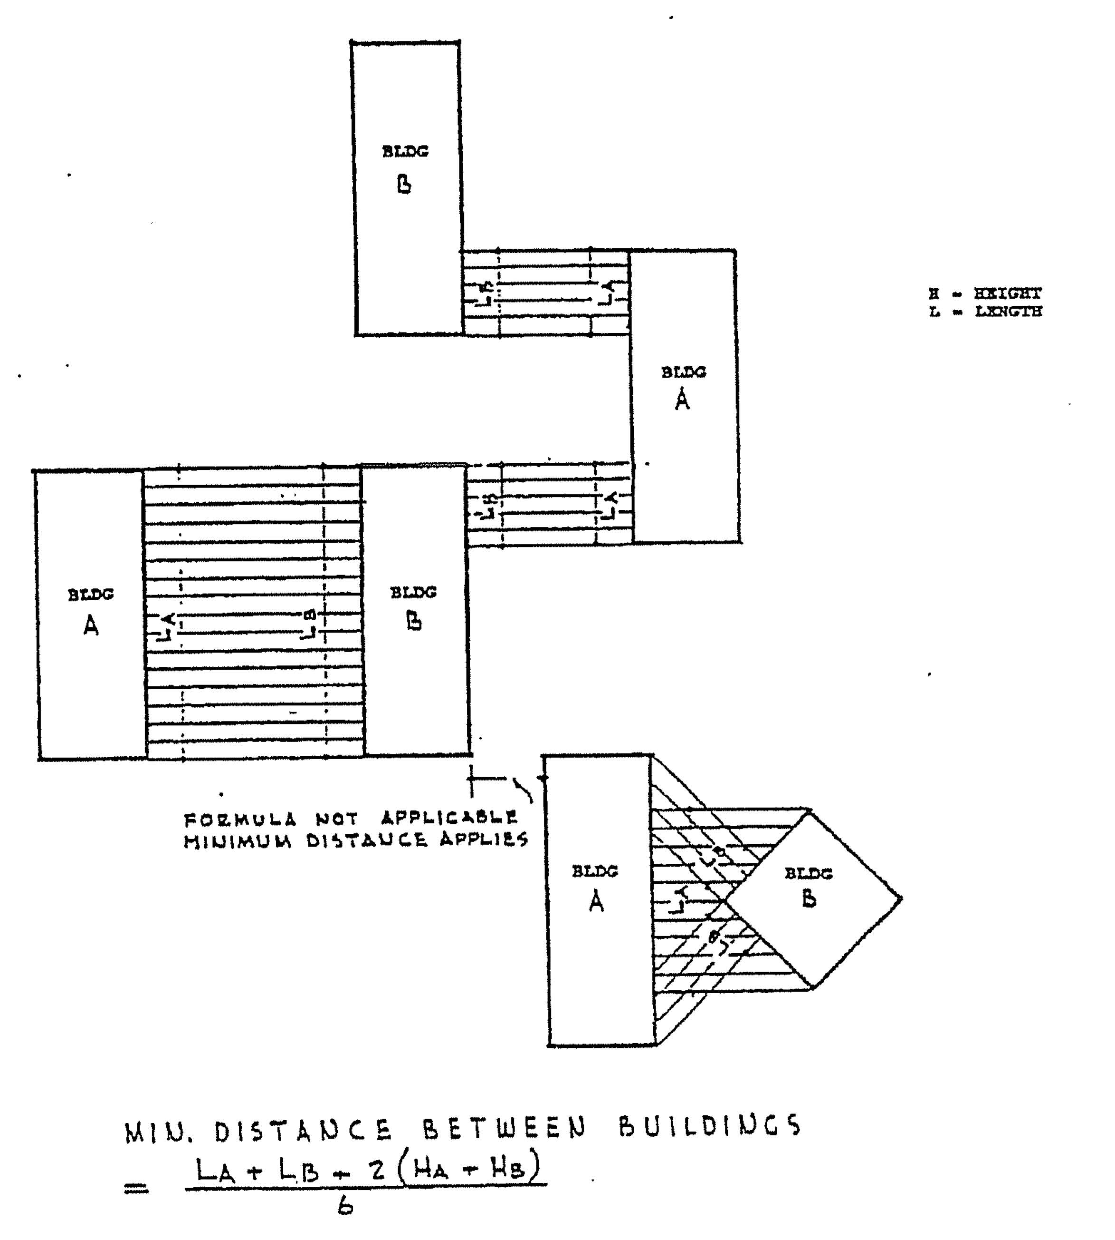
FIGURE 6-1
DISTANCE SPACING FOR MULTIPLE DWELLINGS
F. Minimum Dwelling Floor Area:

1. A minimum dwelling unit floor area does not include common hallways, common storage areas and service areas.
2 Efficiency Unit: Shall have a minimum of five-hundred and fifty (550) square feet of floor area, but only ten percent (10%) of the total number of completed units ma be efficiency units. These units may be in one building or distributed uniformly throughout the various building in the development.
- One-Bedroom Unit: Shall have a minimum of seven-hundred square feet of floor area. A one-bedroom unit shall consist of a minimum of a living room, kitchen, or a combined living room-kitchenette and bedroom.
- First Additional Room: The dwelling unit shall be increased by one-hundred twenty (120) square feet.
- For Each Additional Room Thereafter, the dwelling unit shall be increased by two hundred (200) square feet.

G. Minimum Lot Width:
- One-hundred and fifty (150) feet along the street on which the lot principally fronts, except that in the case where a curvilinear street pattern produces irregularly shaped lots with non-parallel side lot lines, a lessor frontage width at the street line may be permitted, PROVIDED that the lot width at the building line is no less than one-hundred and fifty (150) feet.
- Minimum Lot Width for Private Drives: Sixty-six (66) feet along the street into which the private drive will intersect/exit, PROVIDED that no building construction may take place within such sixty-six feet width.
6.8.8 Other Design Standards
A. Location: In order to facilitate orderly growth and prevent overburdening of public highways, all roadways which provide direct traffic egress to multiple-family developments must be approved in advance by the Ionia County Road Commission.
B. Automobile Parking:
- Developments of twelve (12) units or less, two (2) parking spaces shall be required for each unit, plus four (4) common spaces for visitors.
- Parking areas on sites of five (5) acres or less shall be behind the front building line.
- Parking areas shall not be closer than twenty (20) feet from an adjacent residential zone. Ten (10) feet is permitted when adjacent to more intense land use zones.
- Carports: Parking for multiple-family developments may be contained within carports.
- In developments of thirteen (13) units or more, off-street parking spaces shall be provided as specified in Article 10 of this Ordinance.
- All parking spaces shall be a minimum of two-hundred (200) square feet in area or ten (10) by (20) feet.
C. Curb and Gutters: must be provided for all drives and at the perimeter of all parking areas.
D. Sidewalks: Shall be required on all public and private
streets at a minimum of four (4) feet wide. If the curb is
being used for sidewalk, the width must be increased to five
(5) feet in width.

E. Fencing: Multiple development sites must be fenced on all property lines no fronting on a street by a fence with a minimum height of four (4) feet, except the first twenty (20) feet abutting a road right-of-way shall be three (3) feet in height. The type of fencing shall be approved by the Village. The type, material and location must be designated on the Site Plan.
F. Private Streets: Private Streets or private access drives may be permitted within group housing developments, PROVIDED that the following minimum requirements are met:
- All streets, roadways, or private access drives will be paved to a minimum width of twenty (20) feet when parking is prohibited. Additional widths for streets may be required by the Village Planning Commission based upon the particular density and building relationship proposals of the proposed multiple-family development.
- No dead-end street or roadway shall serve more than one hundred (100) dwelling units as a means of vehicular access.
- Suitable training facilities shall be provided for vehicles at the terminus of all dead-end streets or roadways. A minimum radius of fifty (50) feet shall be required for all turnarounds; an additional width may be required by the Village Planning Commission after consideration of the vehicular needs of a particular multiple-Family housing development proposal. A "T" or "L" turnaround may be used having a width equal to the street or roadway width.
- Satisfactory arrangements have been made with the Village Planning Commission regarding the maintenance and repair of streets, roadways or access drives. Snow removal must be included.
- Open space: A minimum of open space area, exclusive of parking areas and drives, equivalent to the total area of dwelling units, shall be maintained properly and cared for.
- Recreation Area: One hundred (100) square feet per bedroom but no less in area than twelve hundred (1,200) square feet shall be developed and maintained for common recreation use. The recreation space shall be tailored to the characteristics and make-up of the resident population. Where applicable the following shall be included:
- Play courts, such as sandplay, swinging, climbing, sliding, and jumping.
- Community recreation facilities such as field games (softball, soccer, etc.) court games ( basketball, tennis, 4-square) and a swimming pool.

- Picnic areas including tables, grills and the like.
- Passive recreation features such as sitting areas, gardens, walking trails.
- Utility Service: Electric and telephone distribution lines shall be underground. Any utility installation remaining above ground shall be located so as to have a harmonious relation to neighboring properties and the site.
- Solid Waste Disposal: A satisfactory solid waste disposal system shall be designed in accordance with the Article 5 of this Ordinance and approved with the Site Plan. In addition, the following shall be included:
- Solid Waste Dumpsters: Trash dumpsters shall be located throughout the development to facilitate the temporary collection of trash. All dumpsters shall be easily accessible to the dwelling units served. Dumpsters shall be covered and screened from public view with a solid screen constructed on four sides.
- Solid Waste Compactors: Trash compactors, if used, shall be placed in easily accessible location in the development and fully screened from public view.
- Individual Solid Waste Containers are prohibited.
- Litter: Litter shall be collected regularly and the grounds shall be kept neat and orderly in appearance.

Section 6.9 P DISTRICT: PROFESSIONAL OFFICE
6.9.1 Intent and Purpose: It is the intent of this district to provide areas for low intensive office, administrative and institutional uses in geographic locations where adequate public utilities are available and access is provided by Village primary streets.
6.9.2 Uses Permitted By Right
- Offices for attorneys, accountants, architects, engineers, and similar professions.
- Offices for financial institutions, real estate offices, insurance offices, credit reporting agencies, business management and consulting, and similar business offices.
- Photographic studios.
- Professional services establishments providing human health care on an outpatient basis.
E. Medical, optical and dental offices.
- Medical, optical and dental laboratories.
- Offices for non-profit organizations, professional associations, labor unions, civic-social-fraternal organizations, political organizations, and religious organizations.
- Mortuaries and funeral homes, not including crematories.
- Religious institutions.
- Private educational facilities.
- Public Buildings.
L. Any other use, which in the opinion of the Planning Commission, is similar to the above described uses.
6.9.3 Permitted Uses Under Special Conditions
Uses permitted Under Special Conditions shall meet the general conditions identified in Site Plan Review (Article 8), and any requirements identified in Supplemental Regulations (Article 5).
- Temporary Buildings
- Accessory Buildings and Uses
- Off-Street Parking (Within 200 feet of Principal Use)
- Massage Therapy with trained and licensed staff under state of Michigan Regulations for medical/health practices and services.

6.9.4 Uses Permitted by Special Use Permit Pursuant to Article 7 of This Ordinance
- Public Utility Installations (pump or relay stations which are enclosed and unmanned)
- Child Care Center providing care for 12 or more children (PA 116, 1973)
6.9.5 Dimensional Requirements (1)

^{I}MINIMUM LOT SIZE | 10,000 SQUARE FEET
MINIMUM LOT WIDTH | 75 FEET
FRONT YARD | 50 FEET
SIDE YARD | 10 FEET
REAR YARD | 20 FEET
MAXIMUM BUILDING HEIGHT | 35 FEET
OFF STREET PARKING REQUIREMENTS | REFER TO ARTICLE 10
1 MAXIMUM LOT COVERAGE | 40 PERCENT
(1) NOTE: Offices locating in or converting structures on lots of record in the Town Center ("CC") shall meet the requirements of that District.
6.9.6 General Development Requirements
- Off-Street Parking: There shall be no front yard parking permitted in this district. Parking areas shall be paved and landscaped from general public view. All parking shall be located beyond the front line of the primary structure on the lot.
- Solid Waste: All office uses shall employ an approved solid waste disposal system. Trash receptacles/dumpsters shall be properly screened and maintained free of litter and clutter.

Section 6.10 TC DISTRICT: TOWN CENTER DISTRICT
6.10.1 Intent and Purpose: The Town Center District is intended to promote the maintaining, protection, and preservation of commercial activities in the existing mature, historic center of the Village by providing for a variety of retail, office, restaurant, and entertainment activities within the district. The purpose of this District is to allow and encourage the blend of compatible residential and commercial uses in existing business and residential buildings within the district and the development and limited expansion of the town center to serve the needs of the rural area surrounding the village.
6.10.2 Uses Permitted by Right
A. Comparison retail stores selling commodities including but
not limited to food, drugs, liquor, furniture, clothing, dry
goods, notions, gifts, plants and flowers, arts and crafts,
or hardware and using no more than 20% of the usable floor
area for repair facilities/activities.
B. Convenience commercial establishments and antique stores.
C. Financial institutions with no drive-through service.
D. Enclosed theaters, assembly halls or concert hall.
E. Offices and office buildings as indicated below:
- Offices of various professional medical persons concerned with improving personal and community health.
- Offices of architects, engineers, urban planners, artists, and others employed in the graphic arts.
- Offices in which personnel will be employed for work in one of the following fields: executive, administrative, legal, writing, clerical, clerical, stenographic, accounting, insurance, and other similar enterprises.
F. Personal service establishments to include but not limited to tailor shops, beauty parlors, barber shops, interior decorators, photographers, dry cleaners, physical therapy, and professional medical/mental counseling services.
G. Restaurants, bars or taverns where patrons are served while seated within the building and without drive through or open front service. Outdoor seating areas incidental to the primary restaurant, bar or tavern business may be permitted where patrons are served.
H. Government administrative offices, emergency services, postal services, museums, art galleries and libraries.

- Hotels or bed and breakfast accommodations.
- Off-street parking facilities.
- Offices and showrooms of contractors decorators or similar trades, in connection with whom not more than twenty-five (25) percent of the usable floor area of the building or part of the building occupied by such establishment is used for making, assembling, repairing, remodeling, altering, finishing or refinishing the products or merchandise of the trade. All storage of materials shall be within the confines of the building or part thereof by such establishment.
- Public parks or playgrounds.
- Accessory uses pursuant to Section 7 of this Ordinance.
- Other uses similar to the uses permitted in this Section.
6.10.3 Uses Permitted by Special Use Permit Pursuant to Article 7 of this Ordinance.
A. Residential uses if they meet the lot area requirements of the Multiple-Family Residential District. Residential uses when combined with commercial business as described in Section 6.10.4.
B. Automobile/motor fuel and service stations and repair businesses existing at the effective date of this Ordinance which have limited display area, light maintenance and
service, and heavy repair activities. All storage shall be indoors and limited on-site vehicle "awaiting service" storage not to exceed three (3) vehicles for more than twenty-four (24) hours and parked at least twenty-five (25) feet from the abutting property lines and pursuant to Section 7 of this Ordinance.
C. State licensed child care facility which meets the following conditions:
- The facility shall provide and maintain on the lot not less than 4000 square feet of open space.
- For each child in the facility in excess of twenty (20) children the facility shall provide and maintain 150 additional feet of open space.
D. Building Material Suppliers
E. Educational institutions.
F. Religious institutions pursuant to Section 7 of this Ordinance.

_{G.} New and used vehicle, boat or farm implement sales including incidental servicing and minor repair pursuant to Section 7 of this Ordinance.
H. Veterinary Hospital, clinic or indoor kennel provided all activities associated with this establishment are confined to the interior of the primary use building.
I. 4' Nursery and greenhouse.
- Adult entertainment activity pursuant to Section 7 of this Ordinance.
- Commercial recreation facility pursuant to Section 7 of this Ordinance.
- Non-residential uses as permitted in this Section located in converted residential buildings.
- Additions to existing buildings or accessory structures are permitted in the Town Center District pursuant to Article 3 of this Ordinance.
6.10.4 General Site Development Requirements
- All lots created or structures established or converted after the effective date of this Ordinance shall conform to the site development standards set forth in Article 7 of this Ordinance, except as modified by the provisions stated below, or as modified by Article 7, Special Use Permits, or as varied pursuant to Article 13 Board of Appeals.
- All lots proposed for new commercial development and/or converted residential structures proposed for nonresidential uses requiring a Special Use Permit under this Section will require submission of a site plan for review in accordance with Article 8, Site Plan Review, of this ordinance.
- Non-hazardous, solid waste which is normally and reasonably discarded from commercial uses may be externally stored, provided such storage areas are completely screened by an opaque fence of not less than six (6) feet in height and storage is in commercial type of waste containers.
- When new development occurs in this district such that a side or rear lot line abuts or is adjacent to property located in any residential district, a greenbelt, buffer strip, or berm, as specified in Article 8 of this Ordinance. This requirement shall apply regardless of the existence of buildings or improvements on the adjacent residential zoned property.
F. Offices developed in this district shall conform to the development requirements of the Office District, Article 6.9

of this Ordinance in addition to the requirements of the "TC" District
6.10.5 Combined Business and Residential Uses
- A combined business and residential use is permitted with

the Town Center District subject to Site Plan approval according to Article 8 of this Ordinance.
- The residential use within each building shall be limited to the approved area for such use, unless modified by further site plan review.
- No residential use shall be permitted below the second story level of any building with the district, except newly constructed multiple family apartment buildings constructed under the provisions of Article 6.8.
- The business use of any converted or non-residential building within the District shall be the primar^{y} use. Residential use with a building shall not occupy more floor area than business use.
- No more than three (3) residential units shall be permitted in any building within the Town Center District, except newly constructed multiple-family buildings.
F The minimum square footage for multiple-family (MR) residential units under Section 6.8 of this Ordinance shall apply to all residential units within the Town Center District.
- Each residential unit shall be a separate unit for water, sewer, and electrical purposes.
- Two (2) parking spaces shall be required per residential unit, unless the requirement is waived or modified by the Planning Commission.
- Site Plan Review approval is granted according to Article 8 of this Ordinance.

6.10.6 Dimensional Requirements

Minimum Lot Size | 7,500 sq. ft.
Minimum Lot Width | 60 feet
Front Yard (1) | 25 feet (residential)
Side Yard (1) | 10 feet
Rear Yard (1) | 25 feet
Maximum Building Height | 35 feet
Off-Street Parking | Refer to Article 10
Maximum Lot  Coverage | 40% for residential lots  75% for commercial lots
(1) EXCEPTION: Existing commercial buildings along Main Street can continue to maintain zero (0) setbacks for front and side yards where existing row structures share common walls.

Section 6.11 BC DISTRICT: BUSINESS AND COMMERCIAL DISTRICT
6.11.1 Intent and Purpose: It is the intent of this district to provide for a variety of commercial establishments, business firms, and professional offices by right that offer retail sales and services at logical and sound locations near the population being served, which minimizes the distance traveled day to day for convenience goods and services. This district would permit a mixture of land uses; utilizing a variety of setbacks, buffer yards and other means of screening so as to mitigate or minimize conflicts between neighboring, yet different land uses.
The district is also intended to provide for highway oriented, shopping center, and general commercial development which are intended to serve a greater segment of the population under special conditions and special use permits. Whether the intensity of the commercial activity is high or relatively benign the district shall be developed so as to not harm adjacent residential areas. Public utilities and public sanitary sewer shall, and public water system may be required before the larger, more dense commercial development can proceed and shall be available in the foreseeable future for those areas where less intensive commercial development is proposed.
6.10.2 Uses Permitted by Right
- Arcades
- Boarding and Lodging Houses/Bed and Breakfasts
- Convenience and comparison Retail
- Convenience Shopping Centers
- General Retail and department stores
- Financial institutions including drive-through services
- Medical Services
- Motels and Hotels
- Offices
- Personal and Professional Services
- Rapid Copy and FAX Centers
- Restaurants and Taverns
- Second Hand and Antique Stores
- Mortuaries and Funeral Homes
0. Seasonal Farm Markets

- Automobile Parts Sales and Tire Service
- Public buildings, public recreation, and open space
- Signs may be provided pursuant to Article 11 of this Ordinance.
- Accessory uses may be provided in accordance with Article 5 of this Ordinance
6.10.3 Uses Permitted under Special Conditions
Uses permitted Under Special Conditions shall meet the general conditions identified in Site Plan Review (Article 8), and any requirements identified in Supplemental Regulations (Article 5).
- Customary Accessory Uses and Accessory Buildings
- Churches and Other Religious Institutions (2 acre minimum)
- Commercial Garages
- Drive-In Facilities and Theaters
- Convalescent/Nursing Homes
- Off-Street Parking (Within 200 ft. Principal Use)
- Building materials, Hardware, Farm Equipments and Garden Supply
- Commercial Site Condominium Development pursuant to Article 5 of this Ordinance.
- Automobile Service Stations
- Retail Greenhouse and Nurseries (1 acre minimum)
- Vehicle Sales and Service, Recreational Vehicles
- Planned Shopping Centers with less than 100,000 square feet of floor space.
- Adult Entertainment (Sexually Oriented Businesses)
- Pre-Manufactured Housing
- Temporary Outdoor Uses in accordance with Article 5 of this Ordinance.
6.11.4 Uses Permitted by Special Use ^{P}ermit Pursuant to Article 7 of This Ordinance
A. Planned Shopping Center, and Shopping Mall (10 acre minimum)

B. Commercial recreational activities including indoor weapons firing ranges.
- Child care center for 12 or more persons (Michigan Public Act 116 of 1973)
- Public Service and Utility maintenance installations and storage facilities
- Indoor Commercial Pistol Range
- Mini-Warehousing
- General building Contractor establishment with no outdoor storage
- Other Similar and Compatible Uses as defined by the Planning Commission
I. Clinics - Veterinary and Animal Hospital (when entirely indoors)
6.11.5 Dimensional Requirements (General): All lots of records shall conform to the minimum. dimensions for lot area; lot width; front ^{y}ards; all lots shall conform with the required dimensions for maximum lot coverage, minimum floor area and maximum height of buildings specified in the Site Development Standards as set forth in this Ordinance, except as otherwise stated in the text of this district or as modified by Article 7, Special Use Permit; Article 5, Supplemental Regulations; or as varied by the Zoning Board of Appeals pursuant to Article 13 of this Ordinance.
Dimensional Requirements (All Structures)

MINIMUM LOT AREA | 20,000 square feet
MINIMUM LOT WIDTH | 100 feet
FRONT YARD | 50 feet
SIDE YARD | 10 feet
REAR YARD | 40 feet*
MAXIMUM BUILDING HEIGHT | 35 feet
MAXIMUM LOT COVERAGE | I 40 percent
OFF-STREET PARKING | Refer to Article 8
*Parking within required front and side yards is not allowed, however, parking is permitted within 10 feet of rear property line when property line is landscaped per Article 10.

6.11.6 Development Standards
A. All commercial and business development under this section shall be subject to Site Plan Review as specified in Article 8 of this Ordinance.
B. Solid Waste: All business and commercial establishments shall provide an approved solid waste disposal system as required in Article 5 of this Ordinance.

Section 6.12 DI DISTRICT: DEVELOPMENT AND INDUSTRIAL DISTRICT
6.12.1 Intent and Purpose: It is the intent of this district to provide for a variety of heavy commercial and light industrial uses by right which are characterized by relatively low traffic generation and the absence of objectionable external affects in areas of the Village affording direct access to surfaced Village major streets or county primary roads, railroads and airports, Such areas are intended to have existing utilities of power, adequate water source, sanitary sewer and adequate storm water drainage or retention. Such industrial areas should be free of non-compatible uses and designed so as not to harm adjoining conforming uses,
In addition, this district is intended to provide for more intense industrial development with the acquisition of a special use permit in settings which are conducive to public health, economic stability and growth, protection from light, deterioration and non-industrial encroachment, and efficient traffic movement including employee and truck traffic. Land conducive to this intense development shall be located on all-weather roadways, provided with public sanitary sewer, adequate water supply and storm water drainage, has close proximity to a labor force, and has adequate land for expansion. Since such propert^{y} is limited in availability, it will be restricted for industrial use in the interest of the community's tax base and economic growth and development.
6.12.2 Uses Permitted by Right
- Building Materials, Farm Implements, Garden Supplies Sales and Service.
- Heavy Construction Companies
- Jobbing and Machine Shops
- Mini-Warehousing/Storage
- Manufacturing (Light)
- Printing/Publishing Houses
- Research and Development Establishments
- Warehousing
- Monument and Art. Stone Production
- Processing of Machine Parts
- Trade/Industrial. Schools
- Fabricating of small Metal Products
- Contractor Establishments

- Grain and Feed Elevators
- Nursery or Greenhouse
- Corp Land and Horticulture without livestock
Q. Public and Private non-commercial parks and recreation facilities
R. Signs pursuant to Article 10 of this Ordinance
6.12.2 Uses Permitted Under Special Conditions
Uses permitted Under Special Conditions shall meet the general conditions identified in Section 7.1.7 (A) 1-4, Site Plan Review (Article VIII), and any requirements identified in Supplemental Regulations (Article 5).
- Public Service and maintenance and storage facilities
- 4 Indoor Commercial Weapons Range
- Open Outdoor Storage
- Customary Accessory Uses and Buildings pursuant to Article 5 of this Ordinance
- Truck Terminal (2 acre minimum)
- Off-Street Parking (Within 200 feet of Principal use)
- Industrial Laundry
- Wholesale business without storage of flammable liquids or combustible material
- Office incidental to the industrial use
- Accessory uses and buildings pursuant to Article 5 of this Ordinance
- Restaurant or tavern withou^{t} drive-through service
- Veterinary Clinic and Animal Hospital with indoor kennels
6.12.3 Uses Permitted by Special Use Permit Pursuant to Article 7 of This Ordinance
- Above Ground Storage of Flammable Liquids or combustible materials
- Cement and Asphalt Plants
- Communication/Commercial Towers

- Drop Forging, Punch Pressing; Plating, and Chemical Processes
- Metal and Wood Stripping Establishments
- Industrial Parks
- Automobile Salvage and Junkyards
- Livestock Auction Yard and Livestock Transport Facilities Refineries and
- Power Generating Plants
- Rail Terminals
- Meat or Poultry Processing Plant
- Dry Bulk Blending Plant and/or Handling of Liquid
- Nitrogen Fertilizer and Anhydrous Ammonia
- Repair and Storage of Damaged Mobile Homes
0. Wood Processing Facility
6.12.4 Dimension Requirements

MINIMUM LOT SIZE | 40,000 square feet
MINIMUM LOT WIDTF | 150 feet
FRONT YARD | 75 feet
SIDE YARD | 25 feet
REAR YARD | 50 feet
MAXIMUM BUILDING  HEIGHT | 35 feet
MAXIMUM LOT COVEFAGE | 50 percent
OFF-STREET PARKING  REQUIREMENTS | Refer to Article 10  4
6.12.5 Site Development Requirement s
All lots created or structures established after the effective date of this Ordinance shall conform to the site development standards set forth in. Section 6.11.4 of this Ordinance, except as modified by the provisions stated below, or as modified by Article

5, Supplemental Regulations, Article 7, special Use Permit, or as varied pursuant to Article 13, Zoning Board of Appeals.
- External areas for storage are permitted when screened on all sides by an opaque fence of not less than six (6) feet in height.
- When development occurs in this district such that a side or rear lot line abuts or is adjacent to property located in any residential district, a greenbelt, buffer strip or berm, as specified in Article of this Ordinance, shall be required, in addition to the minimum rear and side yard depths as required pursuant to Section 6.11.4 of this Ordinance. This requirement shall apply regardless of the existence of buildings or improvements on the adjacent residential zoned property.
- All industrial developments and/or expansions shall be subject to Site Plan Review including landscaping requirements as specified in Article 8 of this Ordinance.
6.13.6 Other. Development (Performance: Standards
The following Performance Standards for sound, odor, gases, glare and heat, light, smoke, dust, dirt, fly ash, drifted and blown material shall apply to all uses in the I District. It shall therefore be unlawful to carry on or permit to be carried on any activity or operation of use of any land, building, or equipment that produces irritants to the sensory perceptions or is in any way injurious to the health, safety and welfare of the general public.
A. Sound: The intensity level of sounds shall not exceed the following decibel levels when adjacent to the following types of uses:
Decibels (da) Adjacent Use Where Measured
55 Residential Dwellings Common Lot Line
65 Commercial Common Lot Line
70 Industrial and Other Common Lot Line
The sound levels shall be measured with a type of audio output meter approved by the United States Bureau of Standards. Objectionable noises due to intermittence, beat frequency, or shrillness shall be muffled so as not to become a nuisance to adjacent uses in any zoning district.
B Light: Exterior lighting shall be so installed that the surface of the source of light shall not be visible and shall be so arranged as far as practical to reflect away from any residential use, and in no case shall more than one (1) foot candle power of light cross a lot line five (5) feet above the ground in a residential district/area.

- Drifted and Blown Material: The drifting or airborne transmission beyond the lot line of dust, particles, or debris from any open stockpile shall be unlawful and may be summarily caused to be abated.
- Vibration: All machinery shall be mounted and operated in order to prevent transmission of ground vibration exceeding a displacement cf, 003 of one inch, as measured at the property line.
- Odor: The emission of noxious, odorous matter in quantities that are readily detectable at any point along lot lines when diluted in the ratio of one (1) volume of odorous air to four (4) or more volumes of clean air is prohibited.
- Gases: The escape of or emission of any gas that is injurious or destructive or explosive shall be unlawful and shall be abated.
- Glare and Heat: An operation producing intense glare or heat shall be performed within an enclosure so as to completely obscure and shield such operation from direct view from any point along the lot line, except during the period of construction of the facilities to be used and occupied.
- Electromagnetic Radiation: Applicable rules and regulations of the Federal Communications Commission in regard to propagation of electromagnetic radiation are hereby adopted by reference as a part of this Ordinance.
- Radioactive Materials: radioactive materials shall not be emitted to exceed quantities established as safe by the Federal Government.
- Airborne Emissions: Airborne emissions shall be in
compliance with the Air Pollution Act 348, Michigan Public Acts of 1965, MCLA 336.11 et seq, and the rules of the Michigan Air Pollution Control Commission.
K. Other Forms of Pollution: It shall be unlawful to discharge into the air, onto the ground or into the water any material or materials in excess of standards approved b^{y} the Michigan Department of Natural Resources or Ionia County Public
Health Department.

ZONING MAP
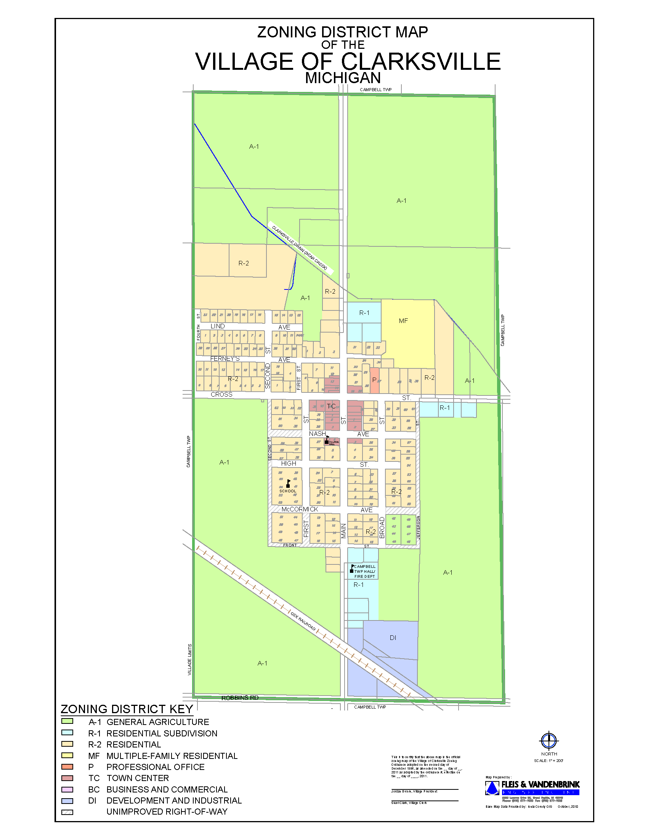

ARTICLE 7: USES AUTHORIZED BY SPECIAL USE PERMIT
Section 7.1 GENERAL STANDARDS AND REQUIREMENTS
7.1.1 Intent and Purpose: Rather than permitting all of the many and varied land use activities within individual and limited zoning districts, it is the intent of this Ordinance to provide a set of procedures and standards for specific uses of land or structures that will allow, on one hand, practical latitude for the developer, but that will at the same time, maintain sound provisions for the protection of the health, safety and general welfare of the inhabitants of Village of Clarksville. In order to provide controllable and reasonable flexibility, this Article permits detailed review of certain specified types of land use activities which, because of their particular and unique characteristics, require special consideration in relation to the welfare of adjacent properties and to the community as a whole. Land and structure uses possessing these characteristics may be authorized within certain zone districts by the issuance of a Special Use Permit. By such a _^{p}rocedure, the Village Planning Commission has the opportunity to impose conditions and safeguards upon each use which are deemed necessary for the protection of the public welfare.
The following section, together with previous references in other Articles of this Ordinance, designate specific uses that require a Special Use Permit and, in addition, specify the procedures and standards which must be met before such a permit can be issued.
7.1.2 Permit Procedures: An application for a Special Use Permit for any land or structure use permitted under this Article shall be submitted and processed under the following procedures:
A. Submission of Application: An application shall be submitted through the Development Official for consideration to the Planning Commission on a form provided by the Development Official not less than forty-five (45) days before any regular meeting of the Planning Commission. The application shall be accompanied by payment of the fee as established by the Village Council to cover costs of processing the application as well as site plan review fees that may be required by ether agencies. No part of any fee shall be refundable.
B. Required Information: One (1) application for a Special Use Permit shall be presented to the Development Official and accompanied by fifteen (15) copies of a site plan in compliance with Section 8.4 (Site Plan Requirements).
C. Incomplete Applications:
- An application made without full compliance with this Ordinance shall be returned to the applicant.
- An application, which is incomplete, shall not constitute submission so as to commence the running of time for processing the application.

3. An application complying with the provisions of this Ordinance shall be scheduled for public hearing by the Planning Commission.
D. Other Having Interest: Any person having an interest in any application may present any petition or document supporting his position for or against such application.
- All documents shall be submitted to the Development Official no later than fifteen (15) days before the hearing at which the application will be considered.
- It shall be incumbent upon the applicant to furnish adequate evidence in support of the proposed use complying with the provisions of this Ordinance. It shall be the obligation of the applicant to furnish sufficient evidence, or proof, of present and future compliance with the provisions of the Ordinance.
- Until a Special Use Permit has been issued for any use requiring the same in this Ordinance, and until a proper building permit has been granted pursuant to the Special Use Permit, there shall be no construction or excavation on said land, nor shall there by made any use of land related to the request for the Special Use Permit.
7.1.3 Reserved.

7.1.4 Public Hearing: The Planning Commission shall hold a public hearing on the Special Use Permit application, providing notice of such hearing in accordance with the requirements of Section 9.5 herein.

7.1.5 Review and Approval: The review of an application and site plan requesting a special use permit shall be made by the Planning Commission in accord with the procedures and standards specified in this Ordinance. If a submitted application and site plan do not meet the requirements of the Ordinance, they may not be approved. However, if the applicant agrees to make changes to the site plan and application in order to bring them into compliance with the Ordinance, such changes shall be allowed and shall be either noted on the application or site plan itself, or attached to it, or these documents shall be resubmitted incorporating said changes. A site plan and application for a special use permit shall be approved if they comply in all respects with the requirements of this Ordinance and other applicable county, state or federal laws, rules or regulations. Approval and issuance of a special use permit shall signify prior approval of the application and site plan, therefore including any modification shall become
part of the special use permit and shall be enforceable as such. The decision to approve or deny a request for a special use permit shall be retained as a part of the record of action on the request and shall incorporate a statement of conclusions which specify basis for the decision, any changes to the originally submitted application and site plan necessary to insure compliance with the Ordinance, and any conditions imposed with approval. Once a special use permit is issued, all site development and use of land on the property affected shall be consistent with the approved special use permit, unless a change conforming to ordinance requirements receives the mutual agreement of the landowner and the Village Planning Commission and is documented as such.
7.1.6 Required Site Plan Review: Site Plans for Special Use Permits must be submitted and reviewed in conformance with Article 8 of this Ordinance.
7.1.7 Basis of Determination: Before approving a special use permit, the Village Planning Commission shall insure that the standards specified in this section as well as applicable standards established elsewhere in this Ordinance, shall be satisfied by the completion and operation of the special use under consideration.
A. General Standards: The Village Planning Commission shall review the particular circumstances of the special use request under consideration in terms of the following standards, and shall grant its approval only upon a finding of compliance with each 3f the following standards as well as applicable standards established elsewhere in this Ordinance.

- The proposed use, activities, processes, materials, equipment. and conditions of operation will not be detrimental to the public welfare, persons or property by reason of excessive noise, fumes, dust, glare, traffic or objectionable odors.
- Essential public facilities and services such as roads, fire and police protection, drainage
facilities, refuse disposal, schools are adequate for the proposed use or are capable of being adequately provided for.
- Requirements for additional public services and facilities which will be created by the proposed use will not b= detrimental to the economic welfare of the community.
- All standards set forth in this Zoning Ordinance will be complied with.
- All administrative requirements pertaining to the issuance of special use permits have or will be complied with.
- The proposed use, activities, processes, materials and equipment and conditions of operations shall be consistent with the objectives of the Comprehensive Development Plan.
- Where feasible, the proposed activity should not be located such that it will directly or in-directly have a substantial adverse impact on the natural resources of the County. Specifically, prime agricultural soils are defined by he Village of Clarksville Soil Conservation Service, wetland protected by P.A. 203, the Goemaere-Anderson Wetland Protection Act, lakes, rivers, streams, county drains, major forests, water recharge areas and major mineral deposits.
C Conditions: The Village of Clarksville Planning Commission may approve, approve with conditions, or disapprove a special use application. If the Planning Commission approves with conditions, the Commission shall have authority to add conditions necessary to insure compliance with the standards contained in this or other applicable County ordinance and regulations. Such conditions shall be enforced by the Development Official.
The conditions may include conditions necessary to insure that public services and facilities affected by a proposed land use or activity will be capable of accommodating increased service and facility loads caused by the land use or activity, to protect the natural environment and conserve natural resources and energy, to insure compatibility with adjacent uses of land, and to promote the use of land in a socially and economically desirable manner.

D. Performance Guarantee: In reviewing a special use permit, the Village Planning Commission may recommend that a cash deposit, certified check, irrevocable bank letter of credit, or surety bond be furnished by the developer to insure compliance with an approved site plan and the special use permit requirements. ?Such guarantee shall be deposited with the County Clerk at the time of the issuance of the special use permit. In fixing the amount of such ,performance guarantee, the Village Planning Commission shall limit it to reasonable improvements required to meet the standards of this Ordinance and to protect the natural resources or the health, safety and welfare of the residents of the County and future users or inhabitants of the proposed project or project area including, but not limited to roadways, lighting, utilities, sidewalks, screening and drainage. The term "improvements" does not include the entire project which is the subject of zoning approval nor to improvements for which a performance guarantee has been deposited pursuant to Act No. 288 of 1967, as amended. The Village Planning Commission and the project developer shall establish an agreeable procedure for the rebate of any cash deposits required under this section, in reasonable proportion to the ratio of work completed on the required improvements as work progresses. Said agreement shall be written as an element of the conditions surrounding the approval of the special use permit.
7.1.8 Effective Date of Special Use Permit: The special use permit shall become effective when the application has been approved by the Planning Commission.
A. A building permit shall not be issued until approval of such special use permit by the Village of Clarksville Council.
B Land subject to a special use permit may not be used or occupied for purposes of such special use until after a certificate of occupancy for same has been issued pursuant to this Ordinance.
7.1.9 Transfer and/or Expiration of 5necial Use Permit
A. Transfer of Special Use Permit: In order to insure continued compliance with the terms of this Ordinance and a special use permit issues under it, each special use permit shall specify reasonable terms for transfer of a valid special use permit from the present landowner or operator to a subsequent owner or operator. The responsibility for said transfer in accord with the terms of the special use permit shall be that of the permit holder of record with the Village of Clarksville Planning Commission. Failure of a special use permit holder to properly transfer a special use permit shall not release the permit holder of record from ordinance penalties for any subsequent action undertaken on the land in violation of the terms of the special use permit. Transfer of a special use permit shall be made on a form supplied by the Development Official for that purpose. Proper completion of the form .shall require documentation of

assumption by the new owner of an interest in the land/operation in question and a written agreement that the new owner/operator will assume the obligations and responsibilities specified in the special use permit, including deposit of a bond or other performance guarantee when so required by the special use permit. When such transfer has been properly completed and any bond or other performance guarantee deposited properly with the Village by the new permit holder, any bond or performance guarantee on deposit with the Village by the previous permit holder shall be returned in accord with the terms of this Ordinance.
B. Expiration of Special Use Permit: A special use permit shall be valid for as long as the permitted use continues in accordance with the terms stated therein, unless otherwise stated in the special use permit. If there is not compliance with the terms of the special use permit within six (6) months from the date of its issuance, then it shall automatically expire and be of no further effect or validity. Approval of a special use permit shall be valid regardless of change of ownership, provided that all terms and conditions of the permit are met by subsequent owner.
The Village Clerk shall notify the applicant, in writing, mailed to the address listed on the application that such special use permit has expired.
7.1.10 Re-application: No application for a special use permit which has been denied, wholly or in part, by the Village Council, shall be resubmitted until the expiration of one (1) year from the date of such denial except on the grounds of newly discovered evidence or proof of changed conditions.
7.1.11 Requirement Compliance - Penalties: It shall be the duty and obligation of the owner(s); or operator(s) if such is under a management arrangement, to at all times be in compliance with the use requirements of this Ordinance and the stipulations of the special use permit under which their particular use is governed. Failure thereof shall be in violation of this Ordinance and subject to the penalties and remedies provided in Section 3.8 and the continuance thereof is hereby declared to be a nuisance per se.
7.1.12 Once Granted a Special Use Permit, the Use is a Permitted Use:
Any use for which a special use permit has been granted shall be deemed a conforming use permitted in the district in which such use is located provided:
- Such permit was issued in conformity with the provisions of this Ordinance;
- Such permit shall be deemed to effect only the lot or portion thereof and uses there upon for which the special use permit shal.1 have been explicitly granted; and

C. Such permit authorizes a use which is subsequently built, operated and maintained to compliance with the Ordinance, the Special Use Permit and all conditions established with its approval.
7.1.13 Specific Requirements: The general standards and regulations of this Section are basic to all uses authorized by Special Use Permit. The specific and detailed regulations set forth or referred to hereafter in other specified Sections of this Ordinance relate to particular uses; and are hereafter requirements which must be met by those uses in addition to the aforementioned general standards and regulations.
Section 7.2 SPECIAL USES THAT MAY BE PERMITTED
Special Land Uses, which may be permitted, are specifically listed within each of the Zoning Districts Article 6. The basis of determination and the general standards for reviewing all listed special land uses in the various zoning districts can be found in Section 7.1.7.
The following table and additional list of land uses identifies special land uses which have additional standards which must be met prior to the issuance of a Special Use Permit.
SPECIAL LAND USE | DIMENSIONAL REQUIREMENT | ADDITIONAL  REGULATIONS
Duplexes | -43,560 Square Feet of Land  Area Per Dwelling Unit  -700 Square of Floor Area Per  Dwelling Unit  -Per District | -Site Plan Review
Multiple Dwelling | -10,000 Square Feet of Land  Area Per Dwelling Unit  -Floor Area Per Dwelling  Unit...  1 BR 350 Sq. Ft.  2 BR 550 Sq. Ft.  3 BR 680 Sq. Ft.  4+BR 680 Sq. Ft. Plus 100  Sq. Ft. for each  additional bedroom  -25 Percent Open Space  -Per District | -Site Plan Review  -Landscape Plan
Sewage Treatment  Facility | -5 Acres Minimum  -100 Feet from all  residential uses | -Fenced Site  -Site Plan Review
Housing For Seasonal  Labor | -40 Acres Minimum  -100 Feet from all  property lines | -Site Plan Review  -Meet State and Village  Health Codes
Airfields (BIT and  BIII) | -20 Acres  -100 Setback from all  property lines | -Site Plan Review
Campgrounds | -5 Acres  -400 Feet from all residences | -Site Plan Review  -Landscape Plan

Livestock Auction  Yard | -10 Acres | -Site Plan Review
Outdoor Firearm Range | -10 Acres  -400 Feet from all residences | -Site Plan Review
Retail Nurseries | -5 Acres | -Site Plan Review
-50 Feet from all
property lines
Hunting Preserve | -40 Acre | -On site parking
 | -400 Feet from all residences
Junk and Salvage | -10 Acres | -Screen entire site
Yards | -50 Foot Setback all sides | -Site Plan Review
Refineries | -10 Acres | -Buffer per D District
 | -100 foot setback all sides | -Site Plan Review
 | -Per District | -PIPP Plan
Sawmill Operations | -20 Acres | -Site Plan Review
 | -400 Feet from all residences
Shopping Centers | -10 Acres | -Hard surfaced Arterial
(Over 100,000 Square | -Per District | Road
Feet) |  | -Site Plan Review
 |  | -Buffer per D District
Storage of Flammable | -400 Feet from all residences | -Site Plan Review
Liquids | -Per District | -PIPP Plan
 |  | -Fire Dept. Review
Animal Slaughter | -10 Acre: | -Site Plan Review
House | -400 Feet from residences
Truck and Rail | -5 Acres | -Site Plan Review
Terminals | -50 Feet from all property | -PIPP Plan
 | lines
Asphalt and Cement | -5 Acres | –  -Site Plan Review
Plant | -400 from all residences
Contractor | -10 Acre | -Site Plan Review
Establishment | -Per District | -PIPP Plan
Industrial Park | -20 Acres | -Site Plan Review
 | -Per District | -PIPP Plan
–......,  Farm Equipment Sales | -5 Acres | -No setback storage
and Service |  | -Site Plan Review

7.2.1 Planned Unit Developments (PUD):
A. Purpose: The Planned Unit Development District is designed to provide for maximum environmental choice for the residents of the Village of Clarksville by encouraging creativity and flexibility of low density residential design, diversity of building types, open space arrangements and environmental preservation, and the integration of nonresidential uses such as professional office, research and supportive services and amenities through the Special Use Permit Process.

B. Intent: It is the intent of this Section to provide for an added degree of flexibility in the placement and interrelationship of buildings incorporating a variety of residential dwellings, and encouraging a more creative approach to development. Such criteria are further intended to:
- Result in a more efficient development pattern with shorter streets and utility networks.
- Preserve existing natural assets, such as stands of trees, flood plain, open fields and the like.
- Accomplish a more desirable residential environment than would be possible through the strict application of minimum requirements of the Zoning Ordinance.
- Encourage the utilization of open space and the development of recreational facilities generally located within a reasonable distance of all living units.
5 Such development may consist of individual lots or common building sites. Common land and open space are essential elements of the plan related to affecting the long-term aesthetic and economic values of the entire development.
- Provide for supportive amenities such as recreational uses, day care centers and similar uses, which in the opinion of the Planning Commission, are in conformance with the Comprehensive Development Plan and the objectives of the proposed development.
- Provide for planned professional office/research working environments in conjunction with the planned living environments which enhance the residential stability and economic base of the Village of Clarksville through the application of the Special Use Permit process.
C. General Requirements, Restrictions and Standards:
- Minimum Project Area: Minimum project area allowable for a PUD shall be fifteen (15) acres.
- Location: PUD's may be located in those districts as designated and upon approval of the Planning Commission and the Clarksville Village Council.
- Uses Permitted: Only the following land and/or building uses may be permitted under the provisions of this Section:
a. All uses permitted in the district for which the PUD is approved.
b Any additional uses which can be shown to be compatible with the general objectives of the Village's Comprehensive Development Plan as well as integral to the specific PUD scheme in which they are contained. For the purpose of this Section, an integral use shall be defined as a use which has a specific functional relationship with other uses contained in the development, as for example, a Day Care Center which serves

primarily the needs of residents of the development.
- Residential land use development is to be the predominant use in a POD and in no case shall office uses exceed more than twenty-five (25) percent of the total development area.
- Performance Objectives:
- Yard, setback, lot size, type of dwelling unit, height, and frontage requirements restrictions are waived for the PUD, provided, however, that the spirit and intent of this Section, as defined in the purpose clause, are incorporated within the total development plan. The Planning Commission may determine that certain setbacks be established within all or a portion of the perimeter of the site, and shall determine the suitability of the total development in accordance with the purpose clause of this Section.
- Access: Every structure or dwelling unit shall have access to a public street, walkway or other areas dedicated to common use. Private streets may be allowed but must meet the design and construction standards the Subdivision Control Ordinance, this ordinance, and the Ionia County Road Commission.
- Land Usage: The approximate location of structures, shown on the conceptual development plan, shall be so arranged as not to be detrimental to existing or proposed structures within the development or surrounding neighborhood.
- Privacy: Each development shall provide reasonable visual and acoustical privacy for dwelling units. Fences, walks, barriers, and landscaping shall be used, as appropriate, for the protection and aesthetic enhancement of property and 'the privacy of its occupants, screening of objectionable views or uses, and reduction of noise.
e. Off-street Parking: Parking convenient to all dwelling units and other uses, shall be provided pursuant to the minimum requirement of ARTICLE 10 of this Ordinance. Common driveways, parking areas, walks and steps maybe required together with appropriate lighting, in order to insure the safety of the occupants and the general public. Screening of parking and service areas may be required through use of trees, shrubs, hedges or screening walls.
f. Development Concept: All of the elements of the site plan shall be harmoniously and efficiently organized in relation to topography, the size and type of plot, the character of adjoining property, and the type and size of buildings. Arrangement of buildings shall be done in such

a way utilize natural topography, existing vegetation and views within and beyond site.
g. Utilities: PUD’s shall, where feasible, provide for underground
installation of utilities (including electricity and telephone) in both public ways and private extensions thereof.
Provisions shall be made for construction of storm sewer facilities including grading, gutters, piping, and treatment of turf to handle storm waters, and to prevent erosion and the formation of dust. This could include the establishment of retention basins in order to minimize storm water runoff.
- Pedestrian Circulation: The pedestrian circulation system and
its related walkways shall be insulated as completely and as reasonably as possible from vehicular movement.
- Recreation Areas: Recreation facilities for impairing the view
and privacy of the living unites, shall be provided easily accessible locations.
- Planting: The appeal and character of the site shall be
Preserved and enhanced by retaining and protecting existing
Trees and other site features; additional new landscaping shall be added for privacy, shade, beauty of buildings and grounds and to screen out objectionable features.
6. Density: The density (dwelling units per acre) in a PUD shall not exceed the density of the zone in which it is located. When more than one zone is involved, the density of the project will be the average of the zones, weighted in direct proportion to the size of the property within the project in each zone. Only one-half (1/2) of the total portion of the site comprised of flood plain, swamps, (wetland) or a water body, may be used in the calculation of densities of a project.
7. Open Spaces: “Common Open Space” is defined as parcel or parcels of land or an area of water or combination of land and water assigned and intended for the use or enjoyment of the residents of the PUD or of the general public. “Common Open Space” does not include proposed street rights-of –way, open parking area, or commercial areas. Common Open Space may contain accessory structures and improvements necessary or desirable for religious, educational, non-commercial, recreational or cultural uses. A variety of open space and recreational areas is encouraged such as: children’s informal play areas in close proximity to individual dwelling units, according to the concentration of dwellings, informal parks, picnic areas, playgrounds, and scenic open areas and communal, non-commercial, recreational facilities.
a. The area of Common Open Space within a PUD

project may not be less than twenty-five (25) percent of the total land area of the project.
b. All Common Open Space shown on the final Site Plan must be reserved or dedicated by lease or conveyance of title to a corporation,
association or other legal entity, or by reservation by means of a restrictive covenant. The terms of such lease or other instrument must include provisions guaranteeing the continued use of such land for the purposes intended and for continuity of proper maintenance of those portions of the open space land requiring maintenance.
- Circulation Facilities: The arrangements of public and commo•1 ways for pedestrian and vehicular circulations shall be coordinated with other existing or planned streets in the area.
- The PUD's landscape plan shall meet the requirements of Artic1T2 8 (Landscape Plan).
10. The PUD's site plan shall meet the requirements of Article 8 (Site Plan Review).
11. The PUD may be developed in stages or phases, but must
receive conceptual approval for future states and
final site plan approval prior to construction of each
state or phase.
- Initial construction on the first phase of the project must begin within two years of approval from the Village.
- In the opinion of the Development Official, amendments to the approved PUD which increase the intensity of use or increase the impact on adjacent properties must be resubmitted to the Planning Commission for review and approval.
- An approved PUD shall amend the Zoning District(s) and Map.
D. Development Agreement and Financial Guarantees: Upon approval of the PUD, the applicant shall develop with the Village, a development agreement to insure that all of the customary municipal improvement required by existing ordinances and regulations will be properly made and that funds will be made available by the applicant to insure the installation of certain site improvements prior to any permits being issued.
Financial guarantee shall be required by the Planning Commission in the form of a cash deposit, certified check, bond or other financial guarantee/instrument acceptable to the Village to ensure compliance with such requirements as infrastructure, drives, walks, parking, landscaping, or other features of the development.
The financial ^{g}uarantee shall be deposited with the Village at the time of issuance of the permit authorizing the project or activity. The Village shall release portions of the guarantee as work is completed on the project or

activity and accepted by the appropriate Village Development Official.
The developer shall establish a separate escrow account with the Village to cover such additional review costs as engineering, legal, or other professional assistance as may be required.
E. APPROVAL PROCESS - Submission, review, and recommendation of a Planned Unit Development District shall be subject to the following three step process:
Pre-Application Conference - Prior to submission of an application for a Planned Unit Development District, the applicant shall meet with the Development Official and other appropriate staff to outline the fundamental elements of the proposed development (location, acreage, residential density, non-residential density, building types, specific uses, open space and natural features and proposed circulation). The applicant shall receive at the pre-application conference an explanation of ordinance requirements, procedures, and estimated time lines.
Preliminary Development Concept - Prior to setting a public hearing on the proposed zoning ordinance amendment, the Planning Commission is required to review and comment on the preliminary development concept for the proposed PUD. The intent of the Planning Commission review is to provide as much feedback as possible to the applicant prior to the official public hearing as required under Section 22.5.
Prior to the Planning Commission's review of a preliminary development concept, the following information shall be submitted:
- Evidence of ownership or equitable interest in the proposed site of the PUD.
- Legal description and generalized location.
- Written, detailed description of the proposed uses.
- Fifteen (15) copies of a conceptual site plan for the proposed development which contains the following information:
-Readable scale
-Existing zoning of the site and adjacent properties -Existing land use of the site and adjacent properties -Location of proposed structures, parking areas, and open space
-Development summary data (acres, units, parking spaces, gross/net density, gross building square footage)
-General description of water, sanitary and storm drainage systems including retention basins -Identification of existing natural features of the

site and 1ocation of specific wetland area
-Description of proposed landscape features, buffers, and pedestrian circulation system
- Identification of existing and proposed easements
- Identification of existing and proposed public and private rights-of-way and adjacent curb cuts
- Identification of any proposed non-residential land uses
5 Description of development ownership, proposed ownership form for residential and non-residential components and proposed maintenance concept.
F. Final Development Plan - The final development plan for a proposed Planned Unit Development District shall meet the requirements of Article 9 (Zoning Amendments) of the Village of Clarksville Zoning Ordinance and shall meet the following additional requirements:
- The application and all supportive materials shall be submitted at least thirty (30) days prior to the scheduled public hearing for the PUD.
- The application and supportive materials shall contain a site plan which contains the information submitted for the Preliminary Development Plan plus following information:
-Meets the requirements of Article 16 (Site Plan Review).
- Indicates engineering recommendations for water, sanitary sewer, storm drainage, natural gas, electric and telephone systems.
-Indicates recommended road alignments, existing contours and proposed topographic data.
-Indicates soil erosion and sedimentation control procedures
-Detailed Landscape plans
- Provides a specific schedule of the proposed development, including phasing for major construction features, open space provision, recreational features, common use areas, utilities, and
landscaping requirements.
- The provision of studies which may be required by the Village, a-t the applicant's expense, which address issues such as, but not limited to, traffic circulation and safety, utility s^{y}stems, and environmental impact.
- If the application for a Planned Unit Development District includes a request for a Special Use Permit as provided under Article 17, that application, review, and recommendation may be performed in conjunction with the request for a zoning change or subsequent to the establishment of a PUD district.

5. The Final Development Plan shall meet the requirements of the Develo^{p}ment Standards as established in 5ection 14.4.
7.2.2 Private Roads: Private roads are unplatted areas of zoning districts A-1 and R-1, serving two or more family dwellings and pursuant to Special Use Permit Article 7, shall meet the following criteria:
- Shall be established within a legally recorded easement 66 feet wide in addition to the zoning district requirement for lot width.
- Shall only provide access for parcels abutting the private road.
- Shall be built to Ionia County Road Commission standards for public roads as reviewed and approved by the County Road Commission.
- Shall be established with a legally recorded agreement for all contiguous lots providing for the maintenance of the road.
- On a Village local road, the intersection of the public road and the private road shall be a minimum of 400 feet from any other private road on the same side of the street/road; on a county primary road, state or U.S. trunk line, a minimum of 400 feet shall be provided from any other private road on the same side of the street/road.
7.2.3 Mobile Home Parks:
A. Intent: It is the intent of this Section to provide for the establishment in a district of comparable intensity of land use, well designed mobile home parks. The regulations and conditions contained in this Section are designed to ensure that mobile home parks will provide a comfortable and pleasing environment for persons who seek mobile home residence. Regulations and conditions contained in this Section are intended to ensure that mobile home park developments will be served adequately by essential public facilities and services such as access streets, public water, sanitary sewer and storm drainage facilities, refuse disposal, schools, and police and fire protection.
The Planning Commission may, by the issuance of a Special Use Permit, authorize the establishment of a mobile home and such authorization shall be granted only when all the applicable procedures ant requirements stated herein are complied with.
B General Requirements, Restrictions and Standards:
- Minimum Project Area: Minimum project area for a mobile home park development shall be fifteen (15) acres.
- Location: Mobile home parks may be located only in

those zoning districts identified in the ordinance, upon appro^{v}al of the Planning Commission and in accordance with the following standards:
a. The site shall be adjacent to and serviced by
major arterial or Village primary road.
b. The site shall be serviced by existing or programmed essential public facilities and services such as access streets, public water, sanitary sewer and storm drainage facilities, and police and fire protection.
3. Uses Permitted: Only the following land and/or building uses may be permitted under the provisions of this Section:
- Mobile homes as defined in this Ordinance.
- One office building exclusively for conducting the business operations of the mobile home park.
- Utility buildings for laundry facilities and auxiliary storage space for mobile home tenants.
- Recreation areas, community building, playground and open space for use by mobile home park tenants.
- Such additional accessory buildings and uses as are customarily incidental to mobile home park development, except that this shall not include the sale of mobile home units other than by their individual resident owners or the servicing of mobile home units except as is required for normal maintenance by the individual resident owner or his contractors.
- Signs pertaining exclusively to the mobile home park.
- General Development Standards:
a. The design and development of mobile home parks shall be subject to all current provisions of the Mobile Home Commission General Rules as adopted by the Michigan Mobile Home Commission, which are hereby incorporated by reference as a part of this Ordinance.
- Operating Standards:
- The operation and business practices mobile home parks shall be subject to all current provisions of the Mobile Home Commission General Rules as adopted by the Michigan Mobile Home Commission, which hereby incorporated by reference as a part of this Ordinance.
- No part of any mobile home park shall be for non-residential purposes, except such uses that are required for the direct servicing and well being of park residents and for the management and maintenance of mobile home parks.

- Home occupations shall be prohibited from mobile home parks.
- The keeping of livestock shall be prohibited from mobile home parks.
7.2.4 Accessory Apartment or "ECHO" Housing:
A. Intent: It is the intent of this section to provide standards that will allow extended family living in traditional single family neighborhoods. Such provisions will permit the conversion of a single family dwelling to include an accessory apartment as a means of accommodating an elderly parent or other family member. Also permitted will be the placement of detached, removable, self-contained residential units designed for installation on the same lot as the principal dwelling.
B. Accessory Apartment: In addition to the requirements of this section, the following provisions shall be met.
- Principal dwelling must be owner occupied.
- No visible change co exterior of structure.
- Improvement must meet applicable codes.
- Additional parking provided per zoning code.
- If necessary, additional sanitary service provided.
C. Elderly Cottage Housing Opportunities (ECHO): Detached, removable, self-contained units, in addition to meeting the requirements of this section, shall meet the following provisions.
1. Only owner of principal dwelling may install ECHO unit.
2. ECHO unit shall be removed upon cessation of occupancy of extended family member identified in the Special Use Permit.
3. The ECHO unit must meet front and side yard setbacks of the district in which it is located.
- Planning Commission may establish temporary rear yard setback for ECHO unit.
- ECHO unit shall meet applicable codes for manufactured housing.
- Applicant for ECHO unit shall document medical or hardship need.
- Bonding, or other economic guarantee satisfactory to Planning Commission, shall be provided to the Village to assure the removal of the ECHO unit upon cessation of use.
- Planning Commission may establish time limits on the utilization of the ECHO unit.
- Provisions of Article 8 (Site Plan Review) shall apply.

ARTICLE 8: SITE PLAN REVIEW
Section 8.1 PURPOSE AND INTENT
It is the purpose of this Article to require Site Plan Review approval for certain building structures and uses that can be expected to have a significant impact on natural resources, traffic patterns and the character of future development in the area.
The requirements contained in this Article are intended to reduce the hazards to life and property due to fire, flooding, soil erosion, poor surface water drainage, inadequate private sewage disposal systems, pollution, dust, fumes, noise vibrations, noxious odors and other hazards; and to promote and facilitate the adequate provision of a system of roads, streets and parking, sewage disposal, drainage, public education, recreation and other public requirements and to promote the harmonious relationship of uses through proper design.
Section 8.2 SITE PLAN REVIEW REQUIREMENTS
No building shall be erected, moved, externally altered, added to, or have any change in use which would affect its approved off street parking, landscaping, or other requirement, and no building or land shall be used nor any building, grading or occupancy permit shall be issued except in accordance with a plan approved under this section. Special Use Permits, Site Condominium Projects, and Planned Unit
Developments shall also obtain site Plan Review. All Public and governmental facilities shall submit site plans to the Village for review under this Section.
The following procedures shall apply:
- Site Plans with ten or less parking spaces - The Development Official shall review and approve in accordance with the Standards for Site Plan Approval (Section 8.5). The Development Official may require review and approval by the Planning Commission.
- Site Plans with more than 10 parking spaces - The Planning Commission shall review and approve in accordance with the Standards for Site Plan Approval (Section 8.5).
SECTION 8.3 SITE PLAN REVIEW COORDINATION
Prior to approving a site plan submitted under this section, the Development Official and the Planning Commission shall obtain the review and recommendations of the Ionia County Drain Commissioner, the Ionia County Road Commission, the appropriate public health official, and any other appropriate technical reviews.
These additional reviews are not mandatory for detached single family construction located in platted subdivisions.
Section 8.4 SITE PLAN REVIEW PROCEDURES
8.4.1 Application: The owner or his designated agent shall file an
application requesting Site Plan Review with the Development
Official on a special form designed for the purpose. The
application shall be accompanied by the appropriate fees as

established by the Ionia County Board of Commissioners and the various agencies having jurisdiction.
8.4.2 Site Plan Each application for Site Plan Review shall be accompanied by a Site Plan. The Site Plan shall consist of a scale drawing of not less than 1" = 40' for parcels less than 3 acres and 1" = 1000’ for parcels 3 acres or more. Twenty copies shall be submitted to the Village. The drawing shall also include:
- North arrow and property dimensions. The date prepared and the name and address of the preparer.
- Existing and proposed topography at contour levels of not more than 2 feet and site drainage plan.
- Zoning classifications of the subject property and all adjacent properties.
- Existing public and/or private rights-of-way and easements.
- Water courses and water bodies, including surface drainage ways within 500' of the subject property.
- Accurate location of abutting streets and proposed alignment of streets, drives, and easements serving the development.
G. Accurate location and use of all existing and proposed structures and the intended uses thereof, lot lines, including set-backs from property lines, and dimensions.
H. Location and design of parking areas in compliance with Article 10.
I Location of water supply, wastewater systems, and all other utilities (existing and proposed).
- Proposed location of common open spaces and facilities, if applicable.
- Proposed location of accessory buildings and uses, including signs.
- Proposed landsca^{p}e plan and significant existing vegetation.
- Proposed location of refuse receptacles.
- Recorded legal description and property tax I.D. number of the subject property.
Section 8.5 STANDARDS FOR SITE PLAN REVIEW APPROVAL
In reviewing an application for Site Plan Review, the following standards shall apply:

- The site shall be developed so as not to impede the normal and orderly development or improvement of surrounding property for uses permitted in this Ordinance.
- All buildings or groups of buildings shall be so arranged to permit emergency vehicle access by some practical means to all sites.
- Every structure or dwelling unit shall have access to a public street, walkway or other areas dedicated to common use.
- Appropriate measures shall be taken to ensure that removal of surface waters will now adversely affect neighboring properties or the County storm drainage system.
- Provisions shall be made :or the construction of storm sewer facilities including grading, gutters, piping and treatment of turf to handle storm water, prevent erosion and the formation of dust. Surface water on all paved areas shall be collected at intervals so that it will not obstruct the flow of vehicle or pedestrian traffic or create puddles in paved areas.
- Secondary containment for above ground areas where hazardous substances are stored or used shall be provided and shall be sufficient to store the substance for the maximum anticipated period of time necessary for the recovery of any released substances.
G. General purpose floor drains shall only be allowed if they are approved by the responsible agency for connection to a public sewer system, an on-site closed holding tank (not a septic system), or regulated through a State of Michigan groundwater discharge permit.
H. State and federal agency requirements for storage, spill prevention, record keeping, emergency response, transport and disposal of hazardous substances shall be met. No discharges to groundwater, including direct and indirect discharges, shall be allowed without permits and approvals.
- All refuse receptacles shall be screened from casual view from the public rights-of-way and adjoining land uses. Full opaque screening shall be required in accordance with Article 5 of this Ordinance.
- Landscape requirements of Section 8.6.
Section 8.6 LANDSCAPE, SCREENING AND BUFFER REQUIREMENTS
8.6.1 Intent: It is the intent of this Section to require landscape buffers and screening to reduce negative effects between incompatible land uses: to provide landscaping within parking areas; and to enhance aesthetic qualities, character, privacy, and land values in the Village. Landscape plans shall preserve,

to the extent practical, the existing vegetation on the site. 8.6.2 Definitions
- Fence: A fence means any wall (except a retaining wall), screen, partition or similar structure existing on a yard or parcel of land, which structure encloses land, divides land into distinct portions, separates contiguous properties, obstructs the passage of light or air into adjacent land or obstructs the vi ion of motorists or pedestrians on or near public roads. Barbed wire shall not be considered part of a fence for purposes of determining the height thereof.
- Landscaping: Landscaping means an arrangement of elements which may include plant materials such as trees, shrubs, ground covers, perennial and annual plants; landscape elements such as rocks, water features, fences, screens, walls, paving materials, and site lighting; and site furnishings such as benches, drinking fountains, trash receptacles, and planters for aesthetic and functional purposes.
- Screen: A screen is a fence, landscaping, berm, or combination thereof that obscures the view from one site to another to a reasonable extent.
- Buffer: A strip of land or space, including a specified type and amount of planting or structures which may be required to protect/screen one type of land use from another, or minimize or eliminate conflicts between them.
8.6.3 General Landscape Development Standards
A. Landscape Plans - The following information shall be provided:
A legend and title block, specifying the scale used, identifying north, specifying the name and address of the site, indicating the date drawn, specifying the name and address of the property owner and the person who prepared the plan shall be shown. It is suggested that the scale of the plan should be one inch equals twenty feet. If the site is larger than twenty acres, the suggested scale should be one inch equal fifty feet.
- Accurate locations and dimensions of all buildings, lot lines, easements and rights-of-way on the subject lot and adjacent residential or nonresidential lots shall be shown.
- Existing and proposed topography, correlated with the grading plan. There shall be two (2) foot topography contours if a drainage problem is anticipated.
- Accurate location, size, type, and condition of existing plant materials to be saved, or moved;

proposed means of protecting plant material during construction.
- Location of proposed planting materials; a planting list of proposed materials (size, quantity, botanical and common names, s^{p}acing, and root type).
- Sections, elevations, plans and details of landscape elements such as berms, walls, ponds, retaining walls, and tree wells.
- Proposed planting dates.
- Planting and staking details.
- Location and method of screening of refuse receptacles and other such facilities and the landscape treatment of each.
B. Plant Materials Standards:
- All plant materials shall be hardy to Ionia County, free of disease and insects and conform to the standards of the American Association of Nurserymen. A list of recommended plants are available in this
section.
- All plant materials shall be installed in such a manner so as not to alter drainage patterns on site or adjacent properties or obstruct vision for reasons of safety, ingress, or egress.
- All plant material shall be planted in a manner so as to not cause damage to utility lines (above and below ground) and public roadways.
- Minimum plant sizes at time of installation (See Figures 8-1 & 8-2):
Deciduous Canopy Tree 2 1/2" caliper
Deciduous Ornamental Tree 2" caliper
Evergreen Tree 6' height
Deciduous Shrub 2' height
Upright Evergreen Shrub 2' height
Spreading Evergreen Shrub 18" to 24" spread

FIGURE 8-1
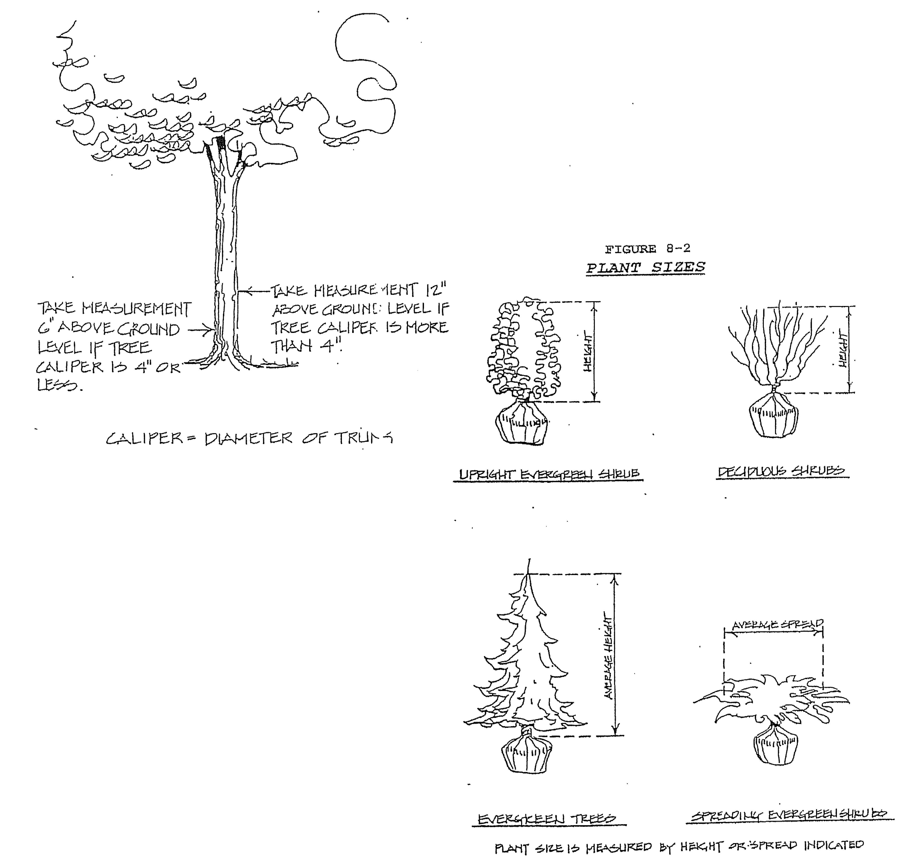
TREE CALIPER MEASUREMEWTS

- Existing plant material which complies with the standards and intent of the Ordinance as determined by the Development Official, may be credited toward meeting the landscape requirements.
- The plant material shall achieve its horizontal and vertical effect within 4 years of initial
installation.

7. Clustering of trees and shrubs within the buffer zone is permitted (See Figure 8-3).
FIGURE 8-3
GREEN BEV2S

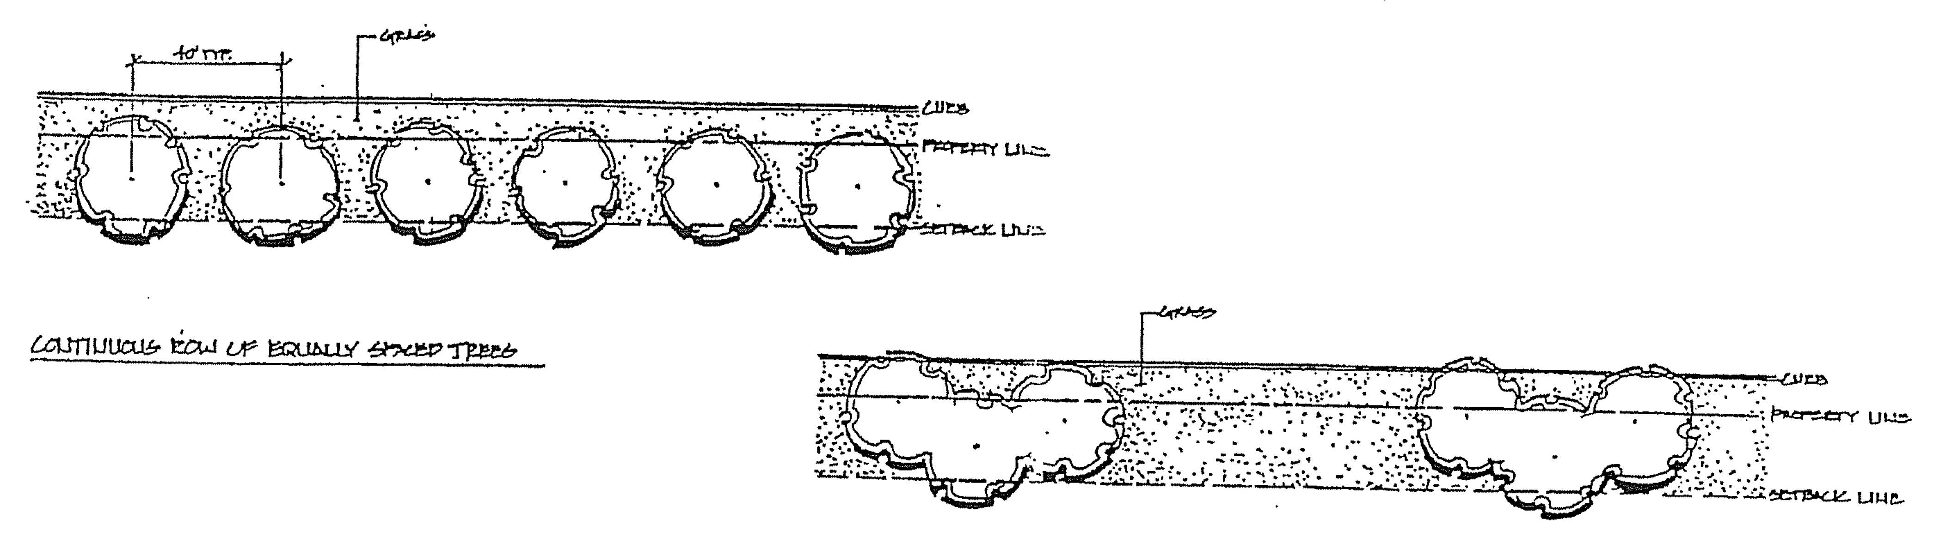
8. LIST OF PREFERRED TREES AND SHRUBS
- Evergreens (minimum of five [5] feet in height)
Fir Red Cedar Spruce
Pine Hemlock Juniper Douglas Fir
- Narrow Evergreen Trees (Minimum of three [3] feet in height)
Column Hinoki Cypress Irish Yew
Chinese Juniper Douglas Arbor Vitae
Swiss Stone Pine Red Cedar
Pyramidal White Pine Columnar Arbor Vitae
- Large Deciduous Trees (Minimum of eight [8] feet in height)
Oaks Hard Maples Beech
Linden Ash Birch
Ginko (male only) Honey Locust
Sycamore Sweet Gum Sycamore
Hackberry Plan tree Hop Hornbean
- Small Deciduous Trees (Ornamental) Four [4] feet in Height)
Flowering Dogwood- Redbud
(Disease resistant) Flowering Cherry, Plum, Pear
Hawthorne (thornless) Russian Olive

Magnolia Flowering Crabs
Mountain Ash Hornbean Rose of Sharon
e. Large Evergreen Shrubs (Six [6] feet in Spread)

Irish Yew
Upright Yew
Pfit2er Juniper Mughc Pine
f. Small Evergreen Shrubs
Brown's Wards
Dwarf Mugho Pine Sevir Yews
Hicks Yew
Spreading Yew Savin Juniper
Dwarf Spreading Juniper Euonvmous Varieties
g. Large Deciduous Shrubs
Honeysuckle Lilac
Border Privet- Sumac
(hedc^{r}e Planting) Buckhorn
Pyralloantha Weigla
Flowering Quince Barberry
Cotoneaster-(peking Sargent Crabapple
and Spreading) Euonvmous Varieties
Viburnum Varities Forsythia Dogwood (Red Osier & Grey) Ninebark
Hazelnut Tall Hedges
- Small Deciduous Shrubs
Dwarf Winged Japanese Quince Fragrant Sumac Potentilla  - Ground Cover | Regal Privet Cotoneaster-(Rockspray, Cranberry)

Periwinkle Baltic Ivy
Euonymous Varieties Hall Honeysuckle Pachysandra
j. Vines
Euonymous Varieties Virginia Creeper
Baltic Ivy Wisteria
2 Trees not permitted
Box Elder Willows
Tree of Heaven Catalpa
PoPoplars Horse Chestnut(nut-
Red Chinese Elm bearing)
Slippery Elm Siberian Elm  Ginko (female only) Honey Locust (with thorns) | American Elm  Soft Maples(red, silver)

C. Installation, Maintenance, and Completion. All landscaping required by this Section shall be planted prior to obtaining a certificate occupancy, or depositing cash, a letter of credit, and/or a certified check placed in escrow in the amount of the cost of landscaping which would be released only after landscaping is completed.
All landscaping and landscape elements shall be planted, and earth moving or grading performed, in a sound, workmanship like manner and according to accepted good -^{p}lanting and grading procedures.
The owner of property required to be landscaped by this Section shall maintain such landscaping in a reasonably healthy condition, free from refuse and debris. All unhealthy and dead material shall be replaced within one year of damage or death or the next appropriate planting period, whichever comes first.
8.6.4 Buffer Zone Requirements:
- A buffer zone shall be required on the subject parcel between zoning districts as indicated in Table 8-1.
- A buffer zone shall be required on the subject parcel even if the adjacent parcel is unimproved land.
- When any developed parcel requiring a buffer zone changes to a more intense land use or a special land use approval and or site plan review is required, the buffer shall comply with the buffer zone matrix (Table 8-1), and buffer zone development standards set forth in this Section.
- If existing conditions are such that a parcel cannot comply with the buffer zone standards, then the Development Official shall determine the character of the buffer based on the following criteria:
- Traffic impacts
- Increased building and parking lot coverage
- Increased outdoor sales, display, or manufacturing area
- Physical characteristics of the site and surrounding area such as topography, vegetation, etc.
- Visual, noise, and air pollution

6. Health, safety, and welfare of the Village
7 Additional dwelling units and resulting density (residential development)
E. If two zoning districts requiring a buffer zone are separated by a thoroughfare, the design of the buffer zone shall be determined by the Development Official based on the criteria contained in Section 8.6.4.
TABLE 8.1
LANDSCA?E BUFFERS MATRIX
ADJACENT ZONE OF ADJOINING PROPERTY
 | A-1 | R-1 | R-2 | RM | P | TC | BC | IR
A-1
R-1
R-2
RM | C | C | C
P | B | B | B | C
TC | B | B | B | B | C
BC | B | B | B | B | B | B
IR | A | A | A | A | A | A | A

NOTE: Read from Subject Zone across to Adjacent Zone
BUFFER ZONES:
A - Buffer Zone Level A 50 feet
B - Buffer Zone Level B 30 feet
C - Buffer Zone Level C 10 feet
(if blank) No Buffer Zone required
F. Required Buffer Zones - The following buffer zone levels are to be utilized for the land' uses listed in the Required Buffer matrix. If a specific land use is not identified within the following classification, the Development Official shall determine the closest appropriate land use classification and appropriate buffer zone to be applied.

TABLE 8.2
REQUIRED BUFFERS MATRIX
CLASSIFICATION OF LAND USES BUFFER ZONE LEVEL
Automobile Parts & Tire Sales | A
Automobile Service Stations | A
Bed & Breakfasts | C
Building Materials, Farm Equipment  and Garden Supplies | A
Churches and Other Religious  Institutions | B
Clinics - Small Animals  - Large Animals | B  A
Commercial Garages | A
Condominiums | C
Convalescent/Nursing Homes | C
Apartments | B
Convenience Retail | B
Drive-in Facility | B
Duplexes | C
Education and Social Institutions | B
Funeral Homes | B
General Retail | B
Home Occupations | C
Medical Services | B
Motels and Hotels | A
Offices | B
Personnel Services | B
Public Buildings | B
Public Recreation Areas or Facilities | B
Public Service Facilities | A
Rapid Copy Centers | B
Restaurants and Taverns | B
Retail Greenhouses | p
Seasonal Farm Market | B
Second Hand Stores | p

Single-Family Dwellings | C
Temporary Dwellings | C
Warehouses and mini-storage | A
8.6.5 Buffer Zone Development Standards
A. Required buffer zones shall comply with the following standards:
1. Buffer Zones Level A (See Figure 8-4)
- Minimum width of 50 feet
- The buffer zone shall contain 1 tree for each linear 20 feet or fraction of buffer zone length. At least one-half of the total number of trees required within the buffer zone shall be canopy trees.
- The buffer zone shall contain a 3 foot high screen comprised of plant material, beams, screen walls or fences, or any combination of these elements.
- If berms are used for all or part of the buffer zone screen, the berm shall contain a minimum of 1 shrub for each 10 linear feet or fraction of be= length. All required plant material shall be placed on the top and exterior side slope of the belle.

FIGURE 0-4
BUFFER ZONE - LEVEL A

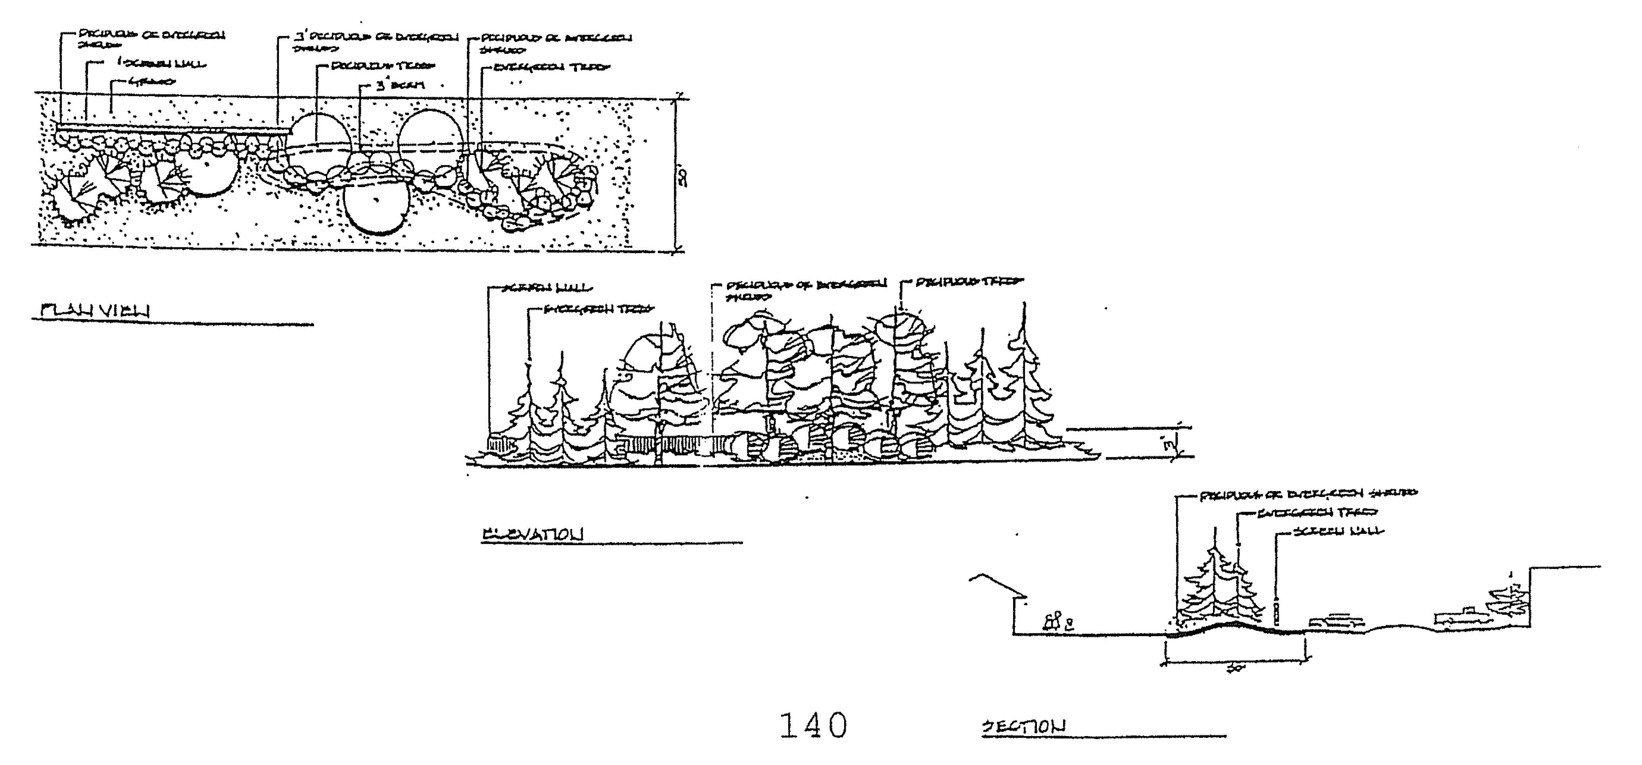

- If a screen wall or fence is used for all or part of the buffer zone screen, a minimum of 1 shrub for each 10 linear feet or fraction of wall or fence shall be placed on the exterior of the wall or fence.
- If plant material is used for all or part of the buffer zone screen, the screen shall consist of a minimum of 4 shrubs for each 20 linear feet or fraction of screen length. The shrubs shall be a minimum of 24 inches high at the time of planting.
^{g.} All areas outside of the planting beds shall be covered with grass or other living ground cover.
h. All applicable standards in Article 8.
2. Buffer Zone Level B (See Figure 8-5)
- Minimum width of 30 feet.
- The buffer zone shall contain 1 tree for each 30 linear feet or fraction of buffer zone length. At least one-half of the total number of trees required with in the buffer zone shall be canopy trees.
- The buffer zone shall contain a 3 foot high screen comprised of plant material, berming screen walls or fences, or any combination of these elements.
- If berming is used for all or part of the buffer zone screen, the berm shall contain a minimum of 1 shrub for each 10 linear feet or fraction of berm length. All required plant material shall be placed on the top and the exterior side slope of the berm.

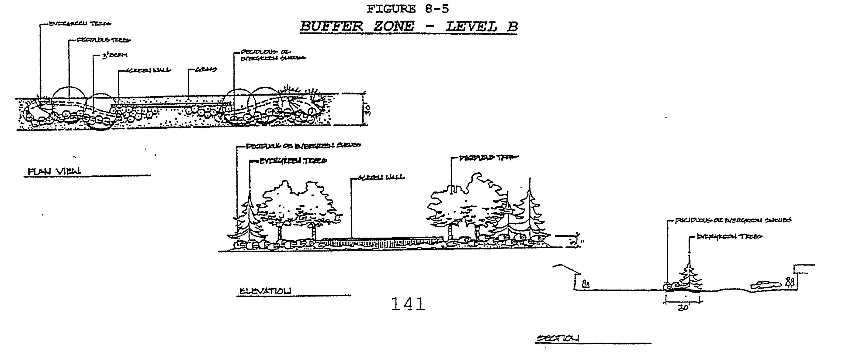
- If a screen wall or fence is used for all or part of the buffer zone screen, a minimum of 1 shrub for each 10 linear feet or fraction of wall or fence shall be placed on the exterior side of the wall or fence.
- If plant material is used for all or part of the required buffer zone screen, the screen shall consist of a minimum of 4 shrubs for each 20 linear feet or fraction of screen length. The shrubs shall be a minimum of 24 inches high at the time of planting.
- All areas outside of the planting beds shall be covered with grass or other living ground cover.
- All applicable standards in this Section.
3. Buffer Zone Level C (See Figure 8-6)
- Minimum width of 10 feet.
- The buffer zone shall contain 1 tree for each 30 linear feet or fraction of buffer zone length. At least one-half of the total number of trees required within the buffer zone shall be canopy trees.
- If berming is used for all or part of the buffer zone screen, the berm shall contain a minimum of 1 shrub for each 10 linear feet or fraction of berm length. All required plant material shall be placed on the top and exterior side slope of the berm. The minimum buffer zone width shall be increased as necessary to accommodate a side slope with a 1 foot rise to 3 foot run ratio.
FIGURE 8-6
BUFFER ZONE - LEVEL C

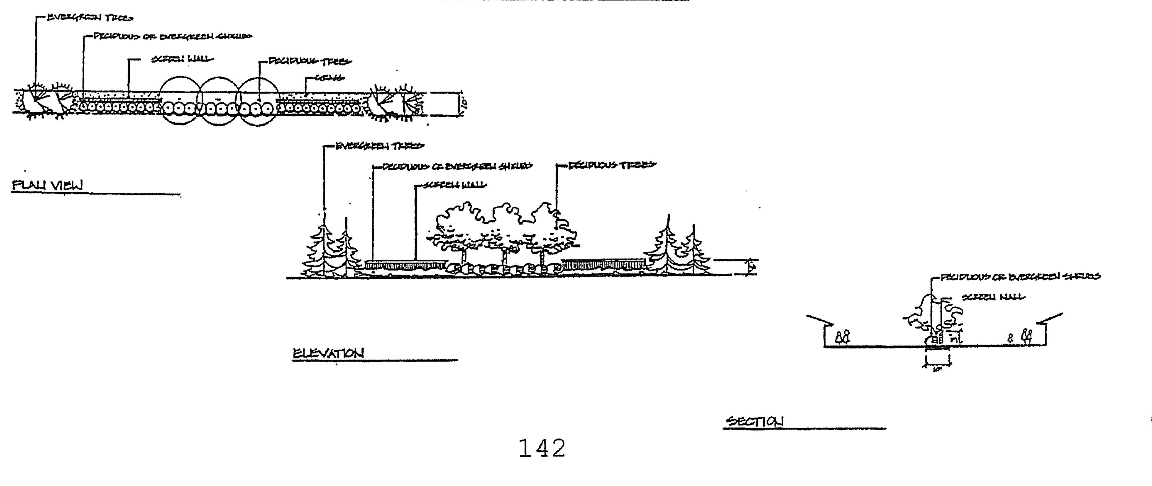
- If a screen wall or fence is used for all or part of the buffer zone screen, a minimum of 1 shrub for each 10 linear feet or fraction of wall or fence shall be placed on the exterior side of the wall or fence.
- If plant material is used for all or part of the required buffer zone screen, the screen shall consist of a minimum of 4 shrubs for each 20 linear feet or fraction of screen length. The shrubs shall be a minimum of 24 inches high at the time of planting.
g All areas outside of the planting beds shall be covered with grass or other living ground cover.
h. All applicable standards in this Article.
8.6.6 Minimum Standards for Berms
A. Berms shall be constructed so as to maintain a side slope not to exceed a 1 foot rise to a 3 foot run ratio. (See figure 8-7a)
FIGURE 8-7a
MAXIMUM SIDE SLOPE FOR BERM
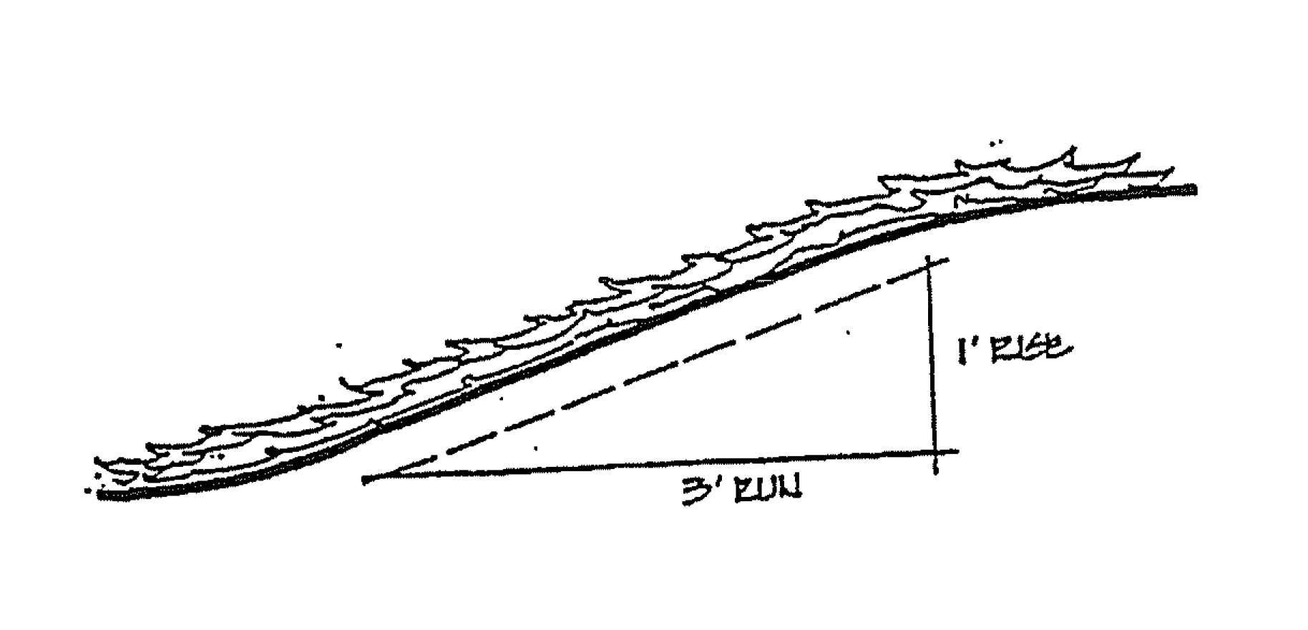
- Berm areas not containing planting beds shall be covered with grass or living ground cover maintained in a healthy growing condition.
- Berms shall be constructed in such a manner so as not alter on-site drainage patterns or on adjacent properties or obstruct vision for reasons of safety, ingress or egress.

D. If a berm is constructed with a retaining wall or by terracing, the earthen slope shall face the exterior or the site (See Figure 8-7b).
FIGURE 8-7b
BERM WITH RETAINING WALLS
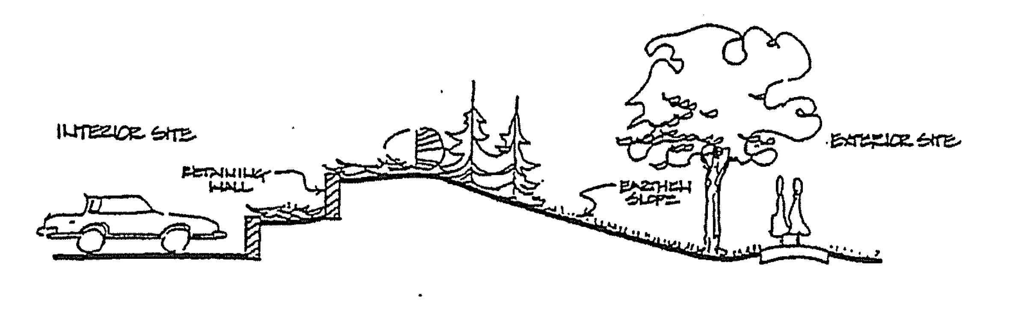
E. Berms shall not encroach into the clear vision areas at intersections or drive ways and property line intersections.
9.6.7 Minimum Standards for Screen Walls and Fences
- All screen walls and fences shall be constructed with new, durable, weather resistant and easily maintainable materials. Chain link and barbed wire fences are not permitted.
- The wall or fence may be constructed with openings that do not exceed 20% of the wall surface. The openings shall not reduce the intended obscuring effect of the wall.
- Screen walls or fences shall not be constructed so as to alter drainage on site or adjacent properties or obstruct vision for reasons of safety, ingress, or egress.
- All fences, walls, or structural screens shall be erected no higher than eight feet (8), nor higher than 4 feet within the required setback.
- No wall, fence or structural screen shall be constructed or erected in the Clear Vision Area for reason of safety, ingress, or egress.
- Detention/retention areas shall be permitted within the buffer zones provided they do not hamper the screening intent of the buffer or jeopardize the survival of the plant materials.
- Solid waste dumpsters and recycling containers may be installed in the buffer zones provided they are shielded by a continuous opaque screen at least 6 feet high. The screen may be comprised of berming, plant material, screen walls or fences or any combination of these elements. All fences,

walls, structural screens and gates refuse receptacle enclosures shall meet the requirements of Article 5 of this Ordinance.
9.6.8 Off-Street Parking Landscape Development Standards
A. Required parking lot landscape areas shall comply with the following standards:
1. Off-street parking areas containing 6 or more parking spaces shall be provided with landscaping in accordance with the following:
- 6 through 50 spaces: 1 canopy tree and 50 sq. ft. of landscaped area per 6 spaces.
- 51 through 150 spaces: 1 canopy tree and 100 sq. ft. of landscaped area per 8 spaces.
2. All landscaped areas shall be covered by grass, shredded bark, mulch, stone, or a living ground cover.
3. All landscaped areas shall contain at least 1 canopy tree. The tree shall be located so as not to be damaged by any surrounding vehicle (See Figure 8).
FIGURE 8-8
TYPICAL OFF-STREET PARKING
LANDSCAPED AREA

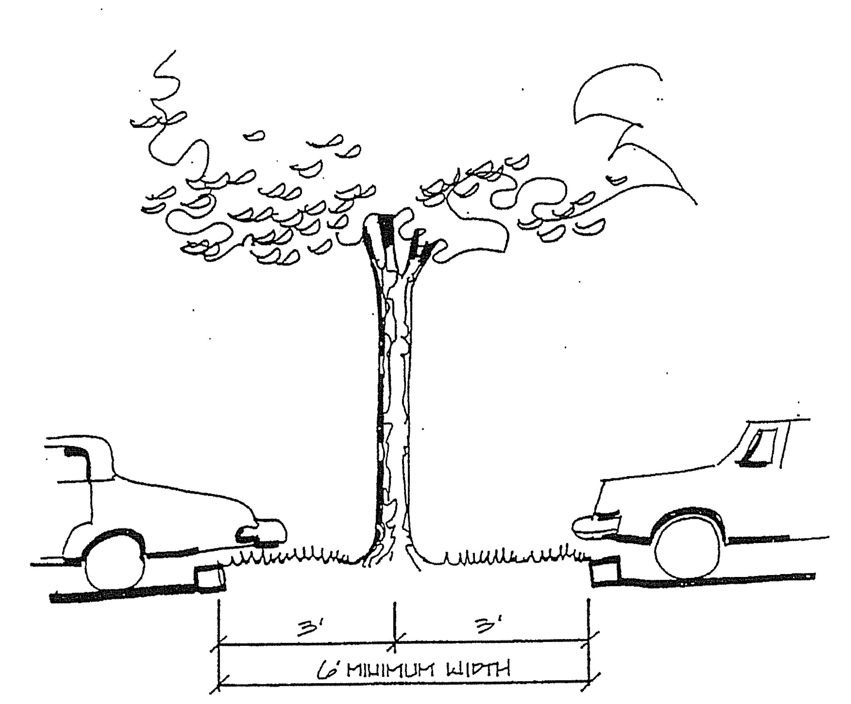
4. The Development Official shall approve the location of required off-street parking landscaping using the following criteria:
- Landscaping shall be installed such that, when mature, it does not obscure traffic signs, fire hydrants, lighting, drainage patterns on site or adjacent properties, or obstruct vision for reason of safety, ingress, or egress.
- Trees shall be installed in such a manner that parked motor vehicles are shaded whenever possible.
- Landscaping shall be dispersed throughout the parking lot in order to breakup large expanses of impervious surfaces (See Figure 9).
FIGURE 8-9
GREENBELT & OFF-STREET PARKING
LANDSCAPE STANDARDS
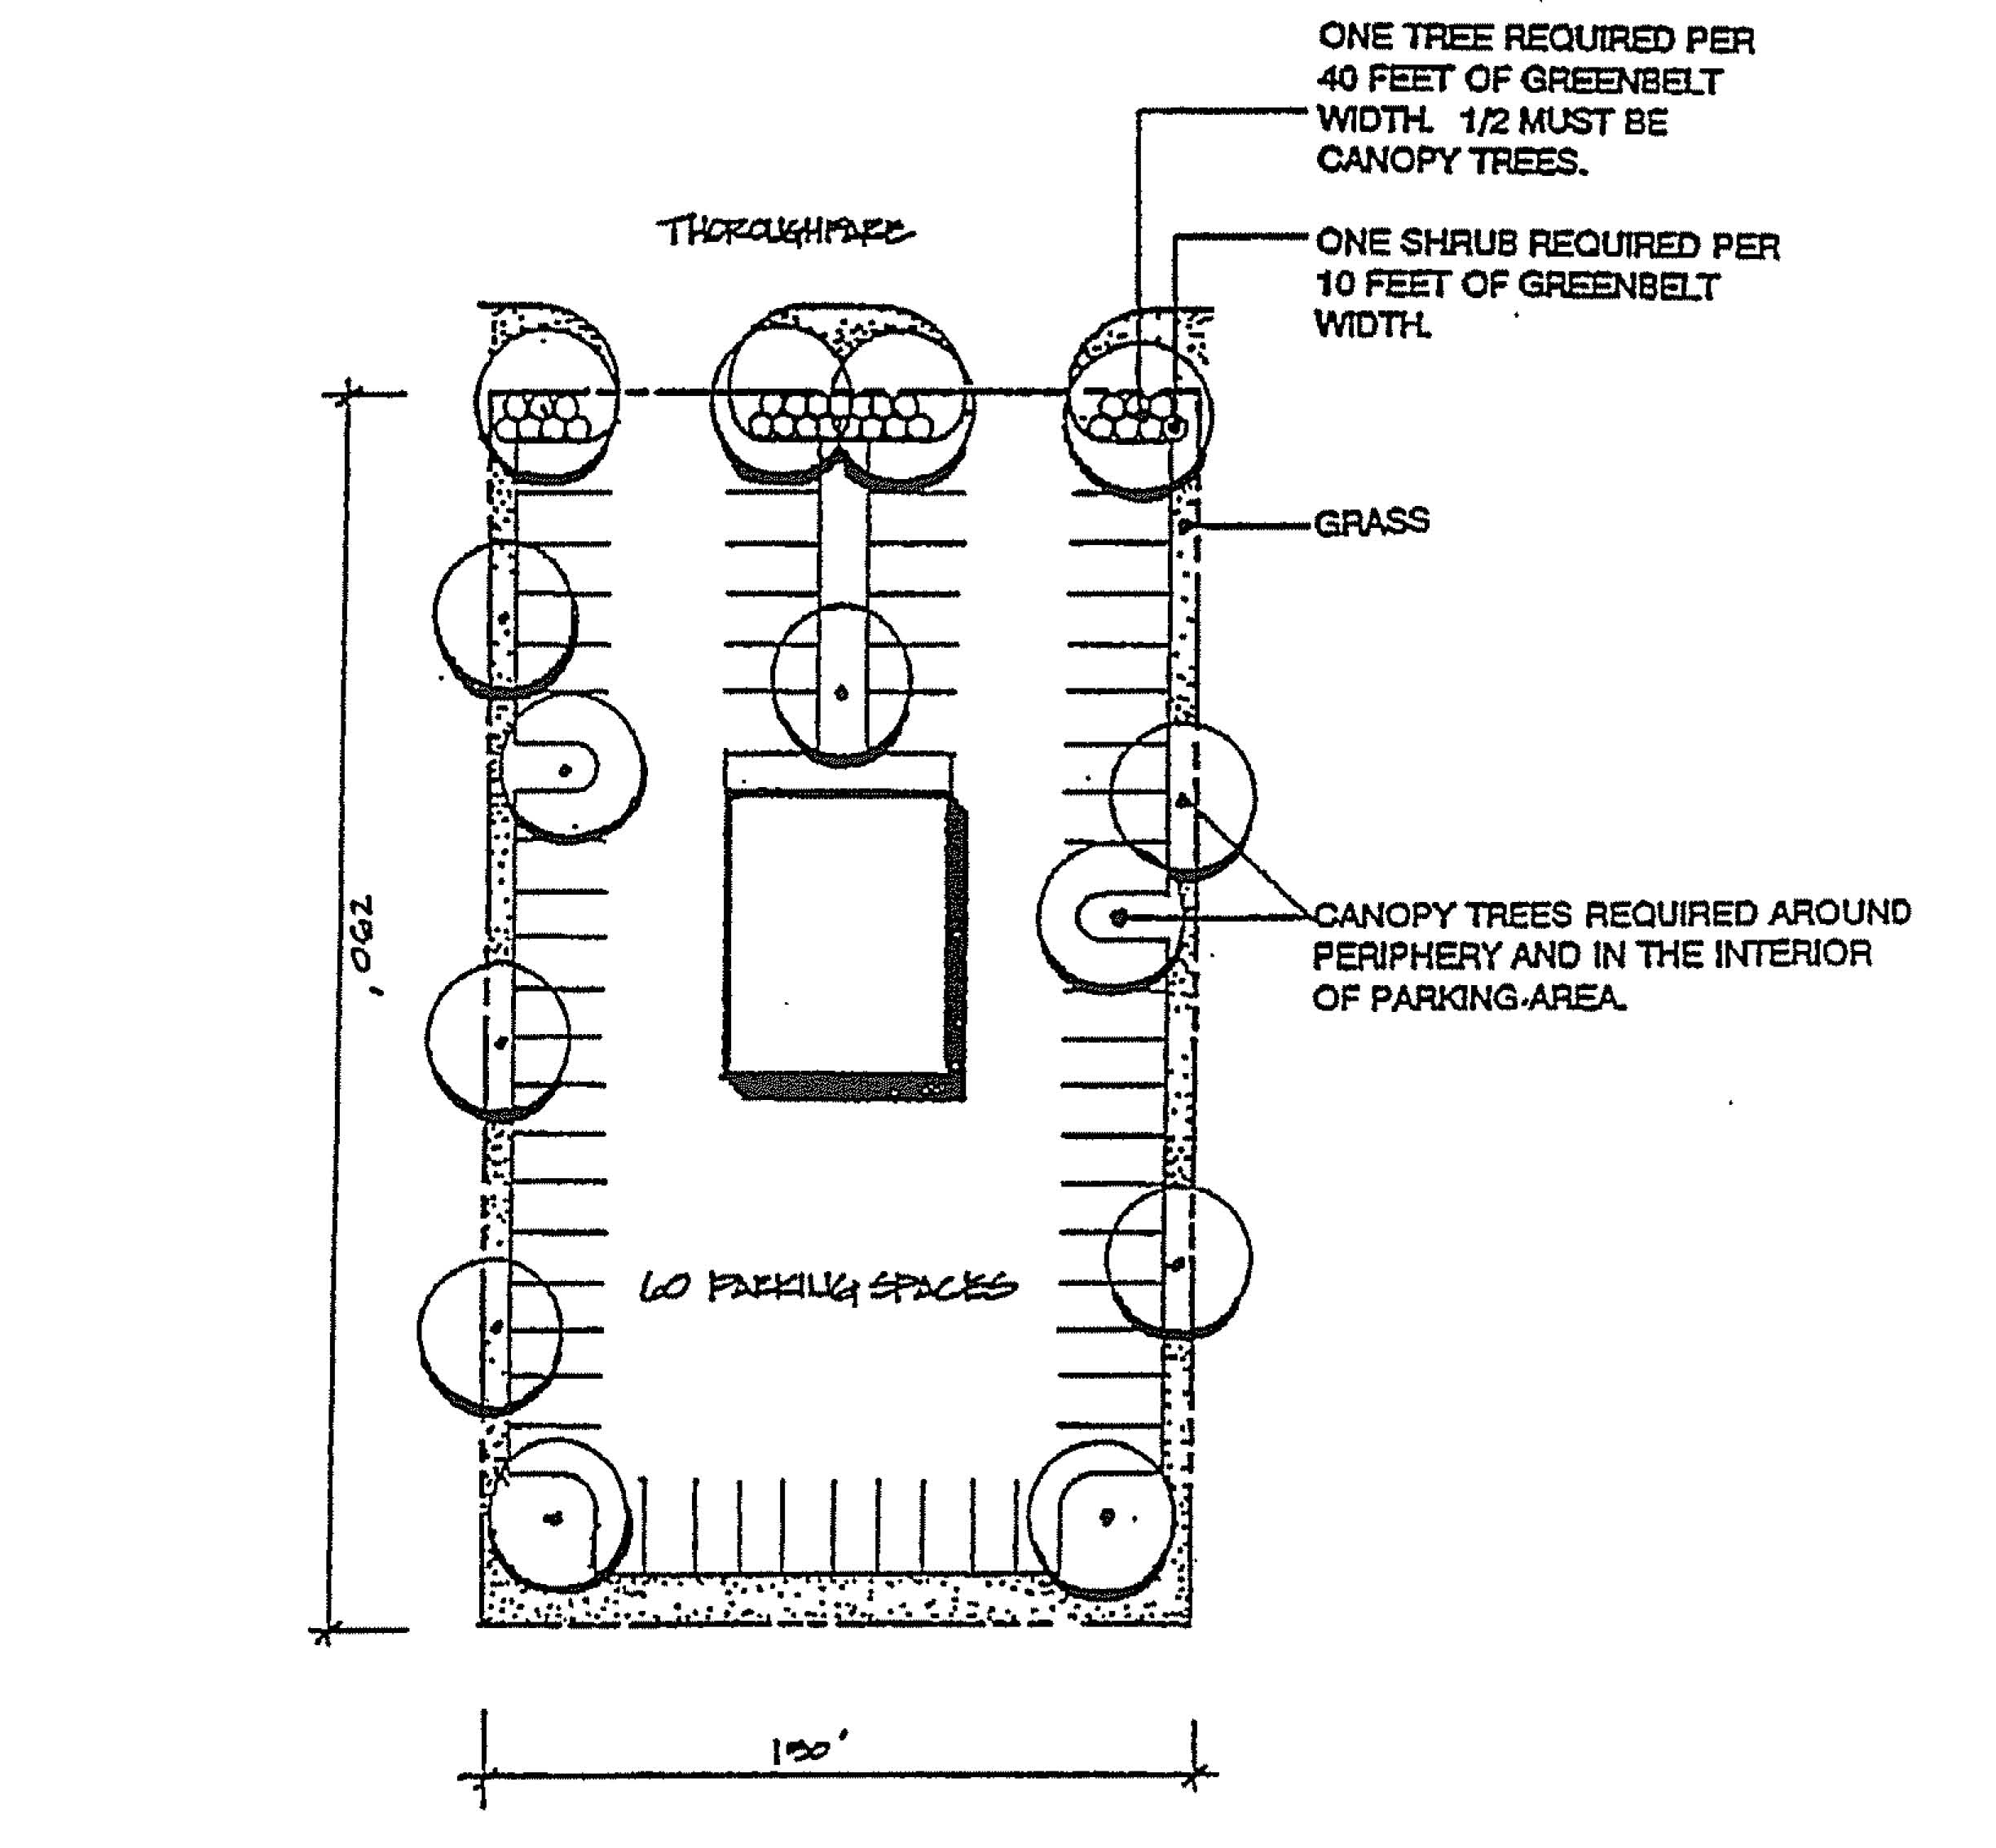

- At least one-half of the required trees shall be installed in the interior of the parking area. The interior shall be considered as any point 10 feet from the outside boundary of the parking area.
5. All landscaped areas shall be protected by a raised standard or rolled concrete curb.

6. All overflow parking areas shall be grass covered with consideration given for use of a grass-crete type of surface.
B. In no case shall any buffer zone be considered as part of the off-street parking landscaped area.
Section 8.7 PLANNING COMMISSION REVIEW
Any applicant for Site Plan Review aggrieved by the decision of the Development Official may have the decision reviewed by the Planning Commission at the next regular meeting or a special meeting called for that purpose. The Planning Commission shall review the matter based on the standards contained in this Ordinance and shall give written justification for any reversal of the decision of the Official.
Section 8.8 APPEALS
The decision of the Planning Commission is final when it is alleged that the decision is inconsistent with the provisions of this Ordinance or that there was an error of fact involved in the decision. In such cases, the applicant may file an appeal with the Village Zoning Board of Appeals. The Zoning Board of Appeals shall review the matter and take action to sustain, reverse, or remand the decision of the Planning Commission.

ARTICLE 9 AMENDMENTS
Sec. 9.1 INTENT AND PURPOSE
The purpose of this Article is to provide for the Amendment of this Ordinance when provisions become obsolete, when identifiable conditions change in relation to the provisions of Ordinance, when errors in this Ordinance are discovered, when changes are made in the Village's Comprehensive Development Plan, or when the Village Council has determined a valid public interest exists.
Sec. 9.2 AMENDMENT INITIATION
An Amendment to this Ordinance may be initiated by resolution of the Village Council, by resolution of the Planning Commission, or by petition of one or more persons having interest in property located within the jurisdiction of this Ordinance.
Sec 9.3 FILING FEE
The Village Council shall establish by resolution a fee to be paid in full at the time of receipt of any application to amend this Ordinance. Said fee shall be collected by the Village Clerk and no part shall be refundable to the applicant. No fee shall be charged when the applicant is a governmental body.
Sec 9.4 AMENDMENT PROCEDURES
9.4.1 The petitioner shall cause to be delivered to the Planning Commission, not less than forty-five (45) days before any regular meeting of the Planning Commission
9.4.2 The Planning Commission shall adopt an application form to be completed and filed with the Village Clerk by the person or persons petitioning for the change. An application shall be submitted for each parcel of land which is not contiguous to any adjacent parcel of land being proposed for the same amendment.
9.4.3 The Development Official shall review the application for completeness. Any application not properly filed or complete shall be returned to the applicant. Complete applications shall be transmitted to the Planning Commission.
9.4.4 The Development Official shall notify the following agencies within five (5) days of receipt of a proper application from a petitioner or an adoption of a resolution from the Village Council or Planning Commission to amend this Ordinance, requesting their comments and recommendations:
- Fire Chief
- Police Chief
- Superintendent of Lakewood Public Schools
- Ionia County Drain Commissioner
- Mid-Michigan District Health Department
- Other governmental units having jurisdiction within one-quarter (1/4) mile of the property affected by the proposed amendment.

- Public Utilities and Ionia County Road Commission
- Other Village or County Officials and agencies deemed as appropriate by the Planning Commission.
    - COMMENTS AND RECOMMENDATIONS. The above mentioned review agencies may submit comments and recommendations on the proposed amendment within thirty-five (35) calendar days of receipt of notice. If no written correspondence is received by the Development Official within said thirty-five (35) calendar days, the Planning Commission shall presume that the review agency has no objections to the proposed rezoning.

9.5 PUBLIC HEARING NOTIFICATION

All applications for development approval for which a public hearing is required by this Ordinance shall comply with the Michigan Zoning Enabling Act, PA 110 of 2006 as amended and the following provisions of this Section with regard to public notification.

- Responsibility for Public Notice: The Clerk or their agent shall be responsible for preparing the content of the notice, having it published in a newspaper of general circulation in the Village of Clarksville and mailed or delivered as provided in this Section.
- Notice Requirements: Notice of a public hearing for a rezoning, special land use, text amendment, planned unit development; variance, appeal, or ordinance interpretation shall be given not less than 15 days before the date of the public hearing. The notice shall be given as follows.
- Newspaper Notice: The notice shall be published in a newspaper that circulates in the Village of Clarksville.

- Mail and Personal Notice: Except for an Ordinance text amendment and an Ordinance interpretation which does not apply to a specific property, notice shall be sent by first class mail or personal delivery to:

  - The owner of property for which approval is being considered, and the applicant, if different than the owner(s) of the property.

  - Except for rezoning requests that are proposed for 11 or more adjacent parcels, the notice shall be sent by first class mail or personal delivery to all persons to whom property is assessed within 300 feet of the boundary of the property subject to the request and to the occupants of all structures within 300 feet of the property, regardless of whether the property or occupant is located within the boundaries of the Village of Clarksville.

If the name of the occupant is not known, the term “occupant” may be used in making notification. In the case of a single structure containing more than four dwelling units or other distinct spatial areas owned or leased by different individuals, partnerships, businesses or organizations, notice may be given to the manager or owner of the structure who shall be requested to post the notice at the primary entrance to the structure. In structures containing four or fewer dwelling units, only one occupant of each unit must be given notice for a public hearing.

c. All neighborhood organizations, public utility companies, airports, railroads, and other persons, which have requested to receive notice.

3. Record of Mailing: The Clerk shall prepare an affidavit of mailing which shall include those to whom the notice was mailed and the date of mailing

4. Content of Notice: The public notice shall:

a. Describe the nature of the request: Identify whether the request is for a rezoning, text amendment, special land use, planned unit development, variance, appeal, ordinance interpretation or other purpose.

b. Indicate the property that is the subject of the request. The notice shall include a listing of all existing street addresses within the subject property. Street addresses do not need to be created and listed if no such addresses currently exist within the property. If there are no street addresses, other means of identification may be used, such as a tax parcel identification number, identifying the nearest cross street, or including a map showing the location of the property. No street addresses must be listed when 11 or more adjacent properties are proposed for rezoning, or when the request is for an ordinance interpretation not involving a specific property.

c. Indicate the date, time and place of the public hearing(s).

d. Include a statement describing when and where written comments will be received concerning the request and a statement that the public may appear at the public hearing in person or by counsel.

- Registration to Receive Notice by Mail: Any neighborhood organization, public utility, company, railroad or any other person may register with the Clerk to receive written notice of all applicants for development.
Sec. 9.6 PLANNING COMMISSION RECOMMENDATIONS
9.6.1 SCOPE OF EXAMINATION. In reviewing any application for an amendment to this Ordinance, the Planning Commission shall identify and evaluate all factors relevant to the application, and shall report its finding in full along with its recommendations for disposition of the application, to the Village Council within a period of sixty (60) days. The matters to be considered by the Planning Commission shall include, but shall not be limited to the following findings of fact:
- What, if any, identifiable conditions related to the proposed amendment have changed which justify the proposed amendment?
- What, if any, error in judgment, procedure or administration was made in the original Ordinance which justifies the petitioners change in zoning?
- What are the precedents and the possible effects of such precedent which might result from the approval or denial of the petition?
- What is the impact of the amendment on the ability of the

Village and other governmental agencies to provide adequate public services and facilities, and/or programs that might reasonably be required in the future if the petition is approved?
E. Does the proposed amendment adversely affect environmental conditions, or the value of the surrounding property?
F. Are there any significant negative environmental impacts which would reasonably occur if the petitioned zoning change and resulting allowed structures were built; such as,
- Surface water drainage problems.
- Waste water disposal problems.
- Adverse effect on surface or subsurface water quality.
- The loss of valuable Natural Resources (such as forest, wetlands, historic sites, wildlife, mineral deposits or valuable agricultural land).
G. Does the proposed amendment generally comply with the adopted policies of the Clarksville Comprehensive Development Plan?
H. The ability of the property in question to be put to a reasonable economic use in the zoning district in which it is presently located.
9.6.2 All findings of fact shall be made a part of the public records of the meetings of the Planning Commission. The Planning Commission shall transmit its findings of fact, a summary received at the public hearing and its recommended action to the Village Council.
Sec. 9.7 CONSIDERATION BY THE VILLAGE COUNCIL
For each proposed Zoning Ordinance amendment or supplement a recommendation shall be made by the Planning Commission and a recommendation made to the Village Council in accordance with the requirements of Act 110 of the Public Acts of 2006 as amended. After receiving such recommendation the Village Council shall consider the proposed amendment. The Village Council may hold a public hearing if the Council considers it necessary. Notice of the hearing shall be made in accordance with the requirements of Section 9.5 herein.

Upon request of any property owner by certified mail to Clerk the Council shall hold a public hearing. The Council may refer any proposed amendments back to the Planning Commission for consideration and comment within the time period specified by the Council. Following this the Council shall vote on the adoption of the Zoning Ordinance request with or without amendments as proposed by the Planning Commission. Approval of a Zoning Ordinance amendment shall require an affirmative vote by a majority of the Village Council.

Sec. 9.8 PROTESTED AMENDMENT
Upon presentation of a protest petition meeting the requirements of this section, an amendment to the zoning ordinance which is the object of the petition shall be passed only by a 2/3 vote of the Village Council. The

protest petition shall be presented to the Village Council before final legislative action on the amendment, and shall be signed by one (1) of the following:
9.8.1 The owners of at least twenty percent (20%) of the area of land included in the proposed change.
9.8.2 The owners of at least twenty percent (20%) of the area of land
included within an area extending outward one hundred (100') feet
from any point on the boundary of the land included in the
proposed change.
9.8.3 For purposes of this section, publicly owned land shall be excluded in calculating the twenty percent (20%) land area requirement.
Sec. 9.9 NOTICE OF ADOPTION
Following adoption of an amendment by the Village Council, one (1) notice of adoption shall be published in a newspaper of general circulation in the Village within fifteen (15) days after the adoption. The notice shall include the following information:
9.9.1 The complete text of the amendment, which shall include the section or sections amended stated in full or a summary of the adopted amendments.
9.9.2 The effective date of the amendment.
9.9.3 The place and time where a copy of the ordinance may be purchased or inspected.
Sec. 9.10 EFFECTIVE DATE

An amendment to the Zoning Ordinance shall take effect as prescribed by the Village Charter after publication of the amendment or a summary of its provisions in a newspaper of general circulation.

ARTICLE 10: OFF—STREET PARKING AND LOADING Section 10.1 INTENT OF PARKING PROVISIONS
It is the intent of this Ordinance that parking spaces shall be provided and adequately maintained by each property owner in every zoning district for the off-street storage of motor vehicles for the use of occupants, employees and patrons of each building and premise constructed, altered or enlarged under the provisions of this Ordinance. All vehicles shall be stored on the premises occupied by the principal building, but may be stored on premises located outside the premises within specifically limited walking distances as specified in this Section of the Ordinance.
10.1.1 Definition of Floor Area: The term "floor area" as applied to offices, merchandising or service types of uses, shall mean the gross floor area used or intended to be used for services to the public, including those areas occupied for fixtures and equipment used for display or sale of merchandise, but excluding floor areas which are used exclusively for storage, housing of mechanical equipment integral with the building, maintenance facilities, or those areas where customers, patients, clients, salesmen, and the general public are denied access. "Floor area" shall be measured from the exterior faces of exterior walls.
10.1.2 Fractional Space: When units of measurement determining
the number of required parking spaces result in a fractional space, any fraction to and including one-half (1/2) shall be disregarded and fractions over one-half (1/2) shall require one (1) parking space.
10.1.3 Requirements for a Use Not Mentioned: In the case of a use not specifically mentioned, the requirements of off-street parking for a use which is mentioned and which is most similar to the use not listed shall apply.
10.1.4 Use of Parking Areas: No commercial repair work, servicing or selling of any kind shall be conducted in any parking area. Parking space shall be used only for the parking of vehicles used to service the establishment to which it is accessory and by its patrons.
A. No sign shall be erected in parking areas except that no more than one directional sign at each point of ingress or egress may be erected which may also bear the name of the enterprise the lot is intended to serve. Such signs shall not exceed twenty (20) square feet in area and shall not project beyond the property line of the premises.
10.1.5 Building Additions or Other Changes in Floor Area: Whenever a use requiring off-street parking is increased in floor area, or when interior building modifications result in an increase in capacity for any premise use, additional parking shall be provided and maintained in the proper ratio to the use change increased floor area or capacity.
10.1.6 Joint Use of Parking Areas: The joint use of parking facilities

by two or more uses may be granted by the Board of Appeals whenever such use is practical and satisfactory to each of the uses intended to be served, and when all requirements for location, design, and construction are met.
- Computing Capacities: In computing capacities of any joint use, the total space requirement is the sum of the individual requirements that will occur at the same time. If space requirements for individual uses occur at distinctly different times, the total of such off-street parking facilities required for joint or collective use may be reduced below the sum total of the individual space requirements.
- Record of Agreement: A copy of an agreement between joint users shall be filed with the application for a building permit and recorded with the Register of Deeds of Clinton County. The agreement shall include a guarantee for continued use of the parking facility by each party.
10.1.7 PARKING
LAND USE | PARKING SPACES PER DESIGNATED UNIT(S)
 | /Room/  Unit | /Employee | /Seat | /100  Sg. Ft. | /Bed/  Bedroom | Other
One and Two-  Family Dwellings | 2
Senior Apartment | 1 | 1 |  |  |  | 5 visit
Multiple | 2
Boarding and  Lodging Houses |  |  |  |  | 1.5
Motels |  |  |  |  | 1 | +3 add 4
Convalescent Home |  | .25 |  |  | .25
Hospitals |  | 1 |  |  | .33
Clinics |  | 3
Auditoriums,  Churches,  Stadiums, etc. |  |  | .33
Elementary and  Middle Schools |  | 1
High Schools and  Colleges |  | 1 |  |  |  | .25 per  student

LAND USE | PARKING SPACES PER DESIGNATED UNIT(S)
Libraries,  Museums, Post  Offices |  | .33 |  | 1
Golf Course,  Tennis Clubs, etc. |  | 1 |  |  |  | 4/Hole
Dance Halls, Pool  Halls, Video  Arcades, etc. |  | 1 |  | 1
Bowling Alley |  |  |  |  |  | 5/Alley
Professional  Offices and Banks |  | 1 |  | 0.5
General Offices |  | 0.5 |  | 0.5
General Retail  Store |  |  |  | 0.5
Barber Shop and  Hair Salon |  |  |  |  |  | 2/Chair
Supermarket, Food  Store |  |  |  | 2
Automobile and  Gasoline Service  Station |  | 1 |  |  |  | 3/Stall
Drive-In  Restaurant |  |  |  | 2.5
Funeral Homes and  Mortuaries |  |  |  | 4
Warehouses and  Wholesale Stores |  |  |  | 0.2
Industrial.  Establishments |  | 0.5 |  | 0.5

10.1.8 Location of Parking Areas: All off-street parking areas shall be located on the same lot, or on the adjacent premises in the same district as the use they are intended to serve, with the exception of the following:
- Uses in BC District: Parking on the premises or within five hundred (500) feet.
- Uses in DI District: Parking on the premises or within eight hundred (800) feet.

C. Public and Quasi-Public Buildings, Places of Assembly, Private Clubs, Associations and Institutions: Parking on the premises or within five hundred (500) feet.
10.1.9 Parking Lot Plan Review: Whenever four (4) or more vehicle parking spaces are required for a given use, plans and specifications for the construction or alteration of an off-street parking area shall be submitted to the Zoning Administrator before a building permit can be issued. Such plans and specifications shall indicate the location, basis of capacity calculation, size, site design, surfacing, marking, lighting, drainage, curb cuts, entrances, exits, landscaping, and any other detailed feature essential to the complete design and construction of the parking area.
10.1.10 Site Development Standards: All off-street parking areas shall be designed, constructed and maintained in accordance with the following standards and requirements (See Figures 10-1, 10-2 and 10-3).
- Parking in the required front yard is prohibited in any residential district within the Village, particularly the A1, R-1, R-2 and MR Districts. Front yard parking may be considered in non-residential districts, only the BC and DI Districts, with appropriate approval under Site Plan Review, Article 8 of this Ordinance. Front yard parking is prohibited within the TC and P Districts.
- All parking shall be located behind the front building line an any sites/parcels
- Parking areas including driveways shall be hard surfaced and properly drained.
- A minimum area of two hundred (200) square feet or ten (10) feet by twenty (20) feet shall be provided for each vehicle parking space; each space shall be definitely designated and reserved for parking purposes exclusive of space requirements for adequate ingress and egress.
- Parking areas shall be so designed and marked as to provide for orderly and safe movement and storage of vehicles.
- Adequate ingress and egress to the parking area by means of clearly limited and defined drives shall be provided.
- Except for parking space provided for single-family and two-family residential lots, drives for ingress and egress to the parking area shall be not less than twenty (20) feet wide and so located as to secure the most appropriate development of the individual property.
- Each entrance to and exit from an off-street parking area shall be at least twenty-five (25) feet from any adjacent lot within a residential district.

G. Each parking space, within an off-street parking area, shall be provided with adequate access by means of maneuvering lanes. Backing directly onto a street shall be prohibited. The width of required maneuvering lanes may vary depending upon the proposed parking pattern, as follows:
- For right angle parking patterns seventy-five (75) to ninety (90) degrees, the maneuvering lane width shall be a minimum of twenty (20) feet.
- For parking patterns fifty-four (54) to seventy-four (74) degrees, the maneuvering lane width shall be a minimum of fifteen (15) feet.
- For parking patterns thirty (30) to fifty-three (53) degrees, the maneuvering lane width shall be a minimum of twelve (12) feet.
- All maneuvering lane widths shall permit one-way traffic movement, except for the ninety (90) pattern which may provide for two-way traffic movement.
FIGURE 10-1
STALL AND AISLE STANDARDS
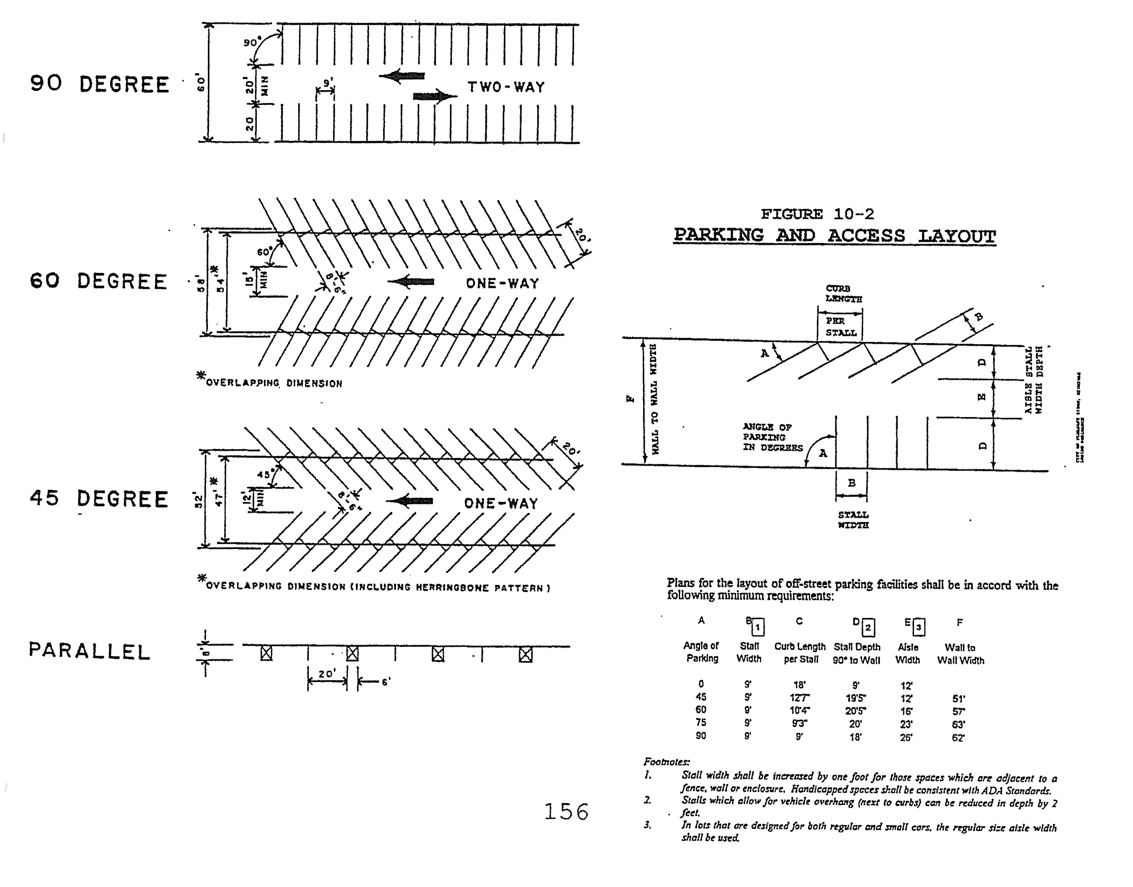

FIGURE 10-3
PARKING SPACE
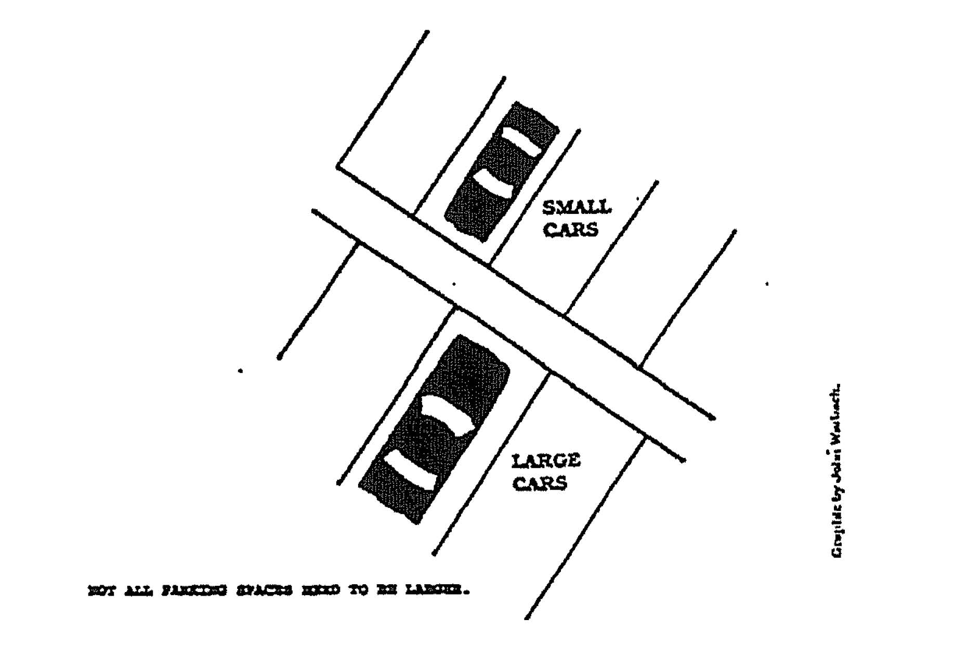
- Parking areas with a capacity of four (4) or more vehicles shall be surfaced with a material that shall provide a durable smooth and dustless surface and shall be graded and provided with adequate drainage.
- Except for single-family and two-family residential lots, adequate lighting shall be provided throughout the hours when the parking area is in operation. All lighting shall be so arranged as to reflect light away from any residential property adjacent to the parking area and any adjacent road or street.
- Where a parking area or drive with a capacity of four (4) or more vehicles adjoins a residential district, a landscaped buffer strip at least ten (10) feet wide shall be provided between the parking area and the adjoining property, or a fence or wall not less than four (4) feet in height shall be erected.
10.1.11 Reduction, Modification, Waiver: The Board of Appeals may authorize a reduction, modification, or waiver of any of the off-street parking or loading regulations provided in this Article when it can be demonstrated that circumstances of extreme practical difficulty exist that would result in hardship to the applicant. Hardship shall not be deemed economic only, but shall be evaluated also in terms of the use of a particular parcel of land. A hardship that is a result of any action of the applicant shall not be considered by the Board of Appeals. In no case shall the off-street parking or loading standards be reduced by more than twenty-five (25%) percent, provided there is compliance with the provisions as follows:
Section 10.2 LOADING AND UNLOADING SPACE REQUIREMENTS
10.2.1 Intent and Purpose: In order to prevent undue interference with

public use of streets and alleys, every manufacturing, storage, warehouse, department store, wholesale store, retail store, hotel, hospital, laundry, dairy, mortuary, and other uses similarly and customarily receiving or distributing goods by motor vehicle shall provide space on the premises for that number of vehicles that will be at the premises at the same time on an average day of full use.
10.2.2 Additional Parking Space: Loading space required under this
Section shall be provided as area additional to off-street parking space as required under Section 10.1.7 and shall not be considered as supplying off-street parking space.
10.2.3 Space Requirements: There shall be provided adequate space for standing, loading, and unloading services not less than twelve (12) feet in width, twenty-five (25) feet in length, and fourteen (14) feet in height, open or enclosed, for uses listed in the following table, or for similar uses similarly involving the receipt of distribution by vehicles of materials or merchandise.
REQUIRED USE FLOOR AREA (Square Feet) SPACE
Commercial uses, such as First 2,000 None
retail stores, personal Next 20,000 or fraction
services, amusement, auto- thereof One Space
motive service. Each additional 20,000 or
fraction thereof One Space
Hotels, Offices First 2,000 None
Next 50,000 or fraction thereof One Space Each additional 100,000 or fraction
thereof One Space
Wholesale and storage, First 20,000 One Space
including building and Each additional 20,000 or fraction
contractor's yards thereof One Space
Manufacturing uses First 20,000 or fraction thereof One Space Each additional 20,000 or fraction
thereof One Space
Funeral Homes and First 5,000 or fraction thereof One Space
Mortuaries Each additional 10,000 or fraction
thereof One Space
Hospitals First 10,000 None'
Next 100,000 or fraction thereof One Space Each additional 200,000 or fraction
thereof One Spac
REQUIRED USE FLOOR AREA (Square Feet) SPACE
Schools, Churches, Clubs, For each building One Space Public Assembly Buildings
For similar uses not For each building 5,000 or over One Space listed
10.2.4 Access: Access to a truck standing, loading, and unloading space shall be provided directly from a public street or alley and such space shall be so arranged to provide sufficient off-street maneuvering space as well as adequate ingress and egress to and from a street or alley.
10.2.5 Site Requirements: Off-street loading spaces and access drives shall be paved, drained, lighted, and shall have appropriate bumper or wheel guards where needed. Any light used for illumination shall be so arranged as to reflect the light away from adjoining premises and streets. Where any off-street loading space adjoins or abuts a lot or premises used for residential, educational, recreational, or religious purposes, or abuts a residential district, there shall be provided a masonry wall or solid fence not less than four (4) feet in height between the off-street loading space and said residential, educational, recreational, or religious premises or residential zone.
Section 10.3 ACCESS DRIVEWAY LOCATION STANDARDS
Curb cuts and driveways for access to commercial property shall be spaced from street intersections and adjacent property lines a specified distance for privacy and safety considerations in accordance with the standards described in Figure 10-4.
FIGURE 10-4
DRIVEWAY ACCESS FOR COMMERCIAL PROPERTIES LOCATED ON CORNERS

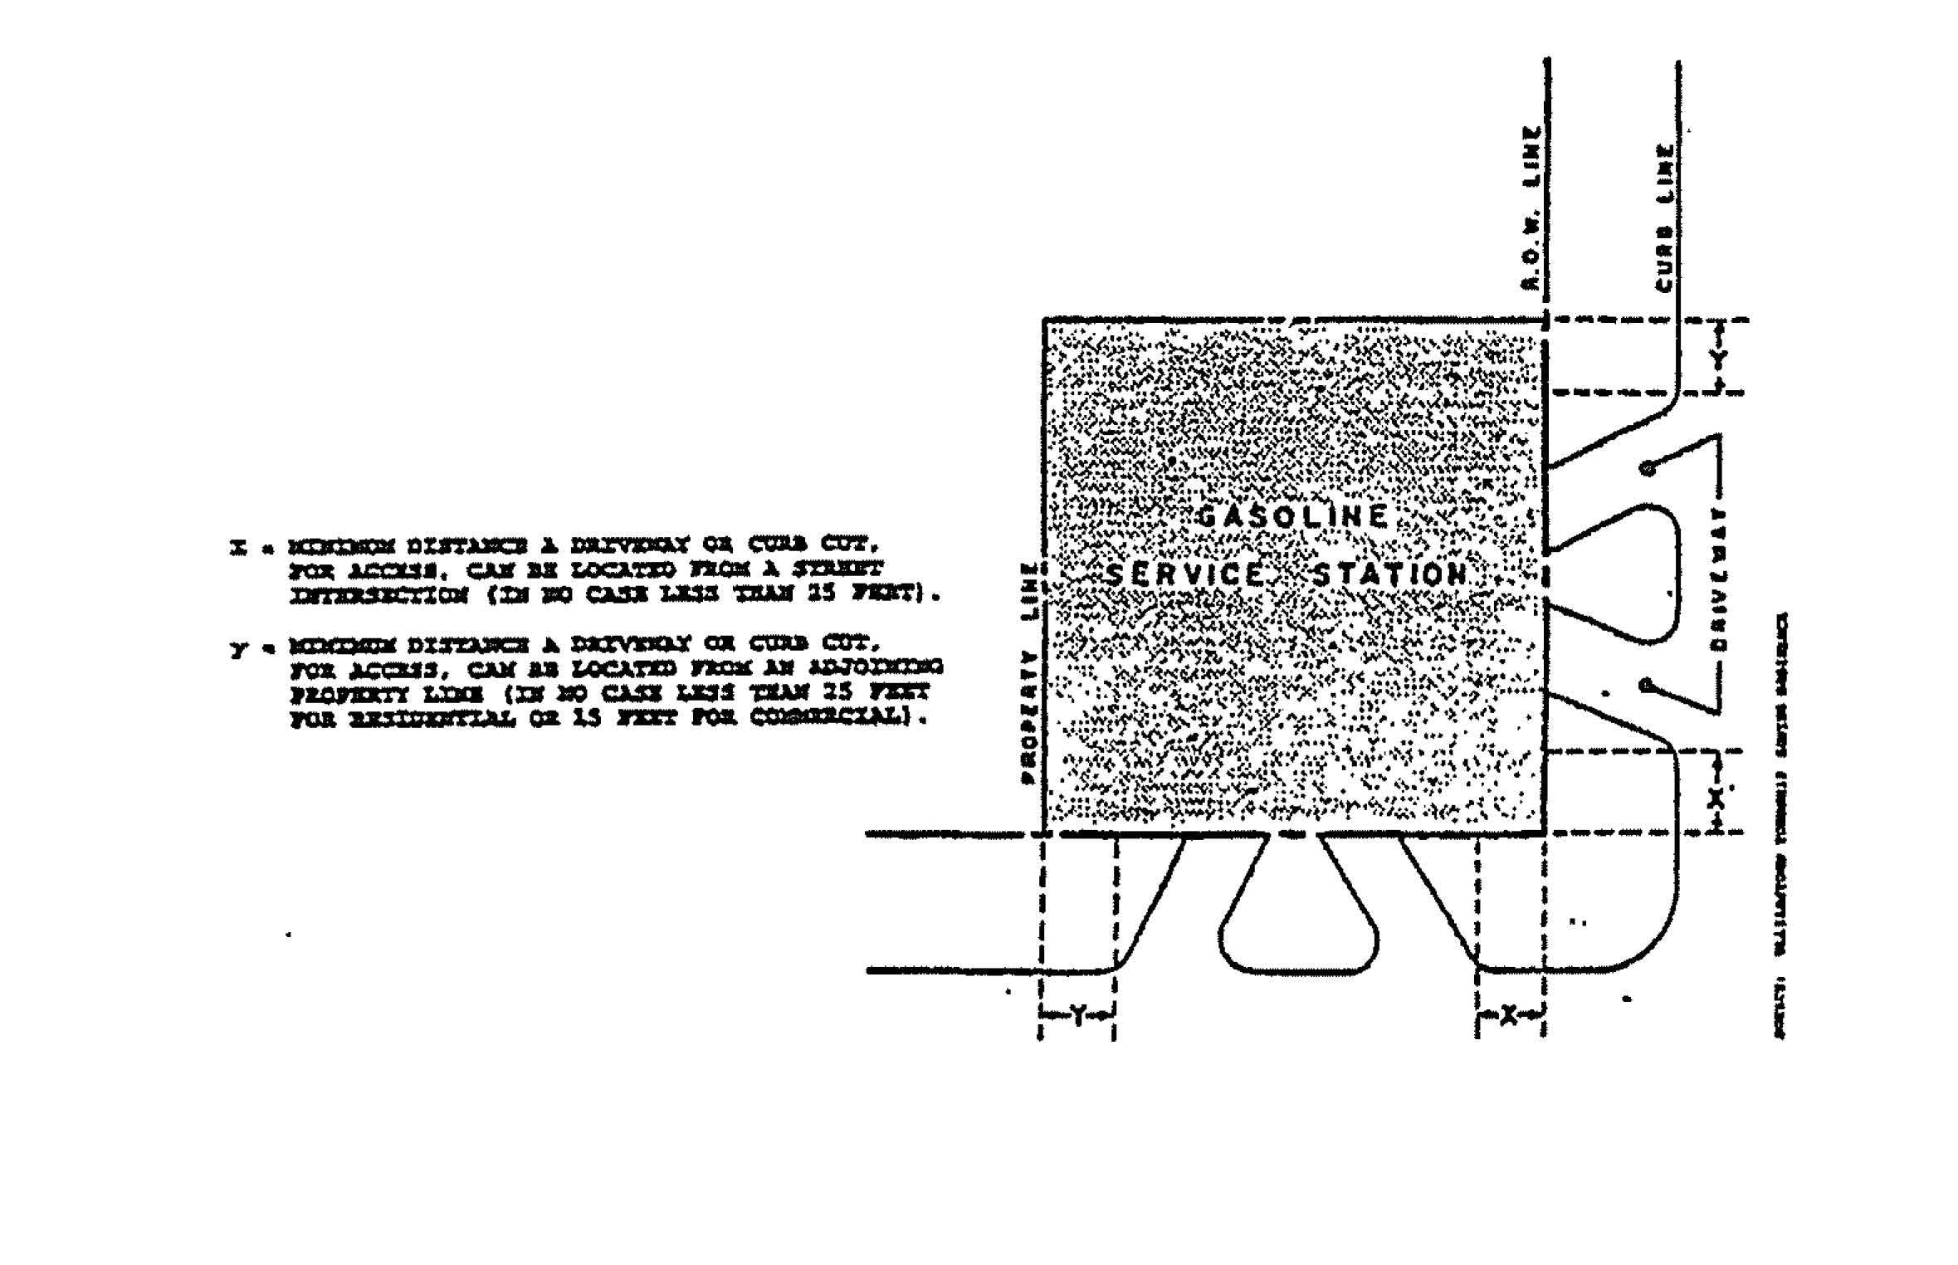

ARTICLE 11: SIGNS, NAME PLATES, AND ADVERTISING STRUCTURES
Section 11.1 PURPOSE AND INTENT
The purpose and intent of these rules and regulations governing signs is to apply reasonable controls over size, placement and general appearance of signs in their use in each district that will insure, promote and safeguard standards for protecting the public health, safety, welfare, and the environment.
Section 11.2 DEFINITIONS The definitions in this Section are unique to the provisions of this Article (See Figure 11-1).
ABANDONED SIGN: A sign which no longer identifies or advertises a bona fide business.
BANNER SIGN: A sign made of fabric or any nonrigid material with no enclosing framework.
BILLBOARD: See OFF-PREMISE SIGN.
CHANGEABLE COPY SIGN (AUTOMATIC): A sign on which the copy changes automatically on a lamp bank or through mechanical means, e.g., electrical or electronic time and temperature units.
CHANGEABLE COPY SIGN (MANUAL): A sign on which copy is changed manually in the field, e.g., reader boards with changeable letters.
CONSTRUCTION SIGN: A temporary sign identifying an architect, contractor, subcontractor, and/or material supplier participating in construction on the property on which the sign is located.
DIRECTIONAL/INFORMATION SIGN: An on-premise sign giving directions, instructions, or facility information and which may contain the name or logo of an establishment but no advertising copy, e.g., parking or exit and entrance signs.
DOUBLE-FACED SIGN: A sign with two faces.
ELECTRONIC MESSAGE CENTER. (See "Changeable Copy Sign, Automatic")
FLASHING SIGN: A sign which contains an intermittent or sequential flashing light source used primarily to attract attention. Does not include changeable copy signs, animated signs, or signs which, through reflection or other means, create an illusion of flashing of intermittent light (compare "Animated Sign," "Changeable Copy Sign").
FREE-STANDING SIGN: A sign supported upon the ground by poles or braces and not attached to any building.
GOVERNMENT SIGN: Any temporary or permanent sign erected and maintained by the city, county, state, or federal government for traffic direction or for designation of-or direction to any school, hospital, historical site, or public service, property, or facility.
HEIGHT (OF A SIGN): The vertical distance measured from the highest

point of the sign, excluding decorative embellishments, to the grade of the adjacent street or the surface grade beneath the sign, whichever is less.
IDENTIFICATION SIGN: A sign whose copy is limited to the name and address of a building, institution, or person and/or to the activity or occupation being identified.
ILLEGAL SIGN: A sign which does not meet requirements of this code and which has not received legal nonconforming status.
MAINTENANCE: For the purposes of this Ordinance, the cleaning, painting, repair, or replacement of defective parts of a sign in a manner that does not alter the basic copy, design, or structure of the sign.
MARQUEE: A permanent roof-like structure or canopy of rigid materials supported by and extending from the facade of a building (compare "Awning").
MARQUEE SIGN: Any sign attached to or supported by a marquee structure.
NAMEPLATE: A non-electric on-premise identification sign giving only the name, address, and/or occupation of an occupant or group of occupants.
NONCONFORMING SIGN: (1) A sign which was erected legally but which does not comply with subsequently enacted sign restrictions and regulations. (2) A sign which does not conform to the sign code requirements but for which a special permit has been issued.
OFF-PRE SIGN: A sign structure advertising an establishment, merchandise, service MISE, or entertainment, which is not sold, produced, manufactured, or furnished at the property on which said sign is located, e.g., "billboards" or "outdoor advertising."
ON-PREMISE SIGN: A sign which pertains to the use of the premises on which it is located.
PAINTED WALL SIGN: A sign which is applied with paint or similar substance on the face of a wall.
POLITICAL SIGN: For the purposes of this Ordinance, a temporary sign used in connection with a local, state, or national election or referendum.
PORTABLE SIGN: Any sign designed to be moved easily and not permanently affixed to the ground or to a structure or building.
REAL ESTATE SIGN: A temporary sign advertising the real estate upon which the sign is located as being for rent, lease, or sale.
ROOF SIGN: Any sign erected over or on the roof of a building (compare "Mansard," "Wall Signs").

FIGURE 11-1
SIGN TYPE ILLUSTRATIONS
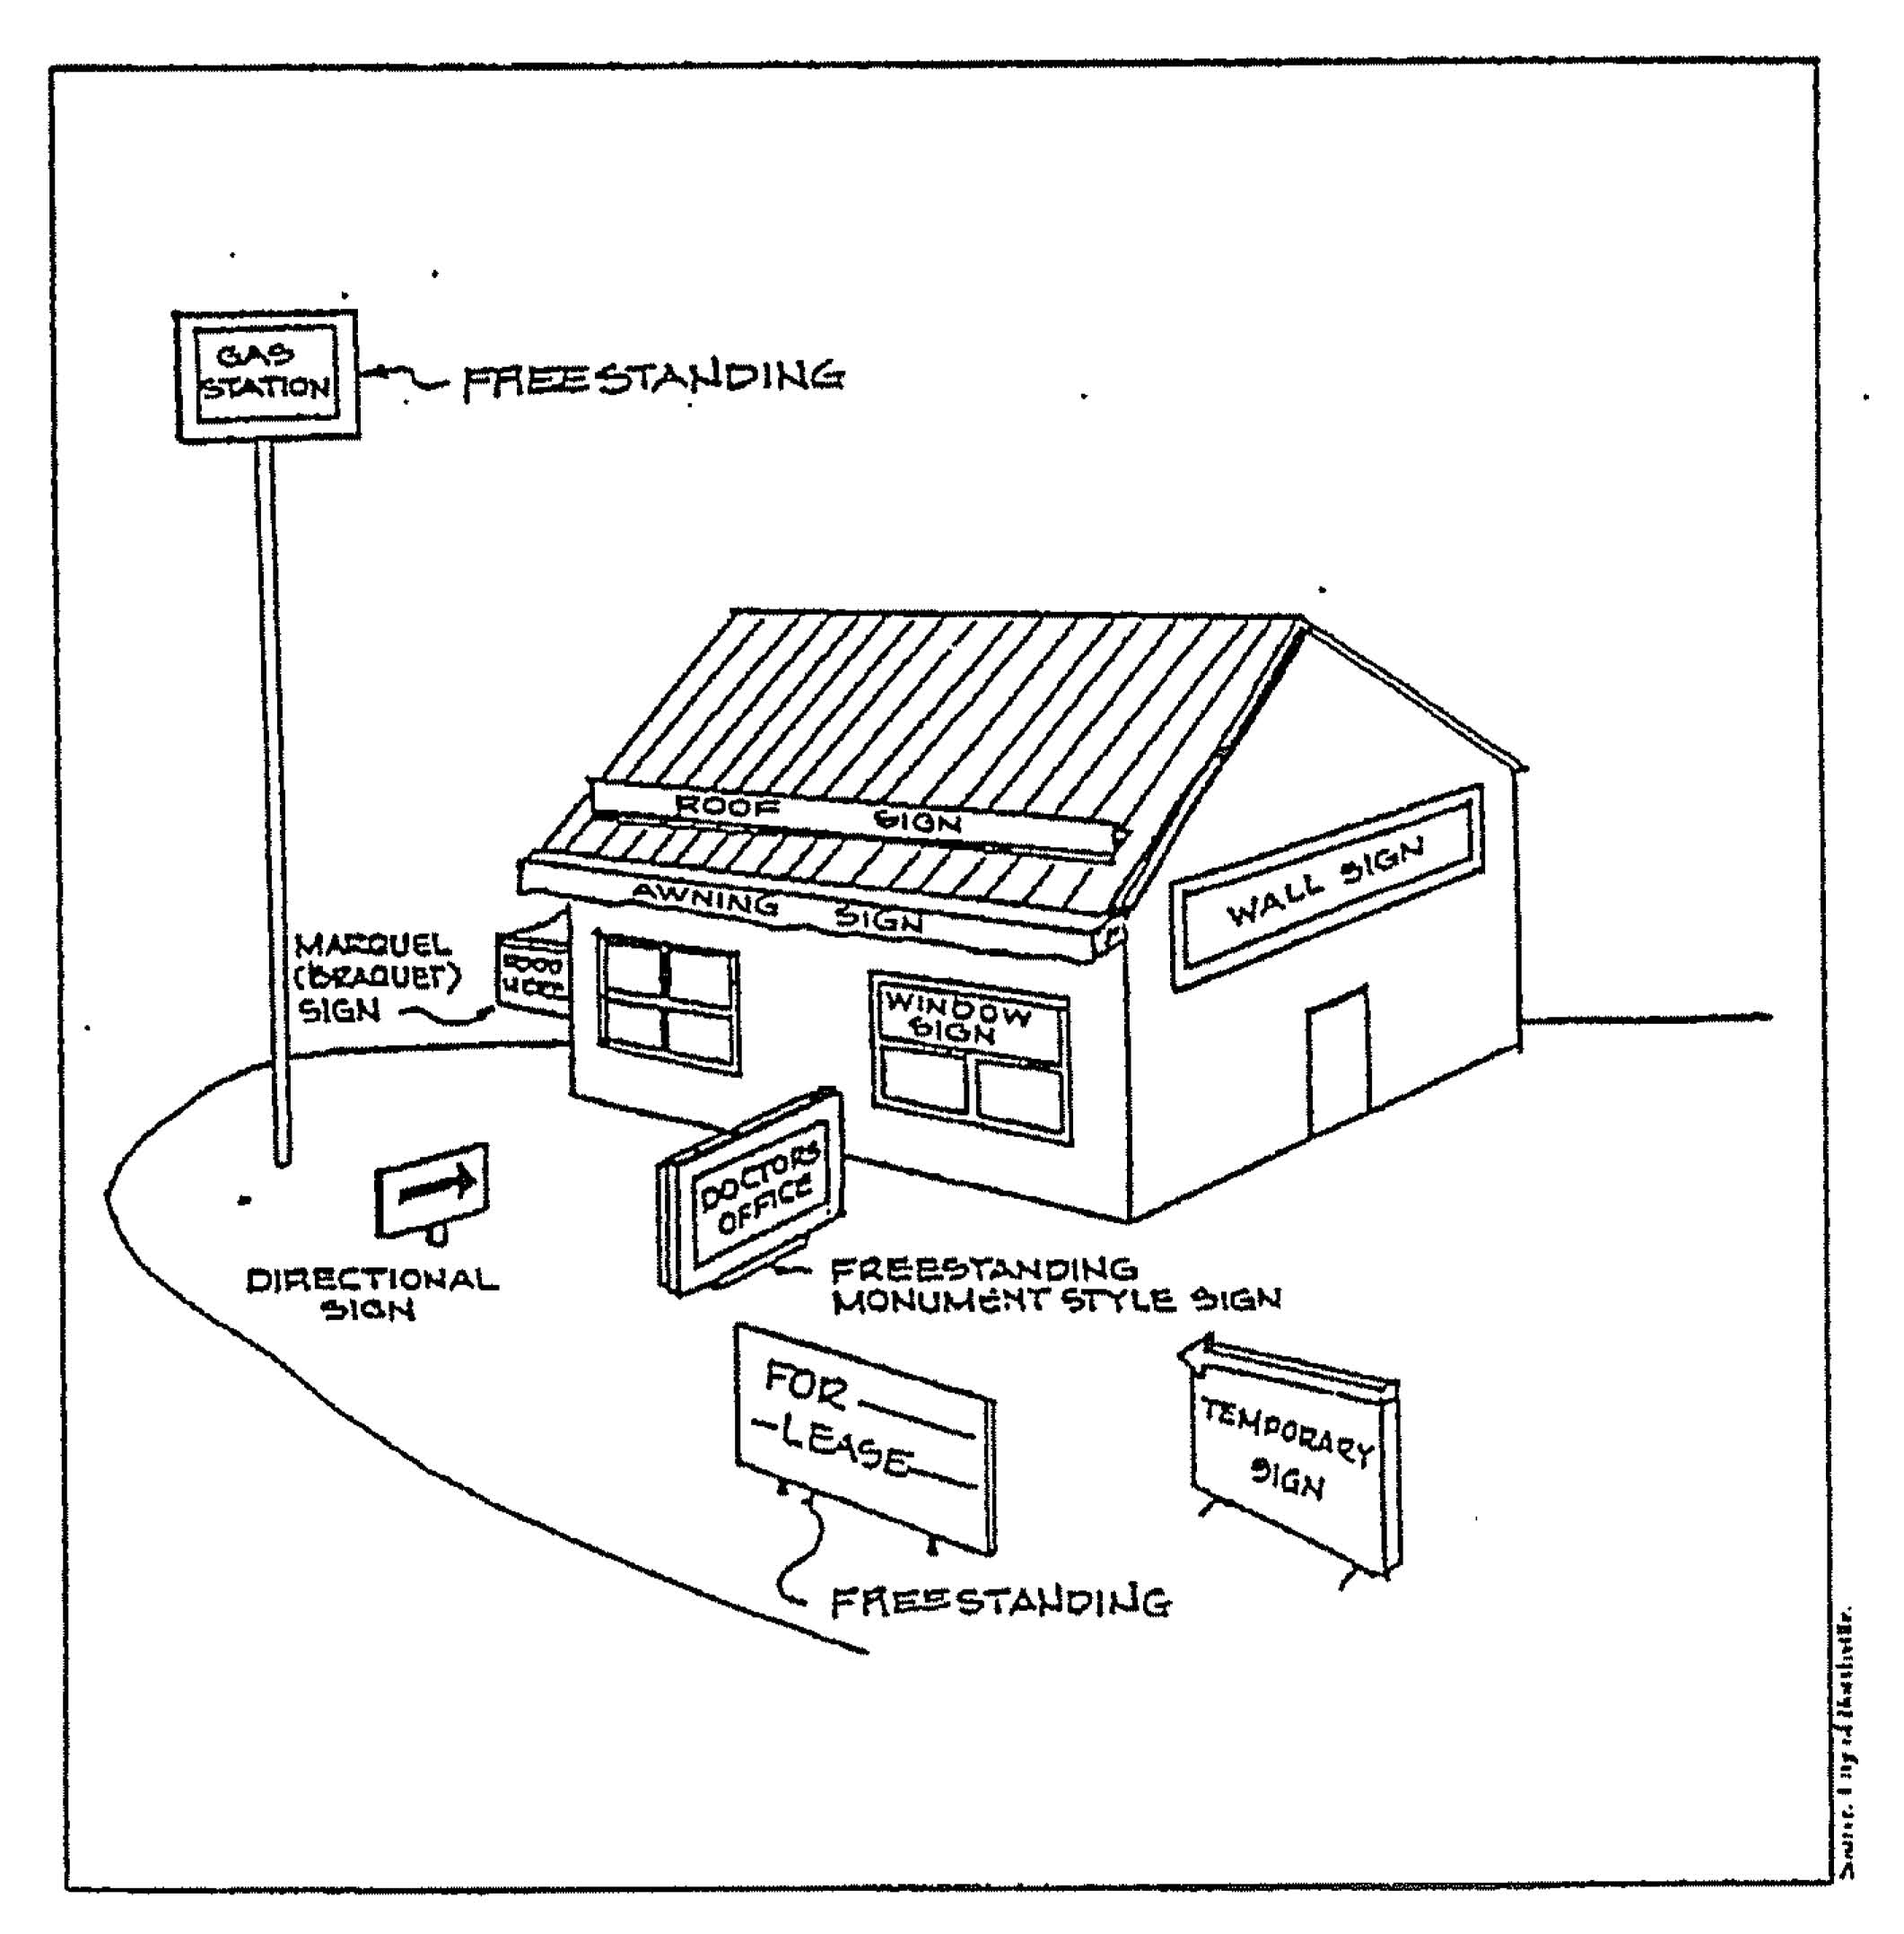
SIGN: Any device, structure, fixture, or placard using graphics, symbols, and/or written copy designed specifically for the purpose of advertising or identifying any establishment, product, goods, or services.
SIGN, AREA OF:
(1) Projecting and Free-Standing: The area of a freestanding or projecting sign shall have only one face (the largest one) of any double or multi-faced sign counted in calculating its area. The area of the sign shall be measured as follows if the sign is composed of one or two individual cabinets:
- The area around and enclosing the perimeter of each cabinet or module shall be summed and then totaled to determine total area. The perimeter of measurable area shall not include embellishments, such as pole covers, framing, decorative roofing, etc., provided that there is not written advertising copy on such embellishments.
- If the sign is composed of more than two sign cabinets or modules, the area enclosing the entire perimeter of all cabinets and/or modules within a single, continuous geometric figure shall be the area of the sign. Pole covers and other embellishments shall not be included in the area of measurement if they do not bear advertising copy.
(2) Wall Signs: The area shall be within a single, continuous perimeter composed of any straight line geometric figure which encloses

the extreme limits of the advertising message. If the sign is composed of individual letters or symbols using the wall as the background with no added decoration, the total sign area shall be calculated by measuring the area within the perimeter of each symbol or letter. The combined areas of the individual figures shall be considered the total sign area.
SUBDIVISION IDENTIFICATION SIGN: A free-standing or wall sign identifying a recognized subdivision, condominium complex, or residential development.
TEMPORARY SIGN: A sign not constructed or intended for long-term use.
WALL SIGN: A sign attached parallel to and extending not more than 4 inches from the wall of a building. This definition includes painted, individual letter, and cabinet signs, and signs on a mansard.
WINDOW SIGN: A sign installed inside a window and intended to be viewed from the outside.
Section11.3 GENERAL PROVISIONS
11.3.1 Prohibited Signs:
- Encroaching signs and roof signs as defined herein, are specifically prohibited.
- Any sign which, by reason of its size, location, content, coloring or manner of illumination, constitutes a traffic hazard or a detriment to traffic safety by obstructing the vision of drivers, or by obstructing or detracting from the visibility of any traffic control device on public streets and roads (i.e., FLASHING SIGNS).
- Signs which make use of words such as "STOP," "LOOK," "DANGER," or any other words, phrases, symbols or characters, in such a manner as to interfere with, mislead or confuse traffic.
- Abandoned signs and sign structures that are no longer in use as originally intended or have been abandoned; or are structurally unsafe, constitutes a hazard to safety and health, or those not kept in good repair or maintenance.
- Any sign which obstructs free ingress to or egress from a required door, window, fire escape or other required exit way.
- Any sign or other advertising structure containing any obscene, indecent or immoral matter.
- Any sign, unlawfully installed, erected or maintained after the effective date of this Ordinance. (Illegal Sign)
- Signs having flashing, blinking or running type lights are prohibited except for signs presenting changing of copy for

time, temperature and date.
- Any sign installed prior to the effective date of this Ordinance without a permit, when in fact previous or other ordinances required a permit. (Illegal Sign)
- Billboards except where off-premise signs are allowed.
- Billboards used for on-premise advertising are prohibited.
- Billboards located within 300 feet of residential districts.
11.3.2 Signs allowed in any District:
- No hunting, no trespassing signs and on-premise directional signs not exceeding 4 square feet in area.
- Signs located in the interior of buildings.
- Any identification, address, or for sale sign affixed to a wall, mailbox, post, lamp post, or pillar; and which is not larger than 4 square feet in display surface; and not for the purpose of advertising a home occupation.
- Traffic control or other governmental signs such as, but not limited to, directional signs placed in right-of-ways, legal notices, railroad crossing signs, danger and other temporary emergency signs.
- Nameplates, memorial signs or tablets, names of buildings, and dates or erection, when cut into any masonry surface or when constructed of bronze or other non-combustible material.
- Flags or banners bearing the official design of a nation, state, municipality, educational institution and organization.
Section 11.4 PERMITTED SIGNS BY ZONING DISTRICT
11.4.1 Agricultural and Residential District Uses (A-1, R-1, R-2, and MR Districts): In all Agricultural and Residential Districts, the requirements of Schedule A shall govern sign use, area, type, height, and numbers in addition to requirements listed elsewhere in this Ordinance. (Refer to Schedule A)
11.4.2 Business, Commercial and Office District Uses (TC, BC, and P Districts): In all Business, Commercial and Office Uses, the requirements of Schedule B shall govern sign use, area, type, height, and numbers, in addition to requirements listed elsewhere in this Ordinance. (Refer to Schedule B)
11.4.3 Development and Industrial District Uses (DI Districts): In all
Industrial Uses the requirements of Schedule C shall govern sign
use, area, type, height, and numbers, in addition to requirements
listed elsewhere in this Ordinance. (Refer to Schedule C)

Section 11.5 TEMPORARY USES
11.5.1 Signs intended for use over a limited period of time may be permitted.
11.5.2 Temporary signs shall comply with all the requirements of this Ordinance and Schedule D. (Refer to Schedule D)
11.5.3 All temporary signs not listed in Schedule D are prohibited.
Section 11.6 CONSTRUCTION REQUIREMENTS
11.6.1 Wind Load: Signs and sign structures shall be designed and constructed to resist wind forces of not less than 20 pounds per square foot on signs up to 60 feet in height and not less than 30 pounds per square foot for signs of over 60 feet in height.
11.6.2 Bracing: All bracing systems shall be designed and constructed to transfer lateral forces to the foundation. For signs on buildings, the dead and lateral loads shall be transmitted through the structural frame of the building to the ground in such a manner as to not overstress any of the elements thereof. Uplift due to overturning shall be adequately resisted by proper anchorage to the ground or the structural frame of the building.
11.6.3 Anchorage: Signs attached to masonry, concrete, or steel shall be safely and securely fastened thereto by means of metal anchors, bolts or approved expansion screws of sufficient size and anchorage to safely support all loads applied.
11.6.4 Electrical: All signs of electrical construction and installation shall comply with the National Electrical Code and shall be connected by a licensed electrician.
11.6.5 Other: The Development Official may require an engineer-sealed set of drawings thereby certifying that all loads are in compliance with this Section.
Section 11.7 SIGN PERMITS
11.7.1 Application for a Permit: Application for a permit to erect or replace a sign shall be made to the Development Official by submission of the required forms, fees, exhibits, and information by the owner of the property on which the sign is to be located, or by his/her agent, or lessee. The application shall contain the following information:
- The property owner's name and address in full.
- Applicant's name and address.
- Address of property on which sign is to be situated.

- Business to which sign belongs or relates.
- Total display area in square feet.
- Proposed setback from right-of-way.
- Sign type.
- Sign purpose.
- Sign height.
- Height and width of building to be served.
- Drawing of proposed sign indicating proposed copy.
11.7.2 Sign permits issued on the basis of plans and applications approved by the Planning Commission authorize only the design and construction set forth in such approved plans and applications, and no other design.
11.7.3 The Planning Commission/Development Official shall not approve plans or issue sign permits for any sign which do not conform to the provisions of this Ordinance.
11.7.4 The Development Official shall maintain a record of all sign permits issued, and said record shall be open for public inspection.
Section 11.8 PERMIT FEES
11.8.1 Permit Fees will be established by Resolution of the Village Council. A copy of current costs will be available from the Development Official and Village Clerk.
Section 11.9 ILLEGAL SIGNS
11.9.1 For all signs hereafter erected without issuance of a required sign permit, the Development Official shall inform, by certified mail, the property owner upon whose property the sign is situated of the alleged violation of the Village of Clarksville Zoning Ordinance. If compliance is not accomplished in the prescribed thirty (30) day period, the Development Official shall present his/her findings and recommendations, in writing, to the Village Legal Officer or Ionia County Prosecuting Attorney's Office and the Planning Commission for appropriate enforcement action.

SCHEDULE A
AGRICULTURAL AND RESIDENTIAL USE SIGNS
Public Park Public
Buildings Other uses permitted in the above Districts
 |  |  |  | RIGHT-OF- way
A. Education
Religious
Day Care  Rumen Care | 18 square feet | Ground | B feet | 2 feet for each  foot of height | one per  principle use
Cemeteries

5 feet
Ground
SETBACK PROW ROAD
SIGN TXPE
USR/PDRPOSR
asaXnunt HEIGHT
MAXIMUM NUMBER
OF SIGNS
MAMMON DISPLAY AREA
10% area of wall to be served
Wall
Not above upper wall line
- Farm Enter-
prise
Aggregate
Company
18 square feet
One per Farm or Enterprise
Ground
8 feet
See Above
- Housing Developments including Mobile home Parks and Apartments
Ground
8 feet
See Above
- Rome
Occupation
4 square feet
Wall
Not above front wall
.101111101104M
See Above
One per Rome Occupation
30 square feet
One per Street Entrance

SCHEDULE B
BUSINESS, COMMERCIAL AND OFFICE USE SIGNS

USE | MAMMON DISPLAY  AREA (1) | SIGN TYPE | MINIMUM/ MAXIMUM HEIGHT | SETBACK  FROM ROAD  RIGHT-OF-WRY | MAXIMUM NUMBER  OF SIGNS
A individual  Commercial  and Office  Botab. (not  located within  a shopping  center or  office  Complex) | 15% area of  wall to be  served | Wall, Roof, or  Projecting  Signs | 5 feet above  roof | Not Applicable | Not to exceed  maximum  display area
 | 100 square feet | Free-Standing  . | 40 feet maxim=  10 feet ninimum | V  !2 ft for each 1  ft of height  mc,ver 10 feet | One Pole or  one Ground  Sign (2)
 | 75 square feet | .  Ground | 12 feet | 2 ft for each 1  ft of height
 | 6 square feet | Marquee | Affixed to  underside of  building  overhang | Not applicable | One per  establishment
B. Commercial  and Office  establishments  located within  a shopping  center or  office complex | 15% area of  wall to be  served | Wall | Not above wall  line | Not applicable | Not to exceed  maximum  display area
Individual Pole
and Ground
Signs
Prohibited
 | 6 square feet | Marquee | Affixed to  underside of  building  overhang | Not applicable | One per  establishment
C. Off-Premise  Signs  Prohibited  except in BC  District | 300 square feet | Ground, Free-  Standing, or  Billboard | 40 feet | 2 ft for each 1  ft height over  10 feet | one sign  permitted on  each parcel or  lot of land  (3)

- Includes the area of manual/automatic changeable copy signs and electronic message centers.
- Corner locations may have one Pole or Ground Sign on each street with a maximum area of 80 square feet each for Pole Signs and 60 square feet for Ground Signs.
- Sign and Billboard spacing shall be a minimum of 500 feet between signs/billboards. Each side of the road shall be considered separately for purposes of measuring 500 feet required spacing.

SCHEDULE C
DEVELOPMENT AND INDUSTRIAL USE SIGNS
- Includes the area of manual/automatic changeable copy signs and electronic message centers.

MAXI:man DISPOSE' AREA (1)
uSE
SIGN TYPE
1)=10)1ExxenT
SETBACK FROM
ROAD RIGHT-OF-
MAY
MAXIMOR NTRaBER
OF SIGNS
A individual 15% area of Nall
Industrial wall to be Establishment nerved
not above upper wall line
mot applicable
not to exceed maximum display area
100 sq ft Free-Standing
30 ft maximum
2 ft for each 1 ft over 10 ft
one pole or one ground sign per establishment (2)
75 sq ft Ground
12 ft
2ft for each 1 ft of height
- Industrial Parks
100 sq ft Free-Standing
30 ft mexianna
2 ft for each 1 ft over 10 ft
one sign per drive
75 sq ft Ground
12 ft
2 ft for each 1 ft of height
- Office and Commercial 15% area of Nall Establishments wall
located in Indus. areas
not above upper wall line
not applicable
not to exceed maximum display area

 | 75 sq ft | Ground | 12 ft
 | 100 sq ft | Free-Standing | 30 Etna:ce=
D. Off-premise  Signs  including  Billboards | 300 sqft | Free-Standing.  Ground or  Billboard | 40 ft IMILMUISIIIIL

2 ft for each 1 ft of height
One per estableihment
2 ft for-each 1 ft over 10 ft
one per establishment
2 ft for each 1 ft over 10 ft
one sign permitted on each parcel of land (3)
- Corner locations may have one pole or ground sign on each street with a maximum area of 80 square feet each for pole signs and 60 square feet each for ground signs.
- Sign and Billboard spacing shall be a minimum of 500 feet between signs/billboards. Each side of the road should be considered separately for purposes of measuring 500 feet required spacing.

SCHEDULE D
TEMPORARY USE SIGNS
USE | MAXIMUM SIZE PER FACE | MAXIMUM DURATION
A. Real Estate Sale,  Rent or Lease in  Residential Uses (no  permit required) | 6 sq ft (single-family)  10 sq ft (multiple-  family) | 5 days after purpose of  sign fulfilled (1)
B. Real Estate, all  other uses (no permit  required) | 32 square feet | 5 days after purpose of  sign fulfilled
C. Building Construction  Signs for Residential  Projects | 20 sq ft (single-family)  32 sq ft (multiple-  family) | First Occupancy
D. Building Construction  - all other Districts  except Residential (3) | 80 square feet | First Occupancy
E. Political Signs, all  Districts (no permit  required) | 32 square feet | 60 days, each election,  removed within 5 days  following election
F. Mobile Signs(2) | 40 square feet | 90 days each permit, 2  permits maximum per year
G. Residential Garage  Sales (no permit  required) | 4 square feet | 5 days

- For single-family subdivisions under development, sign(s) shall be removed within one year after sale of 9C percent of all lots.
- Trailer signs shall have owner's name and address clearly imprinted for identification purposes.
- Include proposed developments and openings, 1 per street project, use or building (structure).

ARTICLE 12: NONCONFORMING USES OF LAND AND STRUCTURES
Section 12.1 INTENT AND PURPOSE
It is the intent of this Article to permit nonconforming lots, structures, or uses to continue until they are removed, but not to encourage their survival.
It is recognized that there exists within the districts established by this Ordinance and subsequent amendments, lots, structures, and uses of land and structures which were lawful before this Ordinance passed, or amended, which would be prohibited, regulated or restricted under the terms of this Ordinance or future amendments.
Section 12.2 NONCONFORMING LOTS
In any district in which single-family dwellings are permitted, notwithstanding limitations imposed by other provisions of this Ordinance, a single-family dwelling and customary accessory buildings may be erected on any single lot of record at the effective date of adoption or amendment of this Ordinance. This provision shall apply even though such lot fails to meet the requirements for area or width, or both; provided that yard dimensions and other requirements of the lot, shall conform to the regulations for the district in which such lot is located. Yard requirement variances may be obtained through approval of the Zoning Board of Appeals.
Section 12.3 NONCONFORMING USES OF LAND
Where, at the effective date of adoption or amendment of this Ordinance, lawful use of land exists that is made no longer permissible under the terms of this Ordinance as enacted or amended, such use may be continued, so long as it remains otherwise lawful, subject to the following provisions:
- In the R-2 and A-1 District, residential single family dwellings shall be permitted on nonconforming lots of record. Expansion of nonconforming structures may be permitted within the guidelines of Section 12.4.
- In the 0, and TC Districts, uses which are permitted in these districts may be permitted on nonconforming lots of record. Expansion of nonconforming uses within these districts may be permitted within the guidelines of Section 12.4.
- In the BC and I Districts, expansion of nonconforming uses may be permitted by the Planning Commission subject to the Site Plan Review and approval, and compliance with the standards for Special Use Permits. Expansion of nonconforming structures may be permitted within the guidelines of Section 12.4.
Section 12.4 NONCONFORMING STRUCTURES
Where a lawful structure exists at the effective date of adoption or amendment of this Ordinance that could not be built under the terms of this Ordinance by reason of restrictions on area lot coverage, height, yards or other characteristics of the structure or location on the lot,

such structure may be continued so long as it remains otherwise lawful, subject to the following provisions;
A. No such structure may be enlarged or altered in a way which increases its nonconformity, but the use of a structure and/or structure itself may be changed or altered to a use permitted in the district in which it is located, provided that all such changes are also in conformance with the requirements of the district in which it is located.
B Should such a structure be destroyed by any means to an extent of
more than sixty (60) percent of twice its assessed value at the
time of destruction, it shall not be reconstructed except in
conformance with the provisions of the Ordinance.
- Should such structure be moved for any reason for any distance whatever, it shall thereafter conform to the regulations for the district in which it is relocated.
- Any structure, or structure and use of land in combination, in or on which a nonconforming use is superseded by a permitted structure or use, shall thereafter conform to the regulations for the district in which it is located, and the nonconforming use may not thereafter be resumed.
- Where nonconforming use status applies to a structure and land in combination, removal or destruction of the structure shall eliminate the nonconforming statue of the land.,
Section 12.5 CHANGE IN NONCONFORMING USES IN BUSINESS/COMMERCIAL AND INDUSTRIAL DISTRICTS
Irrespective of other requirements of this Ordinance, in any business/commercial or industrial district (BC and I. Districts), if no structural alterations are made, any nonconforming use of a structure and land, may be changed to another nonconforming use of the same or a more restricted classification, provided that the Planning Commission approves a Special Use Permit (Article 7) and approves the Site Plan (Article 8) in all cases.
Section 12.6 REPAIRS AND MAINTENANCE
On any building devoted in whole or in part to any nonconforming use, work may be done in any period of twelve (12) consecutive months on ordinary repairs, or on repair or replacement of nonbearing walls, fixtures, wiring or plumbing to an extent not exceeding fifty (50) percent of the assessed value of the building, provided that the cubic content of the building as it existed at the time of passage or amendment of this Ordinance shall not be increased. Nothing in this Article shall be deemed to prevent the strengthening or restoring to a safe condition of any building or part thereof declared to be unsafe by any official charged with protecting the public safety, upon order of such official.
Section 12.7 CHANGE OF TENANCY OR OWNERSHIP
As long as there is no change in the characteristics or increase in the

intensity of the nonconforming use, a change of tenancy or ownership is allowed.
Section 12.8 DISTRICT CHANGES
Whenever the boundaries of a district shall be changed as to transfer an area from one district to another district of another classification, the provisions of this Section shall also apply to any existing uses that become nonconforming as a result of the boundary changes.
Section 12.9 HARDSHIP CASES
Nonconforming buildings or structures may be structurally changed, altered, or enlarged with the approval of the Zoning Board of Appeals when the Board finds that the request is a case of exceptional hardship in which failure to grant the relief requested would unreasonably restrict continued use of the property or would restrict valuable benefits that the public currently derives from the property as used in its nonconforming status, EXCEPT that any approval for structural changes, alteration or enlargement may be granted only with a finding by the Zoning Board of Appeals that approval will not have an adverse affect on surrounding property and that it will be the minimum necessary to relieve the hardship.

Section 12.10 ILLEGAL USES
Uses of structures or land existing at the effective date of this Ordinance that were established without approval of zoning compliance or without a valid building permit or those uses which cannot be proved conclusively as existing prior to the effective date of this Ordinance shall be declared illegal uses and are not entitled to the status and rights accorded legally established uses.

ARTICLE 13: VILLAGE OF CLARKSVILLE BOARD OF APPEALS
Section 13.1 CREATION AND MEMBERSHIP
13.1.1 Establishment: The Village Council is hereby established as the Board of Appeals in accordance with Act the Zoning Enabling Act being Public Act 110 of 2006 as amended. The Village Council as the Board of Appeals shall perform its duties and exercise its powers in such a way that the objectives of this Ordinance may be equitably achieved.
    - Compensation: The members of the Board of Appeals shall be paid such amount per meeting as shall be determined by the Board of Commissioners and in addition shall be reimbursed for reasonable expenses actually incurred in the performance of their duties.
    - Alternate Members: The Village President with the approval of the Council may appoint up to two alternate members who are electors of the Village of Clarksville for the same term as regular members. Alternate members shall serve in the case of absence of a regular member or the inability of a regular member to serve due to conflict of interest. The alternate member, having been appointed shall serve on the case until a final vote has been made. Alternate members shall have the same voting rights as regular members.
Section 13.2 ORGANIZATION AND PROCEDURE
13.2.1 Rules of Procedure: The Board of Appeals shall adopt rules of procedure for the conduct of its meetings and implementation of its duties. The Board shall choose its own chairman, and in his absence, a vice-chairman, who may administer oaths and compel the attendance of witnesses.
13.2.2 Meetings and Voting:
A. The presence of four members shall constitute a quorum.

B. A member of the Board of Appeals who is also a member of the Planning Commission shall not participate in a public hearing on or vote on the same matter that the member voted on as a member of the Planning Commission . The member may consider and vote on the other unrelated matters involving the same property.
13.2.3 Records: Minutes of all meetings shall be recorded and shall contain the grounds of every determination made by the Board of Appeals including all evidence and data considered, and all findings of fact and conclusions drawn by the Board for every case, together with the votes of the members and the final disposition of each case. Such minutes shall be filed in the Office of the Village Clerk, and shall be available to the public.
The Record of Proceedings shall contain the following information when applicable:
- The application (for an appeal, variance, and interpretation).
- Any reports, plans, surveys or photos.
- Notice of Public Hearing to affected parties in newspaper.
- Letter from the Building and Development Official granting or denying the application or referring it to the Board of Appeals and all other relevant records related to the case.
- Affidavit of publication of Notice of Hearing.
- Record of testimony heard and evidence presented.
- A copy of the zoning article(s) and section(s) in question.
- Briefs, correspondence or other communications made to the Board of Appeals.
- Statement of facts found by the Board, of its own knowledge, regarding the request including any information gained from personal inspection.
- Decision of the Board as specifically related to the Findings of Fact.
- A copy of any other correspondence to the appellant regarding the request.
13.2.4 Counsel: Legal counsel may be retained, by the Board of Appeals, for any purpose deemed necessary provided that such appointment or retainer shall be approved in advance by the Village Council.
    - Hearings: The Board of Appeals shall fix a reasonable time and date for a Public Hearing, not to exceed forty-five (45) days from the date of filing any petition with the Building and Development Official, and give due notice to be delivered personally or by mail addressed to the applicant/respective owners at the address given in the last assessment roll. Upon the hearing, any party may appear in person or by agent. The Board of Appeals may reverse or affirm, wholly or partly, or may modify the order, requirement, decision, or determination appeals from and shall make such order, requirement, decision or determination as in its opinion ought to be made in the premises and to that end shall have all powers of the officer from whom the appeal is taken.

13.2.6 Notification: Notice of the public hearing shall be made in accordance with the requirements of Section 9.5 herein.
13.2.7 Majority Vote: The concurring vote of a majority of the total membership of the Board of Appeals shall be necessary to reverse any order, requirement, decision, or determination of the Building and Development Official or to decide in favor of the applicant of any matter upon which they are required to pass under this Ordinance or to effect any variation.
13.2.8 Decisions: The Board of Appeals shall return a decision on a case within sixty (60) days after a request or appeal has been filed unless an extension of time is agreed upon by the appellant and a majority of the members of the Board of Appeals present. Any decision of the Board shall not become final until the expiration of five (5) days from the date of entry of such order, unless the Board shall find the immediate effect of such order is necessary for the preservation of property or personal rights and shall so certify on the record.

13.2.9 Final Action on Board of Appeals Decisions: The decision of the Board of Appeals shall be final. However, any person having an interest affected by any such decision may appeal to the circuit court to the extent and in the manner permitted by law. Such appeal shall be filed within 30 days after the Board of Appeals issues its decision in writing signed by the chairperson, or 21 days after the Board of Appeals approves the minutes of the decision. The records of the Board of Appeals shall be made available for the court’s review.

Section 13.3 APPEALS
13.3.1 Filing of Appeal: An appeal may be taken by any person aggrieved or by an officer, department, board of the County, from which the appeal arises, of any order, requirement, decision or determination made by any administrative official charged with the enforcement of this Ordinance.
13.3.2 Procedure on Appeals: A notice of appeal shall be filed within 30 days by the appellant with the Building and Development Official. Such petition shall state the reasons for the appeal and the order or ruling appealed from. When applicable, the legal description of the property involved shall be stated in the notice of appeal. Before such an appeal shall be processed, the fees for an appeal, as hereinafter set forth, shall be paid to the Building and Development Official, who shall deliver same to the County Treasurer to be credited to the appropriate fund of the County.
13.3.3 Fees on Appeal: Appeal fees shall be established, from time to time, by the Village Council, sufficient to cover all costs incurred by the County pursuant to the processing of any appeal, including but not limited to the costs of advertisements, investigations and Appeal Board member attendance fees.
    - Stay of Proceedings: An appeal stays all proceedings in furtherance of the action appealed from unless the officer from whom the appeal is taken certifies to the Board of Appeals, after the petition of appeal shall have been filed with the Building and Development Official, that by reason of facts stated in the appeal petition, a stay would, in his opinion, cause imminent peril to life and property.

13.3.5 Notices: For a request seeking an interpretation of the Zoning Ordinance or an appeal of an administrative decision, a notice of a public hearing shall be published in a newspaper of general circulation within the Village and shall be sent to the person seeking the interpretation or appeal not less than 15 days before the public hearing.
In addition to the newspaper notice required by the above paragraph, if the request for an interpretation or appeal of an administrative decision involves a specific parcel, written notice stating the nature of the interpretation request and notice of the public hearing on the interpretation request shall also be sent by first-class mail or personal delivery to all persons to whom real property is assessed within 300 feet of the boundary of the property in question and to the occupants of all structures within 300 feet of the boundary of the property in question. If a tenant’s name is not known, the term “occupant” may be used.
Section 13.4 DUTIES AND POWERS
13.4.1 Duties: The Board of Appeals shall have the duty to rule on those matters provided in this Ordinance for administrative review, interpretation, variance or exception.
13.4.2 Powers: The Board of Appeals shall have the power to make final determinations, within its jurisdiction and duties herein prescribed, in such a way that the objectives of this Ordinance may be equitably achieved in order there shall be uniform interpretation and flexibility in the enforcement of this Ordinance or to fulfill any other 'responsibilities bestowed upon the Appeals Board by this Ordinance.
13.4.3 Review: The Board of Appeals shall hear and decide appeals where it is alleged that there is an error in any order, requirement, permit or decision made by staff or any other board, including the Village Council, in administering or enforcing any provision of

the Ordinance.
13.4.4 Interpretation: The Board of Appeals shall have the power to:
- Interpret, upon request, the provisions of this Ordinance in such a way as to carry out the intent and purpose of the Ordinance;
- Determine the precise location of the boundary lines between zoning districts;
13.4.5 Variances: The Board of Appeals may authorize specific variances from such requirements as: lot area and width regulations, yard and depth regulations, off-street parking and loading space requirements, and sign and billboard regulations, provided all of the basic conditions listed herein and any one of the special conditions listed thereafter shall be satisfied.
A. Basic Conditions: A variance from this Ordinance:
- Will not be contrary to the public interest or to the intent and purpose of this Ordinance.
- Shall not permit the establishment within a district of any use which is not permitted by right within that district, or any use variance for which a special use permit is required pursuant to Article 7 of this Ordinance.
- Will not cause a substantial adverse effect upon property values in the immediate vicinity or in the district in which the property of the applicant is located.
- Is not one where the specific conditions relating to the property are so general or recurrent in nature as to make the formulation of a general, regulation for such conditions reasonably practical.
- Will relate only to property that is owned or occupied, or where the applicant has equitable interest.
- Shall not be the result of a condition created by the applicant.
- Shall be assessed for the possible precedents or affects which might result from the approval or denial of the appeal.
B. When all of the foregoing basic conditions can be satisfied, a variance may be granted when one of the following special conditions can be clearly demonstrated:
1. Where there are practical difficulties which prevent carrying out the strict letter of this Ordinance. These difficulties shall not only be deemed economic,

but shall be evaluated in terms of the use of a particular parcel of land.
- Where there are exceptional or extraordinary circumstances or physical conditions such as narrowness, shallowness, shape, or topography of the property involved, or to the intended use of the property, that do not generally apply to other property or uses in the same zoning district. Such circumstances or conditions shall have not resulted from any act of the appellant subsequent to the adoption of this Ordinance.
'3. Where such variation is necessary for the preservation of a substantial property right possessed by other properties in the same zoning district.
C. In addition to the foregoing conditions, the following rules shall be applied to the granting of variances:
1. The Board of Appeals may specify, in writing, such conditions regarding the character, location, and other features that will in their judgment secure the objectives and purposes of this Ordinance. The breach of any such condition shall automatically invalidate the permit granted.
2. Every variance granted under the provisions of this
Ordinance shall become null and void unless:
The construction authorized by such variance or permit has been commenced within six (6) months after the granting of the variance, and the occupancy of land, or premises, or buildings authorized by the variance has taken place within one (1) year after the granting of the variance.
- No application for a variance which has been denied wholly or in part by the Board of Appeals shall be resubmitted for a period of one (1) year from the date of the last denial, except on the grounds of newly discovered evidence or proof of changed conditions found, upon inspection by the Board of Appeals, to be valid.
13.4.9 Essential Services: The Board of Appeals shall have the power to permit the erection and use of a building, or an addition to an existing building, of a public service corporation or for public utility purposes, in any permitted district to a greater height or of larger area than the district requirements herein established, and permit the location in any use district of a public utility building, structure, or use if the Board shall find such use, height, area, building or structure reasonably necessary for the public convenience and service.
13.4.10 Determination of a Lot of Record: The Board of Appeals shall have the power to make "Lot of Record" determinations in accordance

with the following:
- Upon application of any person claiming to be the owner of the legal or equitable title to a parcel of land which was the subject to a deed or land contract not recorded in the Office of the Register of Deeds on the effective date of this Ordinance, the Board of Appeals is authorized to conduct a hearing to determine whether a variance should be granted to such owner entitling him to have the parcel treated as a "lot of record" in accordance with definition contained in this Ordinance.
- The Board shall grant said variance when it finds by a preponderance of the evidence that the instrument purporting to transfer title to the parcel of said owner was executed prior to the effective date of this Ordinance. In making its determination, the Board is authorized to consider all matters it deems relevant including, but not limited to, the tax roll of the County, the relationship of the parties to the purported transfer, the degree of formality of the purported document of transfer, and the testimony of the applicant and his witnesses.
- Such a determination shall have only the effect of equating such an owner with the owner of a lot of record and shall not relieve such owner from complying with the other conditions set forth in this Ordinance.
13.4.11 Site Plan Review: The Board of Appeals shall review and make final determination on properly filed appeals from action by the Planning Commission on Site Plan Review cases pursuant to Article 8 of this Ordinance. The Board of Appeals has the power to sustain, reverse or remand for further consideration the decision of the Planning Commission when it is found that the decision is inconsistent with the provisions of this Ordinance or that there was an error of fact involved in the decision of the Planning Commission. In making this determination, the Board of Appeals shall examine the application and all accompanying data as well as the records of the Planning Commission. Decisions of the Board of Appeals are appealable to Circuit Court.
13.4.12 Nonconformity Appeals: Nonconforming buildings or structures may be structurally changed, altered or enlarged upon appeal, in cases of hardship or other extenuating circumstances (see Section 12.9), and when approval of said appeal will not have an adverse effect on surrounding property.
3.4.13 Bond for Compliance: The Board of Appeals may require that a bond be furnished to insure compliance with the requirements, specifications, and conditions imposed with the granting of any variance, appeal, special exception, conditional permit, special use permit or site plan review approval, or to insure the discontinuance of a conditional or temporary use by a stipulated time. The amount and type of the bond shall be. determined by the Ionia County Zoning Board of Appeals. The Board shall, in estimating the amount and type of the bond, take into account the scale of said operation. The bond shall be reasonable,

appropriate and commensurate with the scope of the project.
The amount of the bond may be reduced at a rate equal to the ratio of work completed on the required improvements as work progresses. The term "improvements" should not be construed to mean the project itself, but rather those features associated with the project which are deemed necessary to protect the health, safety and welfare of Ionia County's resources and future users or inhabitants of the proposed project.
13.4.14 Administrative Variance on Lots of Record: The Building and Development Official may allow on lots of record up to a twenty-five (25%) percent variance on any required lot area, lot width, side or rear yard. Any variance thus granted shall be only to the extent essential for fulfillment of pur^{p}ose intended and shall create additional buildable lots. Such administrative variance shall be recorded on a form provided for such purpose. Fees shall be as prescribed by the Ionia County Board of Commissioners.
The Building and Development Official shall provide the Village Clerk with a signed copy of all such administrative variances granted and shall further maintain a file on all such variances.
13.4.15 Conditional Permits: When conditions exist that are unique to a particular situation, a conditional permit may be issued with specific limitations imposed by the Board. The land or structure use may be permitted to be established and to continue in use as long as the conditions unique to the use exist. The permit may be canceled when the conditions upon which the permit was issued cease to exist. The permit issued shall contain all the specific conditions under which continued use may be allowed. Conditional permits may be issued for the following uses:
- Permit more than two (2) roomers in any one dwelling, but not more than four (4), when it can be demonstrated to the satisfaction of the Board of Appeals that such an expanded capacity is a clear necessity for satisfaction of this particular housing demand; that adequate off-street parking space can be provided in accordance with standards stated in Article 10 and that such use will not injure the character or value of the immediate neighboring property owners.
- The Board of Appeals may authorize a reduction, modification, or waiver of any of the off-street parking or off-street loading regulations in Article 10, when it can be demonstrated that circumstances of extreme practical difficulty exists that would unquestionably result in hardship to the appellant when a literal interpretation of the regulations is required. Hardship shall not only be deemed economic, but shall be evaluated in terms of the use of a particular parcel of land. A hardship that is a result of any action of the appellant shall not be considered. In no case shall the off-street parking or off-street loading standards be reduced by more than twenty-five (25%) percent.
- Joint use of off-street parking areas may be authorized when the capacities outlined in Article 10 are complied with and

when a copy of an agreement between joint users shall be filed with the application for a building permit, and is recorded with the Register of Deeds for Ionia County.

ARTICLE 14: FEES AND PERFORMANCE GUARANTEES
Section 14.1 PURPOSE
The purpose of this Article is to establish fees and performance or financial guarantees the Village of Clarksville deems necessary to implement the provisions of this Zoning Ordinance.
Section 14.2 FEES
14.2.1 The Village Council shall establish and set fees for making application for zoning permits, site plan review, certificates of occupancy, zoning appeals, and sale of copies of the Zoning Ordinance.
14.2.2 The Village Council shall establish a fee schedule to cover cost of inspections required for the implementation of this Zoning Ordinance. Before considering any application, submitted in accordance with the requirements of this Ordinance, a fee shall be collected by the Village Clerk.
Section 14.3 PERFORMANCE AND FINANCIAL GUARANTEES
14.3.1 General. The Village of Clarksville as a condition of any zoning approval may mandate a performance or financial guarantee of a sufficient amount to insure the implementation and proper installation of required on-site improvements. Such improvements shall include but not be limited to the installation of roadways, curbs, lighting, drainage, driveways, utilities, landscaping and screening, and similar items.
14.3.2 Arrangements. A performance guarantee in the form of a financial security may be required from a petitioner/ developer in one or a combination of the following arrangements, whichever the petitioner/developer elects. The amount of the performance guarantee shall not exceed 100 percent of the cost of installing the required improvements.
- Performance Bond. A performance bond or surety bond to cover the costs of the required improvements as described above and as estimated by the Village Development Official or authorized agents shall be filed with the Village Clerk. The Village Planning Commission may require the petitioner/developer be responsible for submitting a certified estimate of costs for the required improvements.
- Escrow Fund. A cash deposit, or deposit by certified check, sufficient to cover the cost of the required improvements, as estimated by the Village or its authorized agents, shall be deposited with the Village Clerk. The escrow deposit shall be for the time period estimated as necessary to complete the required improvements.
- Irrevocable Letter of Credit. An irrevocable letter of

credit issued by a bank authorized to do business in the State of Michigan, in an amount to cover the cost of the required improvements as estimated by the Village or its authorized agents, shall be deposited with the Village
Clerk.
14.3.3 The Village may base the amount of the performance/ financial guarantee to be deposited with the Village for required improvements on the development phasing schedule for the approved zoning.
14.3.4 The Village Council shall determine the costs of the required improvements and approve by resolution the amount for the petitioner/developer to guarantee by one of the above described methods of financial arrangement.
14.3.5 The Village shall rebate or release to the petitioner/developer, as the work progresses, amounts equal to the ratio of the completed and accepted work to the guaranteed project phase.
14.3.6 Failure to Complete Improvements. If the petitioner/developer fails to complete the required improvements work within such time period as required by the conditions or guarantees provided in this Section, the Village Council may proceed to have such work completed and reimburse itself for the cost thereof, by appropriating the cash deposit, certified check, performance or surety bond, or by drawing upon the letter of credit, or shall take the necessary steps to require performance by the bonding company.
Section 14.4 FEES FOR PROFESSIONAL ANALYSIS
The Village Council may require the petitioner/developer to provide a fee to cover the costs of a professional planning analysis to be performed on a zoning application. Such rezoning proposal shall be of a complex nature that is determined by the Village or its authorized agents to be beyond the capability of the Village Council and Village Planning Commission to formulate a decision on the merits of the proposed development or rezoning application. The required fee shall be deposited with the Village Clerk prior to the zoning application being processed.

ARTICLE 15: RELATIONSHIP TO OTHER ORDINANCES
This Ordinance is not intended to abrogate or annul any ordinance, rule, regulation, permit, easement, covenant, or other private agreement previously adopted, issued, or entered into and not in conflict with the provisions of this Ordinance.
However, where the regulations of this Ordinance are more restrictive or impose higher standards or requirements than other such ordinances, rules, regulations, permits, easements, covenants, or other private agreements, the requirements of this Ordinance shall govern.

ARTICLE: 16 SEVERABILITY CLAUSE
This Ordinance and the various articles, sections, and clauses thereof, are hereby declared to be severable. If any part, sentence, paragraph, section or word is adjudged unconstitutional or invalid for any reason, by any Court of competent jurisdiction, such invalidity shall not affect portions or applications of this Ordinance which can be given effect without the invalid portion or application, provided such remaining portions are not determined by the Court to be inoperable.

ARTICLE: 17 EFFECTIVE DATE
The “Zoning Ordinance” was adopted at a regular meeting of the Village Council held on the 2nd day of December 1996, and became effective on the 1st day of March 1997.

Amendments made to the Zoning Ordinance, by Village Ordinance #41, to be in compliance with the Michigan Zoning Enabling Act PA110 of 2006 were adopted at a public session held September 13, 2010 published in the Lakewood News on September 18, 2010.

I, the undersigned Clerk of the Village of Clarksville, certify that the above Ordinance is a true and complete copy of Village of Clarksville Zoning Ordinance, as amended, at a public session held September 13, 2010, pursuant to notice, and notice of its adoption, as published. I further certify that the above Ordinance, as amended, was entered into the Ordinance Book of the Village effective on October 3, 2010.

Dated: October 3, 2010 _________________________________

Shari Clark, Village Clerk

